The Parish Church of Saint Luke

Stone Cross with North Langney

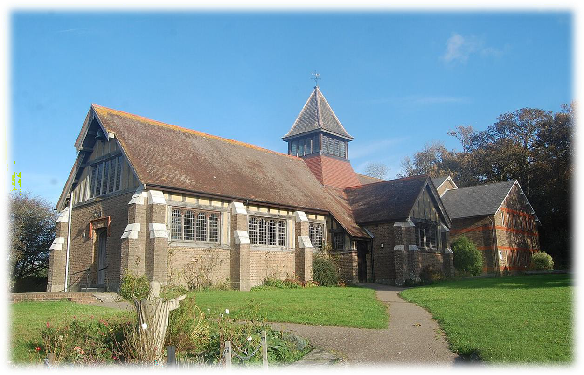

Parish Profile Winter 2026
Thank you for taking the time to read this profile document. We hope that it will both inform you and enable you to get to know us a little better.

Where we are:
The Parish, (in red) and the Church:
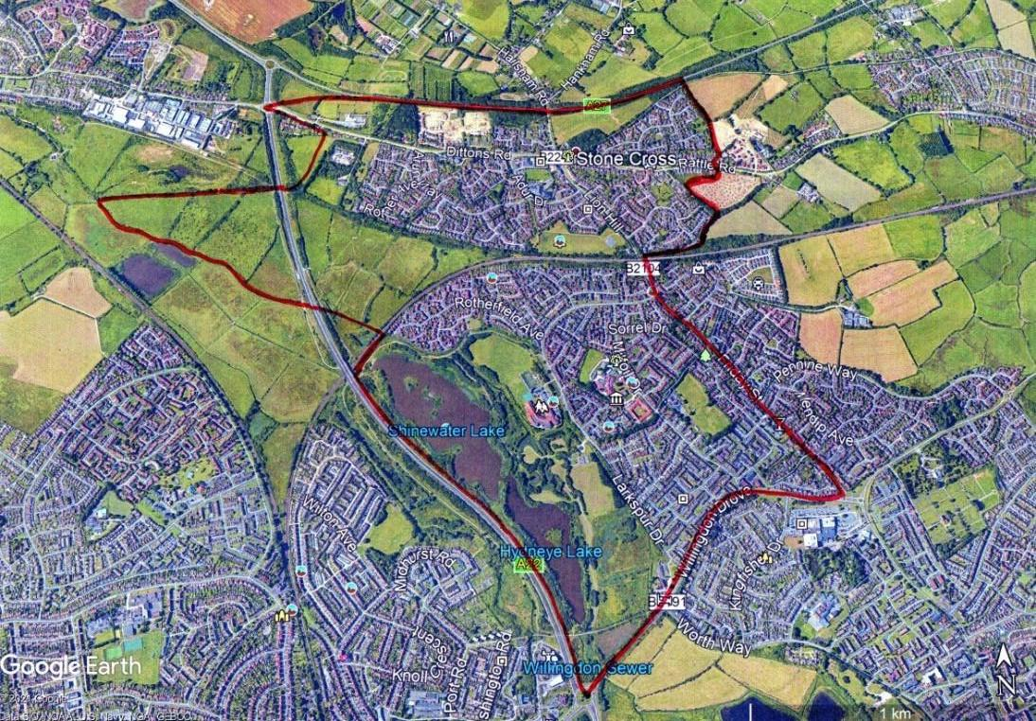
About us:
We are a friendly and welcoming parish church on the outskirts of Eastbourne, situated to the North East of the Stone Cross crossroads, opposite the Red Lion pub. (With whom we have an excellent relationship!). We have an attached Parish Centre which is well used by the local community.
Stone Cross is an excellent place to build a ministry, which needs to meet the needs of a broad age range of worshippers who are drawn from a large parish population of some 12,000 people.
Church Life:
Our style of worship is in the Catholic tradition of the Church of England, but we are free and flexible in our views, and we feel that the Church should not be bogged down in dogma, but doing the work of Jesus with care for others, love, and community as our central tenet.

Services:
We worship in a relaxed modern catholic tradition, and are fully affirming of all three orders of women’s ministry. We have a keen, well trained and capable young serving team, who we feel are a credit to the church.
Currently, our Sunday Sung Parish Mass is celebrated at 10:00am. On the 2nd Sunday of each month, an all-age Eucharist is celebrated at 10:30am followed by a shared lunch in the Parish Centre. The congregation play a full part in masses, reading, singing the psalm, praying the intercessions, welcoming people to the services, etc.
The Eucharist is also celebrated at 19:30pm on Tuesday Evenings and 10:30am on Wednesday Mornings. Also, Morning Prayer on Wednesday at 09:30am.
We would be keen to see the re-introduction of the monthly healing service, which lapsed during covid.
Compline is sung at 20:00pm on the First and Third Sundays of each month.
On the Fourth Sunday of the month, we hold a joint Evening Prayer/Evensong with nearby churches, St Nicholas’ Church, Pevensey and St Wilfrid’s Church, Pevensey Bay and St Richard’s, Langney. This is an opportunity for all four churches to worship together and get to know each other.


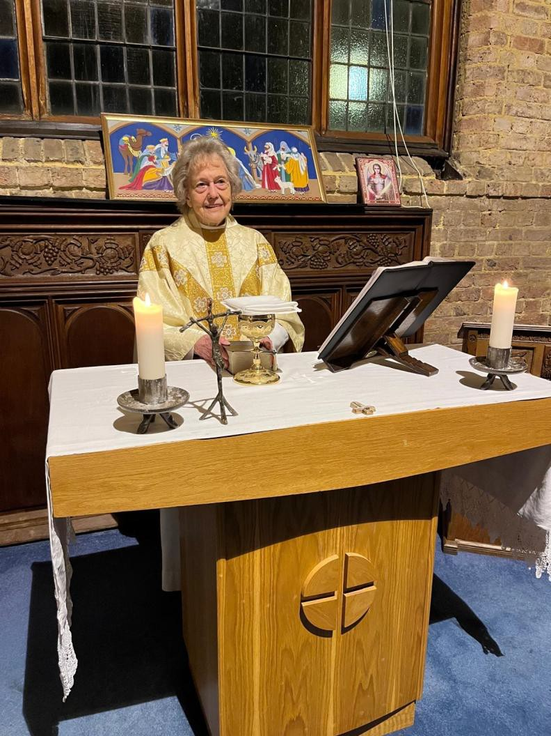

The Blessed Sacrament Chapel.
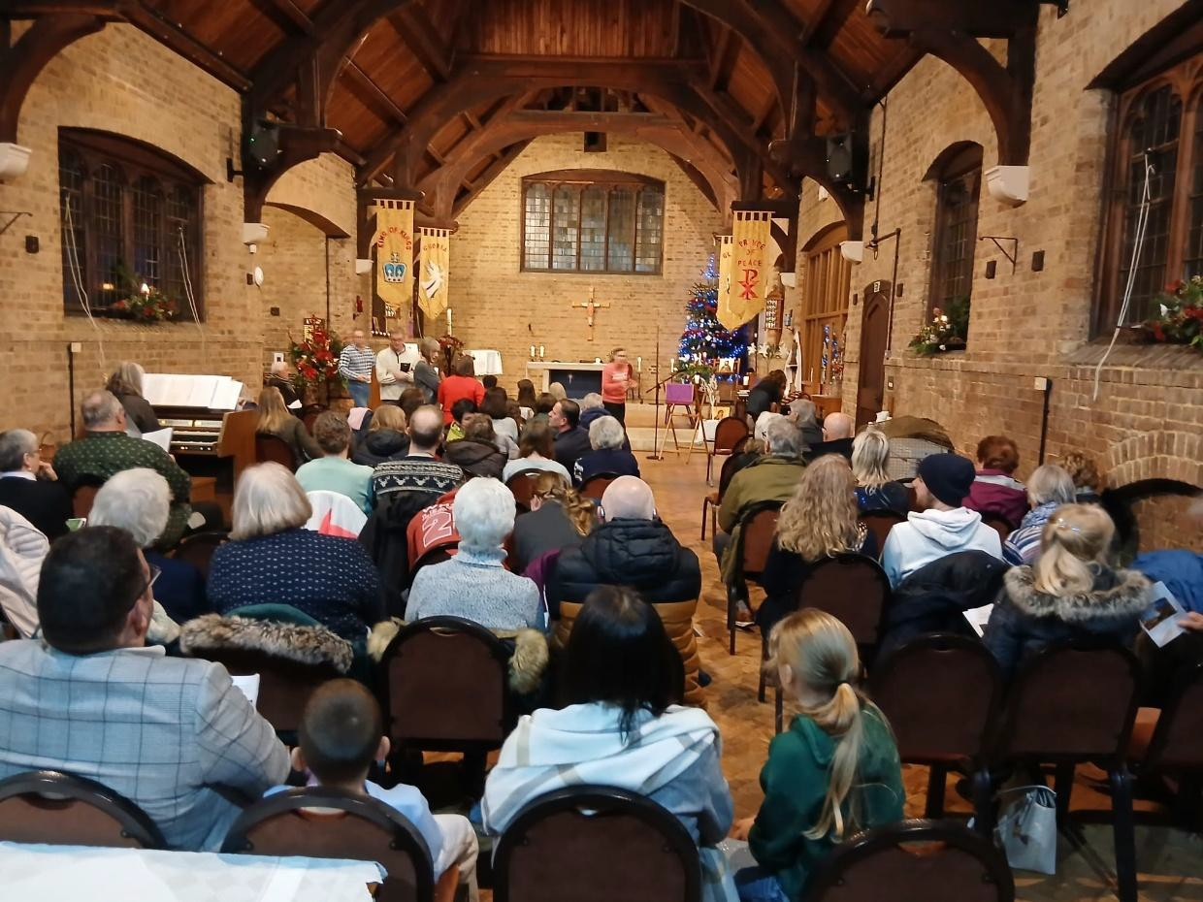

Nine Lessons and Carols at Christmas.


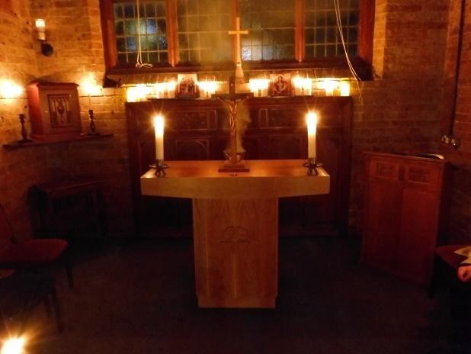

Compline.

Christmas:

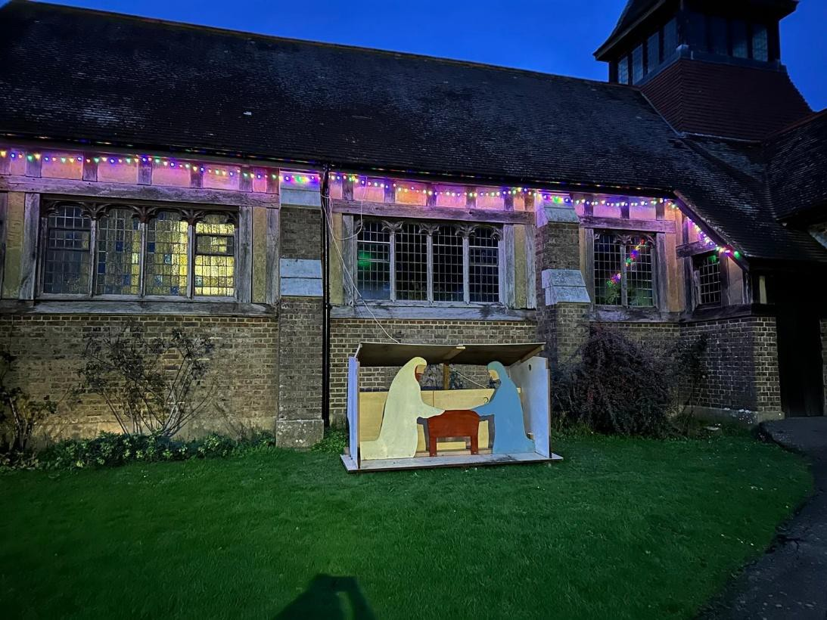

Outdoor Crib Scene and Festive Decoration.


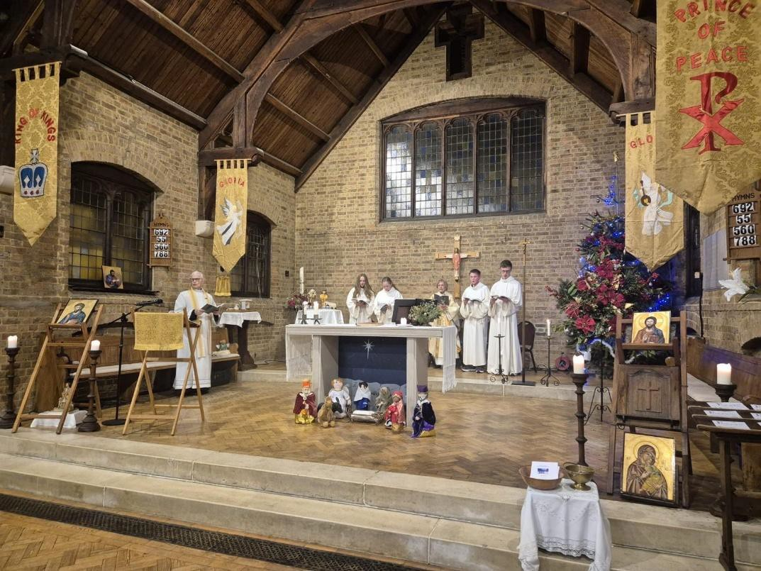

Epiphany Mass.
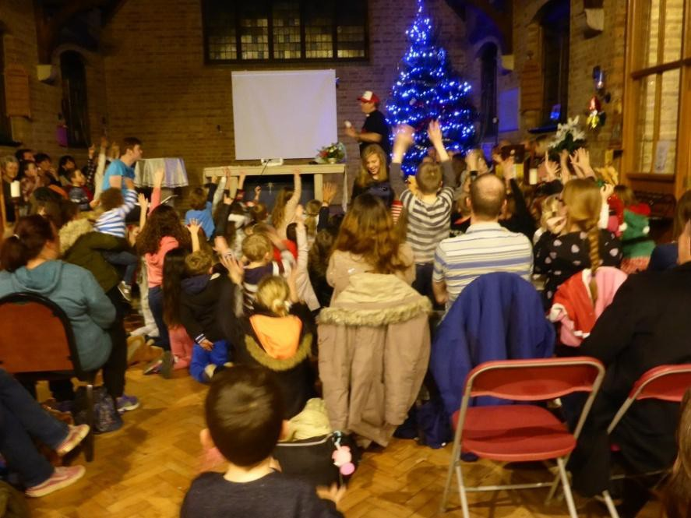

Christmas Eve Crib Service.

The Church Building:

St. Luke’s Church was built in 1923/25 as a daughter church to St Mary’s Westham, in the ‘Arts and Crafts’ Style. It was closed in 1976 because of some cracking caused by a hot dry summer. In 1988 it was re-opened by the Bishop of Lewes to serve the massive burgeoning of the population of Stone Cross and North Langney areas. This has led to us being one of the largest (by population) of the Sussex Parishes.

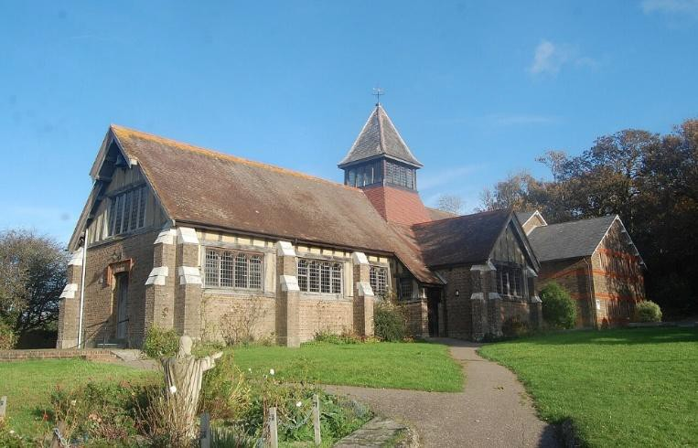
There are some ongoing and long-standing problems with the church building, but these are slowly being addressed. The Church is however watertight and warm!! We have had some severe cracking at the West End of the Church, for which we have a grant are awaiting a date for the works to begin

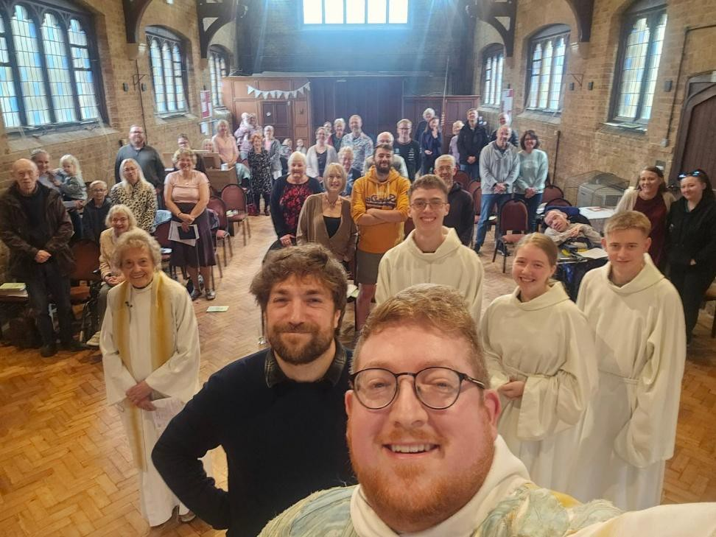

St Luke’s Day.

Parish Centre:

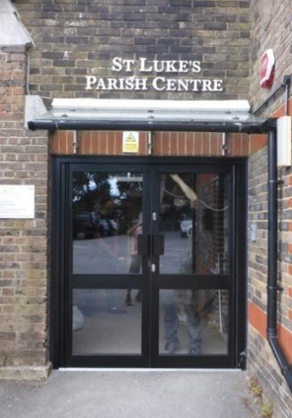
We are blessed to have a large and attractive Parish Centre which comprises a Main Hall, a Meeting Room, the Parish Office, and two commercial offices upstairs. The Hall regularly hosts Dancing, Tai Chi, Beavers, Cubs, Scouts, the ‘Little Luke’s’ Mother and Toddler group, an NHS group for older people, a Friday morning coffee morning with crafters and the St. Luke’s Community Pantry (a free foodbank resource to support our local community), children’s and adult’s parties and more. In the Meeting Room, we hold NHS Driveability, Moviemakers and various intermittent activities. We have an osteopath who works in one of the upstairs offices, so we feel that we are an asset to the community.

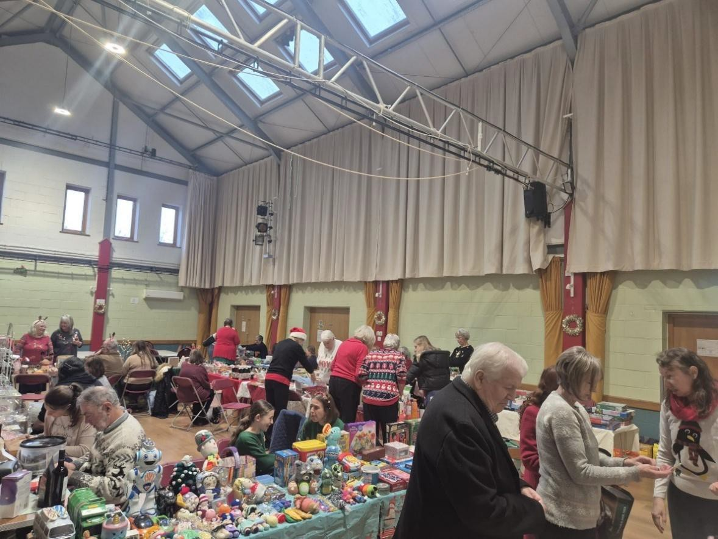

The Hall in Action for a Church Fair.


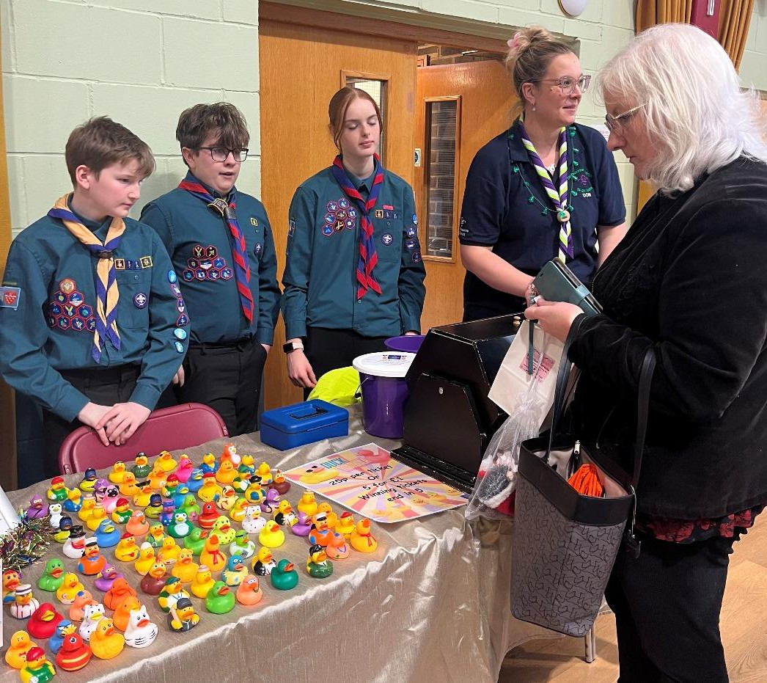

Our Uniformed Groups Assisting at a Church Fair.
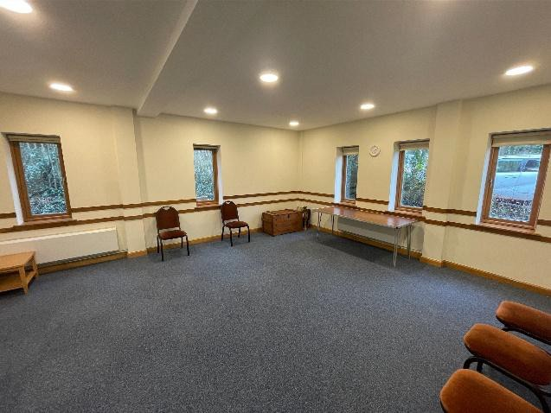

The Meeting Room.

Finance:

We are very conscious that we are part of the family of the diocese, and we are determined to move to a position where we are able to contribute our full Parish Share. However, we have been hit by a number of problems: major repairs to the roof and tower of the Church; necessary redecoration and refurbishment of the Parish Centre; and worrying cracks to the North West end of the Church, for which we are in process of obtaining estimates for repair, and which called for expensive investigative work.
Although we have been successful in obtaining grants toward the major works, our general income has fallen, mainly due to clubs and societies having ceased to use the Parish Centre, following Covid. We are taking active steps to attract new users of the Hall and Meeting Room.
In addition, we have recently formed a Fundraising Group, which is already showing results; but there will always be real challenges.

The ‘Staff’:

We have a team of volunteers including a treasurer and two churchwardens, who are responsible for the day to day running of the church. Our Safeguarding Officer ensures that we are fully compliant with the Diocesan Safeguarding Requirements. Other volunteers include those who decorate the church with flowers, and maintain our website and social media. During our Interregnum, our spiritual needs are mainly looked after by the amazing retired Fr. Colin, who has PTO (and to whom we are all deeply indebted!)
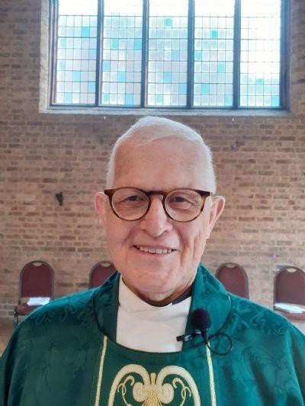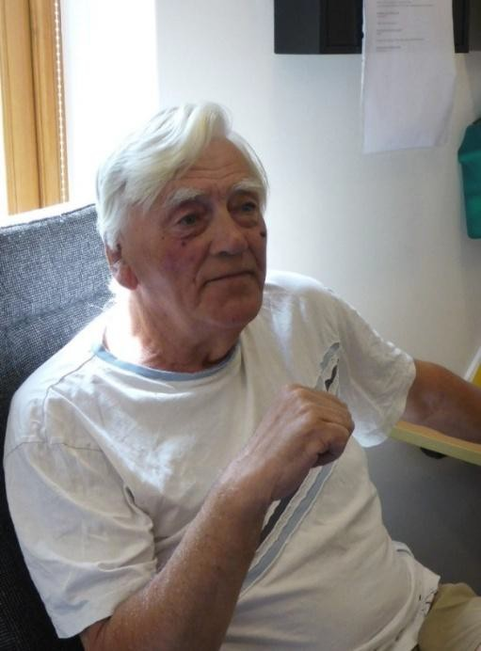

Fr Colin Boswell (Associate Priest). Roy Maryan (Treasurer).


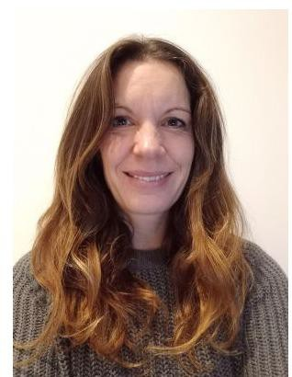

Lara Lloyd (Safeguarding Officer).
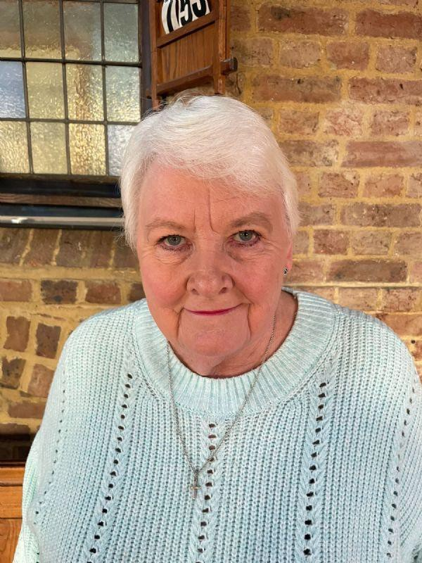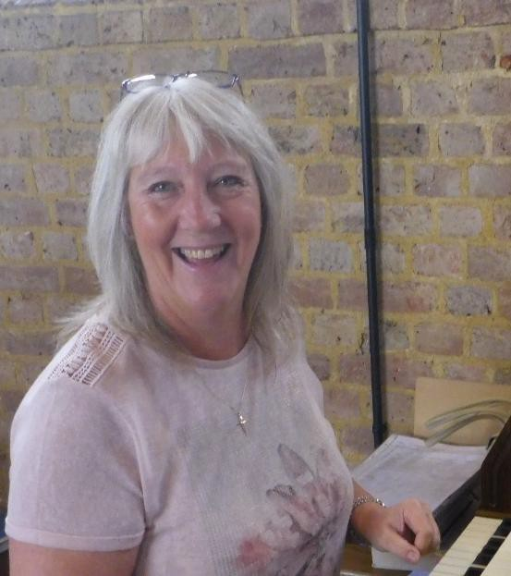

Fiona Jenkins Cheryl Gibson
(Churchwarden) (Churchwarden and Organist)


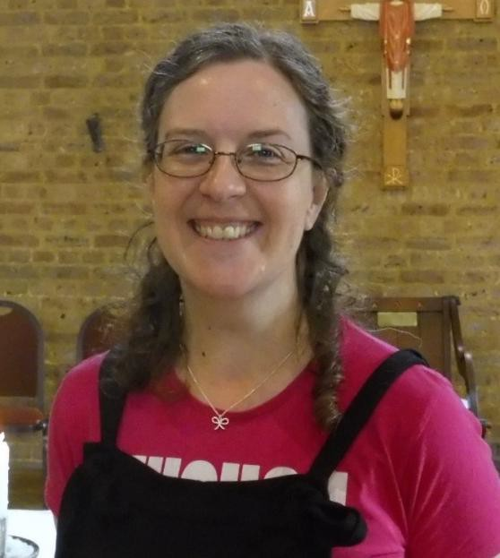

Yvonne Corbishley
(PCC Secretary)

Music:

St. Luke’s has a strong musical tradition! Our congregational singing is excellent and is supported by a small group of ‘cantors’. We have a more than adequate Viscount Digital Organ and are very grateful for the services of our talented volunteer organist. We sing from the ‘Celebration Hymnal for Everyone’ and sing all parts of the Parish Mass.

Local Area and Outreach:

Stone Cross Windmill
We have had good links with the Stone Cross Windmill and have celebrated Harvest and Christmas with them at the mill or in Church. It would be lovely to see these links restored as they have dwindled since Covid. The Windmill is a five storey Tower Mill, that has been fully restored, and is open to the public.
The Red Lion Pub
We have a good relationship with the Red Lion and we carol sing there every year. We also go there for coffee after Wednesday Morning mass and they have always been very willing to help us out with catering – for instance, for our previous incumbent’s leaving party.

Sycamore Grove
This is a residential care home for the elderly within the parish. Members of the congregation visit on a monthly basis and some of the residents participate in church outreach activities.

The Vicarage:

The Vicarage is a fairly modern (1985) four-bedroomed family house about half a mile from the church, situated in a quiet Cul-de-sac. The kitchen has just been replaced, as have all the windows and doors. The garden is easily manageable with mature shrubs and trees.
It is situated about half a mile from the Langney Shopping Precinct, and about 200 yards from a Co-op store. There are Railway Stations in Polegate (2½ miles) and Westham (2 miles) with good links to London, Brighton, Eastbourne and Hastings.
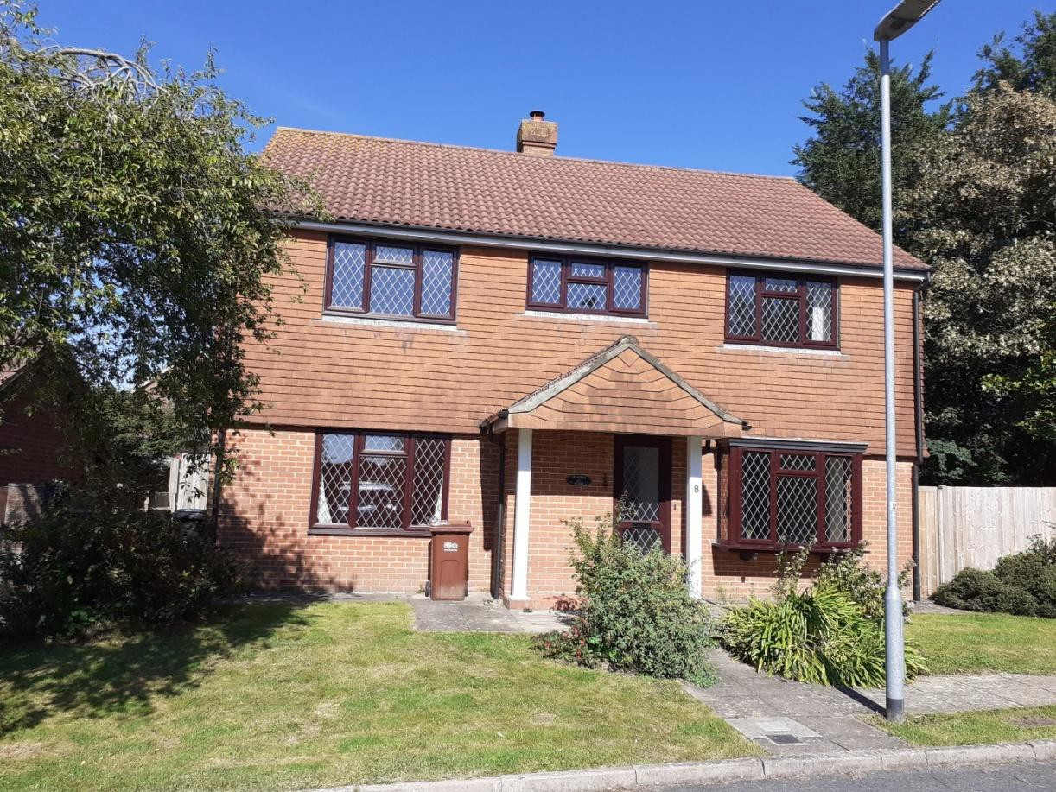


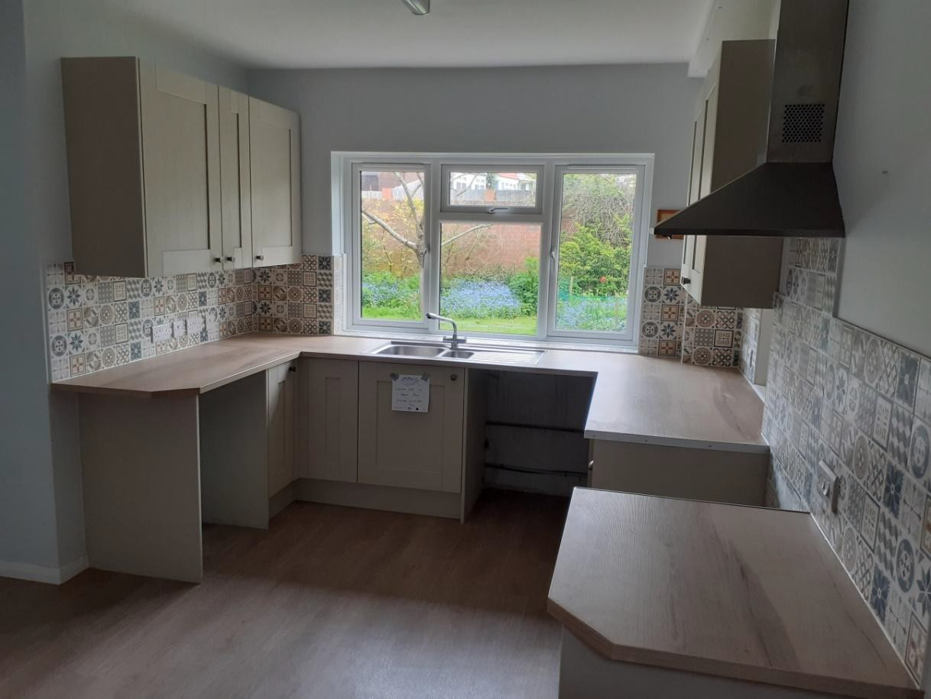

Pastoral Care:

We had a pastoral group, which really stopped functioning during the pandemic, but we are in the process of restarting this, because we strongly believe in being outward looking.

The Numbers:
There are currently 77 members on the electoral roll. The attendance at the main Sunday morning service ranges between 35 and 55. We tend to average about forty at present. On special occasions, numbers have risen to over 100, including a large number of children. The Christmas Eve crib service has been known to have over 200 present!

Young People:

On a Tuesday mornings, we hold ‘Little Luke’s’; an amazing mother and toddler group in the Parish Centre, run by Imogen Lade. This attracts a good crowd, and is very lively.

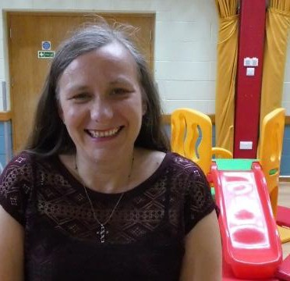

Imogen Lade (Little Luke’s).

Every two weeks, there is a ‘Youth Fellowship’ meeting in the parish centre.
As mentioned before, we have a group of dedicated and very well organised servers at Mass. It would be lovely to encourage some more young people to become part of this wonderful team.
On the second Sunday of the month, our Sunday parish mass holds an emphasis on younger people and families, and we all bring and share a light lunch after the service.

Uniformed Groups:

We have Beavers, Cubs and Scouts, who meet regularly in the Parish Centre, and we are striving to deepen the link with them. They attend Remembrance Sunday, and other services, and it is always a pleasure to see them. Some of the congregation are Scouts or Scout Leaders, and this enables us to work closely together.
We are also deeply honoured to enjoy the presence of the local Royal British Legion for our Remembrance Day Service, and we fly their Standard in the Memorial Chapel.

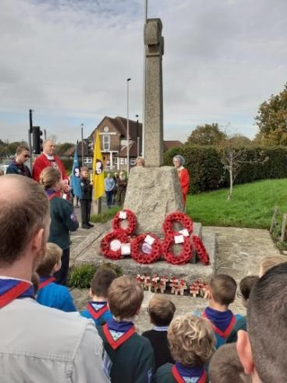

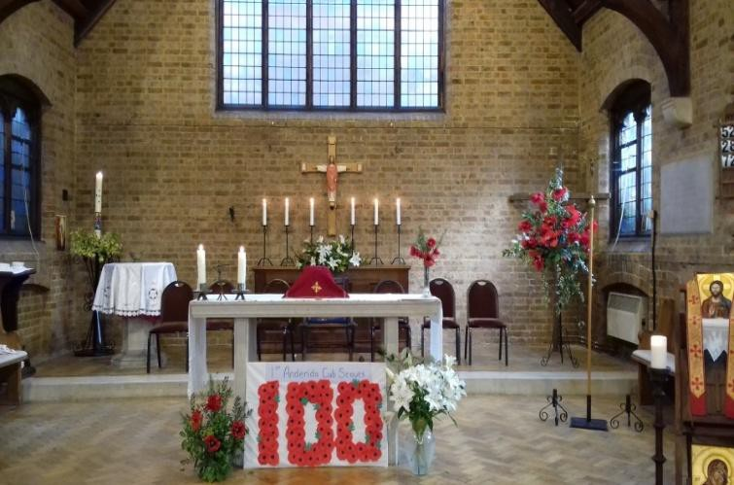

Remembrance Sunday.

Schools:
There are established links with several local schools, including Hankham and Stone Cross Primary Schools, and St Catherine’s College (C of E Secondary School).

Stone Cross school in particular is keen to be involved in activities throughout the church and school year. Our previous incumbent was on the board of governors at both Hankham and Stone Cross, and was involved with St. Catherine’s. Additionally, he used to carry out assemblies each term and they seem to have been very well received.
The children at Stone Cross, Hankham and Hazel Court Schools have had their Christmas carol services at the Church, as do the local Bluebell Nursery.
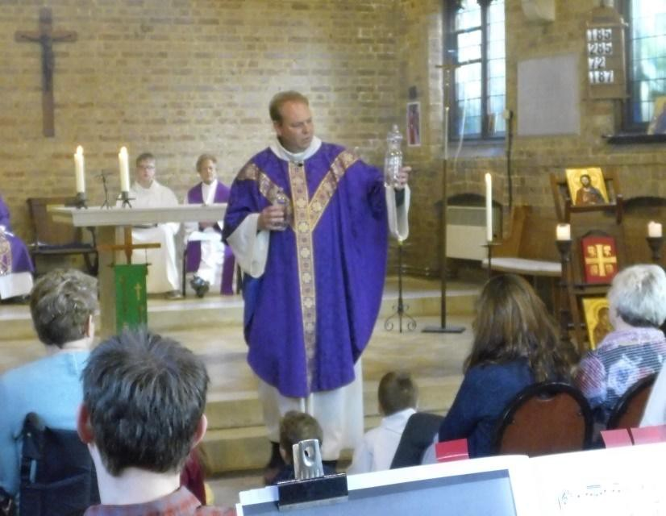

A Family Mass on the Second Sunday of the Month.

The PCC:
The PCC currently meets monthly, with extraordinary meetings being called as required.

Relationships with Other Churches:


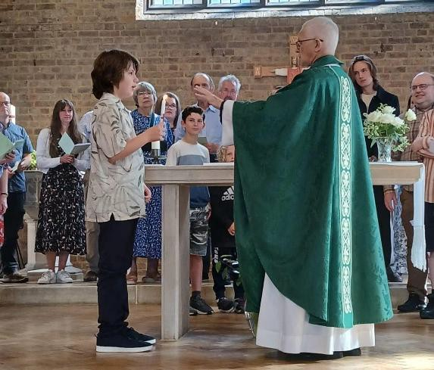
We are re-joining the ‘East Side Churches’, which has been non-functioning since the advent of Covid. This is a loose affiliation of some of the Churches in the East of the Deanery and we have had ties with several other denominations in the area.

Online Presence and IT:

The Church has a comprehensive website (www.saintlukestonecross.org.uk), and we are also on Facebook (‘Saint Luke’s Church & Parish Centre – Stone Cross with North Langney’), Instagram and Twitter.
A Church WhatsApp group keeps parishioners in touch with each other and up to date on church news, events and concerns.

We have a good sound/P.A. system, and stable Wi-Fi is available across the whole site.

The Centenary:

Work on building the church took place between 1923 and 1924, the consecration taking place in January 1925.
We held a joint day of celebration with the Red Lion Pub on 20th July 2024, with live music, a bar, food and much more, to celebrate the centenary of the building of the church.
We also had a visit from the Lord Bishop of Chichester to celebrate Mass on the centenary of our consecration.

Recent Events and Charity Support:

We strive to reach out and help others in this unequal world, and are involved in raising money for charitable purposes locally, within the country, and in other areas of the world.

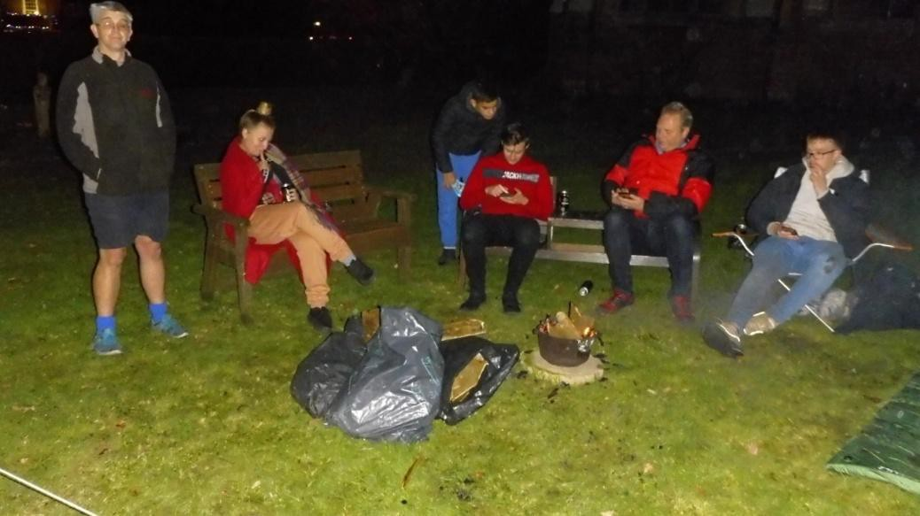

Sleepover Raising Funds for the Homeless.
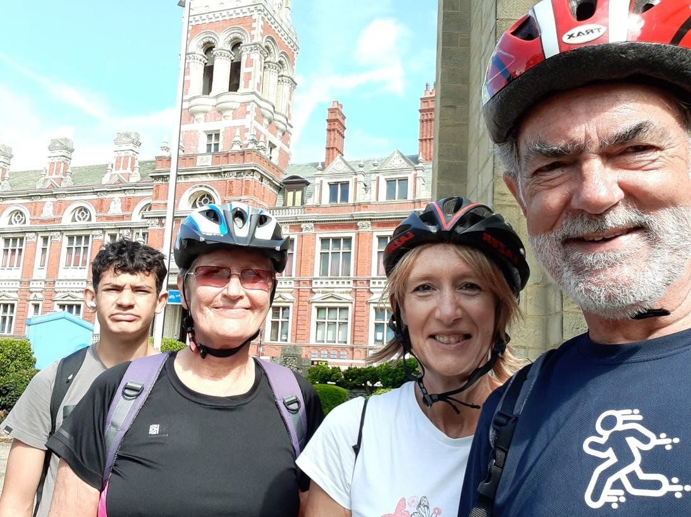

Cycling as Part of the Historic Churches Trust’s ‘Ride and Stride’ Event.


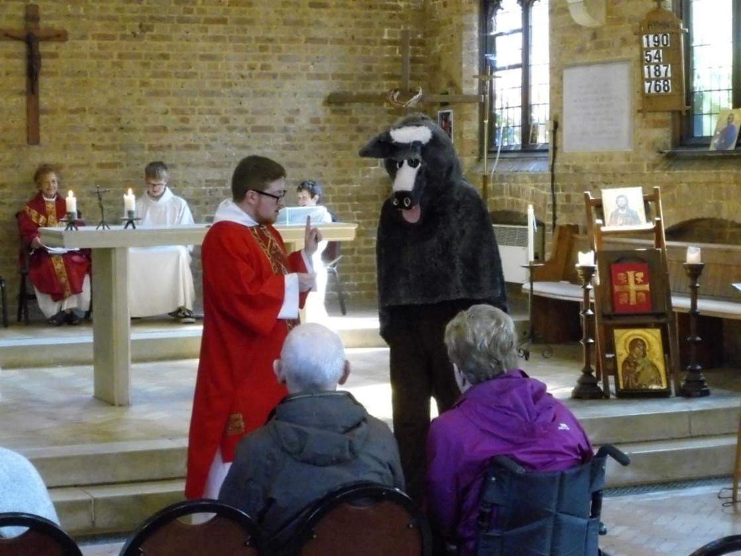

A Visitor in Church.
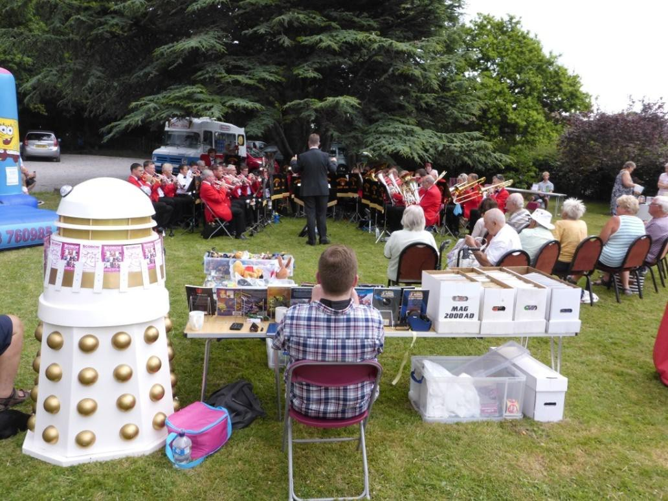

Annual Summer Fair, with Entertainment from the Eastbourne Silver Band.

Our New Incumbent:

We are looking for a Priest to continue walking with our Church family. He / She will need;
- An engaging personal faith, and the commitment to celebrating the Liturgy in the modern catholic tradition of the parish –and imaginatively commending this to others,
- A commitment to community ministry and outreach to people of all ages,
- Strong pastoral skills,
- And Personal resilience, warmth and good humour.

We feel that the parish is a lively environment and we would love to see it grow, the potential is enormous, and we feel that with enthusiasm and work we can again raise our profile in the area.
We have seen a reduction in young people attending since the pandemic and with so many sports being held on a Sunday, and we will need someone who will be happy to visit the local schools and attract more young families. Also, we need someone to encourage the spiritual life of the Church, with activities such as prayer groups, Bible studies, quiet days, and retreats. We have already booked and are looking forward to our Parish retreat to Sint Andries’ Abbey near Bruges in May.
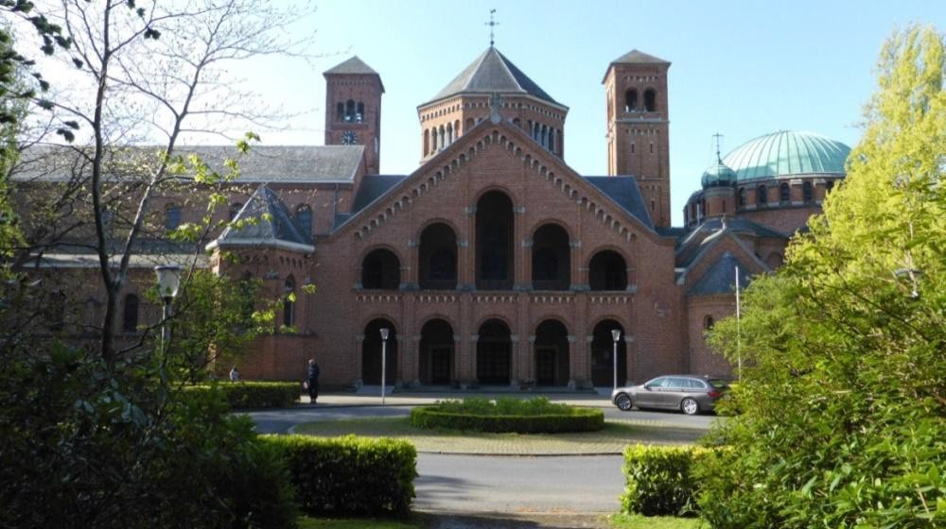

Sint Andries Abbey.

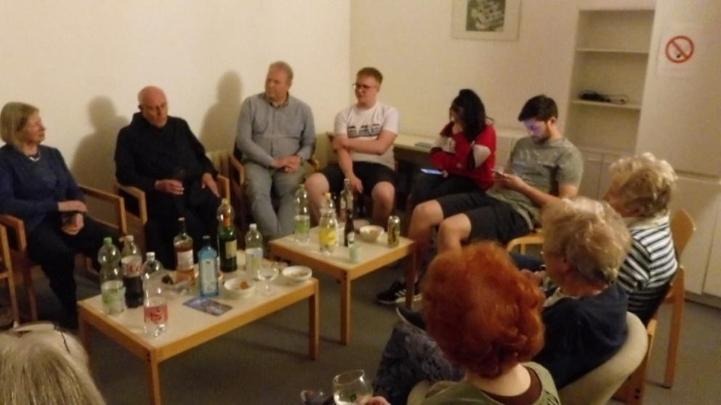

Parish Pilgrimage 2023 (Sint Andries Abbey with the Abbot).

We hope that you have found this a useful insight into our wonderful parish and all that we have to offer so far.
Please do pray about this post and discern if God is calling you to join us here
in Stone Cross & North Langney. We’d love to meet you!

Addendum from the Archdeacon of Hastings

In the Diocese of Chichester, we are praying for a gifted priest to lead Stone Cross parish in the coming years. The many opportunities at St Luke’s are evident from the above parish profile.

Applications are particularly welcome from those with a real passion for schools ministry and a willingness to take advantage of opportunities that may arise to minister in schools both in Stone Cross parish and in neighbouring parishes.

It is expected that in the coming years, there will be further pastoral re-organization involving Stone Cross. The Diocese hopes to support and part-fund the development of a ministry team as part of the diocesan growth strategy (funded by a bid to the Diocesan Investment Programme). Therefore, it will be important for the successful candidate to have a track record of building a team.

Those considering an application are encouraged to contact me to talk through these plans in more detail.

The Ven Russell Dewhurst
Archdeacon of Hastings
mobile 07827 275649
archhastings@chichester.anglican.org

