

Canon Chancellor
Recruitment Pack
April 2025

Team: | Clergy
Location: | Chantry Offices and Chichester Cathedral
Contract type: | Permanent
Hours: | Full Time
Annual Salary: | Residentiary Canon Stipend

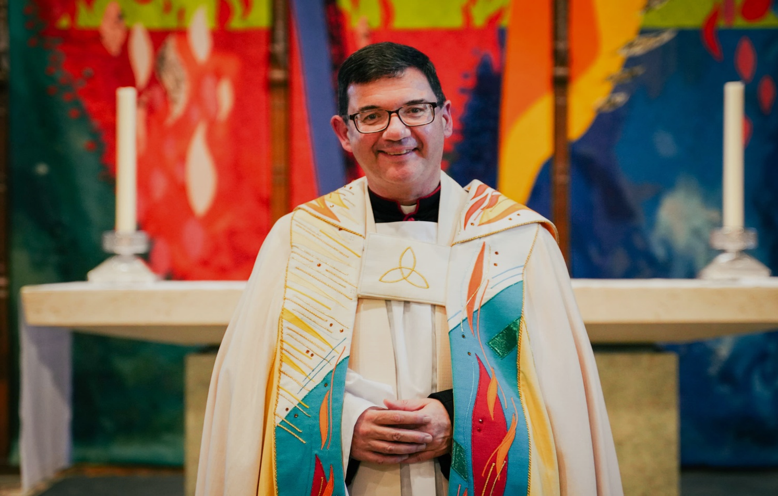

Welcome from the
Dean of Chichester

Thank you for your interest in the post of Canon Chancellor of Chichester Cathedral.
We are hoping to appoint a residentiary canon who will be able to play a full part in the Cathedral community, with a special responsibility for theological education and Christian formation of people from every background and age group.
The appointed person will make a vital contribution not only to the Cathedral, the wider diocese and, we hope, others who are further afield.
Chichester Cathedral is an exciting and inspiring place in which to work: the new Canon Chancellor will have a supportive spiritual pattern of prayer and worship, a committed and able team of colleagues, both lay and ordained, a large worshipping congregation, and many links with the local community throughout East and West Sussex.
We hope that you will be interested in the details we have provided and, if you discern a possible vocation to this work, be prompted to apply for the post.

The Very Revd Dr Edward Dowler
Dean of Chichester

About Chichester Cathedral

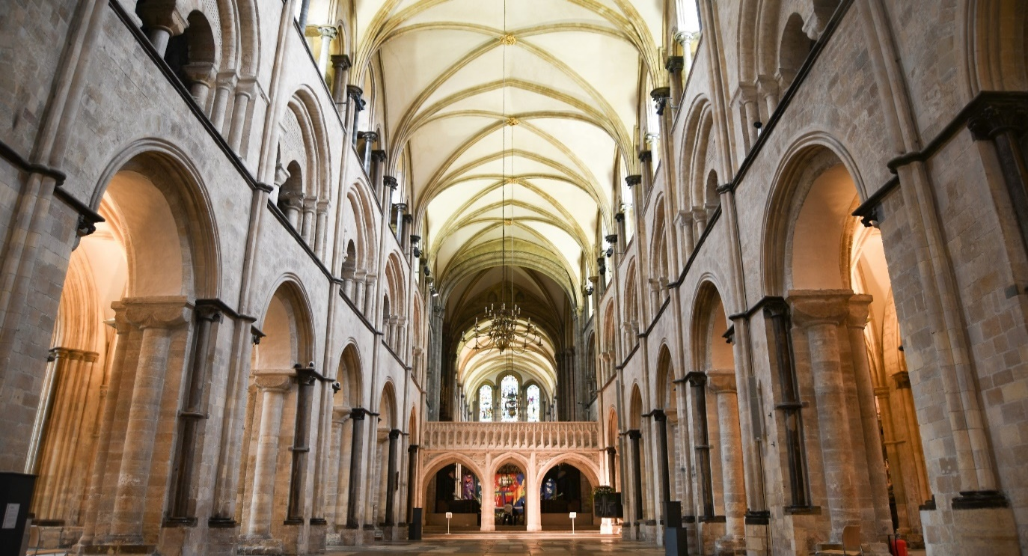
The Cathedral is a living church that has been at the centre of life in Chichester for over nine centuries. We are a place of worship and mission, the Mother Church of the Diocese of Chichester (which covers East and West Sussex) and the seat of the Bishop of Chichester. We are supported by a committed worshipping congregation, a small but dedicated staff team and over 400 volunteers.  The Cathedral is a leading visitor attraction, a venue for artistic and cultural activity, and an all-round hub for the community, welcoming over 250,000 visitors each year. Music is a central element in the Cathedral’s life. The choir, which offers eight sung services each week and contributes to the Cathedral’s outreach around the diocese, has a high reputation at national and international level. We also host many high-quality musical performances each year by choirs, orchestras and chamber groups. | The Cathedral presents a comprehensive events programme and has a trading subsidiary, Chichester Cathedral Enterprises Ltd (CCEL), offering hospitality and retail services that support the Cathedral in delivering its mission. We have both a residential and commercial property portfolio many of them listed, in the Cathedral Close and beyond.  The Cathedral does not receive statutory or Church of England funding and is self-supporting, relying on self-generated income, donations, and fundraising activities. The Chapter is supported by the Chichester Cathedral Restoration & Development Trust and the Friends of Chichester Cathedral.  Further information about Chichester Cathedral can be found on the Cathedral website, including our Annual Report & Accounts.
Our Vision
In recent years, Chichester Cathedral has found inspiration for its life and work in the four ‘pillars’ established by St Dominic, whose influence deeply shaped the ministry of St Richard of Chichester in the Cathedral and the wider Diocese. As in a cathedral building, these four pillars are deeply interconnected, and undergird the vision that we seek to articulate and live out.
The four pillars are:

Prayer  Committed to seeking the face of God in contemplation and worship, we hope to be guided by the Holy Spirit to enter more deeply into the mystery of Jesus Christ and to radiate His beauty. | Study  We seek to discern true wisdom in an age of technological, political, social and economic change – through study, dialogue and engagement with the world.
Community  We seek to build up our community in love, compassion and hospitality – encouraging each other to step out in faith and hope. | Mission  We seek to take the message of God’s grace into the World with imagination, beauty and confidence, radiant with the promise of salvation.

2025 also marks 950 years since our Cathedral was moved from Selsey to Chichester.
It’s an anniversary that’s significant not only for the Cathedral, but for the life of the whole Diocese and for the Christian faith in Sussex. The year also marks 1700 years since the Ecumenical Council of Nicaea – a definitive turning point in the Church’s witness to the God who has revealed himself to us in Jesus Christ and continues to lead us into all truth through the Holy Spirit. This anniversary has invited us to think more deeply about our purpose here at the Cathedral.

You can read our full Vision document on the Cathedral website.

Commitment to Safeguarding
In accordance with Church of England’s policy, Promoting a Safer Church and the House of Bishops’ Safeguarding Policy and Practice Guidance, Chichester Cathedral is committed to the safeguarding of children, young people, and vulnerable adults who may be at risk.
The Cathedral works in partnership with the Diocese of Chichester to ensure that we operate in accordance with best practice at all times.
The care and protection of children, young people and vulnerable adults are the responsibility of the whole Cathedral community, whether clergy, staff, volunteers, contractors or members of the congregations. Everyone who participates in the life of the Cathedral has a role to play in promoting a safe environment for all.
You can learn more about Safeguarding at the Cathedral please see our website.

Commitment to Equality & Diversity
At Chichester Cathedral we are dedicated to encouraging a supportive and inclusive workplace culture amongst our employee and volunteer workforce. It is our aim to ensure that if you work here or apply to work here, on either a paid or voluntary basis you will have an equal opportunity. We are also committed to working towards an organisation workforce that is diverse and as representative of our wider community as it can be.
We respect and value each of our employees and volunteers and are committed to enabling you to be able to perform to the best of your abilities and to be your authentic self in the workplace.

About the Role
The Chancellor, as a residentiary canon and a member of the Chapter, joins our Senior Management Group working closely with the Dean, our Canon Treasurer, Vanessa Baron and our Chief Operating Officer/Communar, Amy Sim.
A full copy of the role description for the Canon Chancellor is available on our website.
As a member of the Cathedral’s clergy team, the Chancellor also works with the Dean, Canon Treasurer and Priest Vicar, The Revd Nigel Ashworth. As a group their primary responsibility is to minister at Chichester Cathedral and undertake responsibilities as Canon in Residence as required.
Further details about the arrangements for Canons at Chichester Cathedral is available on our website.

How to apply

Please apply through the CofE Pathways Website by clicking ‘apply for this vacancy’. by midnight on Sunday 11 May 2025

Please note that interviews are scheduled for: Tuesday 27 May 2025
If you wish to have a discussion about this role with the Dean, The Very Reverend Edward Dowler, before submitting your application, please email him: dean@chichestercathedral.org.uk

This post is offered with accommodation within the cathedral grounds at No.2 St Faiths

2 St Faiths is a beautiful, recently refurbished 4-bedroom property across three floors.
It comprises a generous kitchen and dining area and separate living room looking out onto the cathedral and small court-yard garden, the property benefits from two cloakrooms, large shower-room on the first floor and a family bathroom on the second floor.

Recently refurbished to a high standard there is additional storage available in the basement of the property.

