**THE CHURCH OF ST PETER, PARISH OF LYNCHMERE & CAMELSDALE**

**PARISH PROFILE**

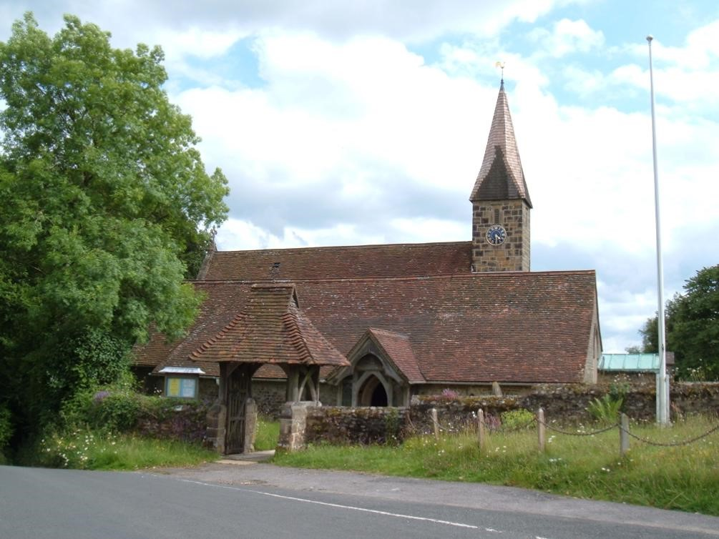

**Church of St Peter, Lynchmere**

St Peter’s Lynchmere

Lynchmere Road  
Lynchmere  
West Sussex  
GU27 3NG

[Google Maps link](https://maps.google.com/maps?q=GU27%203NG)

Churchwarden:

Julian Biggs

[julian.biggs@outlook.com](mailto:julian.biggs@outlook.com)

07999 300940

Church website:

[www.flcchurches.org](http://www.flcchurches.org)

**CONTENTS**

**Page**

The Parish 4

Our New Vicar 5

Our Worship 5

Our Churches 7

Other Parish Venues 8

The Vicarage 9

People in the Parish 9

The Friends of St Peter’s 10

Parish Events 10

Outreach 11

Finance & Funding 11

The Future 12

The Locality 12

Conclusion 13

# Proclaiming the Mystery of Faith

# In 2025 this diocese celebrates the 950th anniversary of witness and evangelisation from a mission base in Chichester, building on the earlier mission founded by St Wilfrid at Selsey. 2025 also marks the 1700th anniversary of the Council of Nicaea with its reminder of the formative claim upon us of the catholic creeds.

# These anniversaries are more than historical footnotes. They speak powerfully about the richness of faith and mission that is our inheritance locally and universally.

# Inspired by that inheritance, we seek to be a household of faith that is endlessly curious about how the Holy Scriptures and the sacraments of the New Covenant enable us to know, love and follow Jesus Christ in today’s noisy and distracted world.

# If God is calling you to join us in the task of proclaiming the mystery of faith in some part of this diocese, we pray that the contribution of your gifts and experience will enrich our witness and deepen your own discipleship.

# We take very seriously the call to diversity and radical inclusion as characteristic of the Church’s mission. For this reason we welcome applications from ordained women and Global Majority Heritage clergy, who are under-represented in those who serve this diocese.

# +Martin

# The Parish

The parish of Lynchmere & Camelsdale joined with the parish of Fernhurst to become the United Benefice of Fernhurst, Lynchmere & Camelsdale on 3rd November 2016.

This profile presents the views of St Peter’s Lynchmere only. St Margaret’s PCC will produce its own profile. These two profiles will illustrate the similarity in Christian outlook of both churches as well as highlighting subtle differences. Without doubt, both parishes tread a similar Christian path.

The regular services at St Peter’s are more varied with a mixture of Holy Communion and Morning Prayer. Morning Prayer services are often taken by one or other of our Lay Readers. Both congregations get on well and there is some crossover of parishioners attending services in both churches, particularly when the vicar is taking Communion services at Lynchmere. We support each other’s mission and congregations. [(](http://www.stpandp.co.uk/)[www.flcchurches.org.uk](http://www.flcchurches.org.uk)).

The regular congregants of St Peter’s reside in all parts of the parish, and many have long and deep connections with the area. There exists dedicated support for St Peter’s beyond the hamlet itself.

The parish is situated on the borders of three counties: West Sussex, Surrey & Hampshire. It is in the Midhurst Deanery and looks to the Suffragen Bishop of Horsham. It is on the “northwest frontier” of the diocese of Chichester. The parish consists of three distinct areas:

**Camelsdale** is a village a mile to the south of Haslemere with a popular primary school and pre school. Many households are families with hybrid working parents dividing their time between working from home, London and nearby cities.

Similarly, the village of **Hammer** has a community of young families with working parents and there is a small estate which is home to both families and elderly residents.

**Lynchmere**, a mile from Hammer and where the church itself is located, is a sprawling hamlet with no central focus and a number of large, detached houses and a cricket ground. The inhabitants are a mixture of working families with children of all ages, and retired couples.

# Our New Vicar

We are an open and inclusive congregation which has been well led by our previous vicar for the last eight years (12 in Fernhurst). We are looking for the following in his successor:

* A priest who is comfortable with the subtle difference in worship styles of the two churches. The differences are slight: St Margaret’s has a strong Eucharistic tradition with the use of incense. St Peter’s does not use incense, does not present the Bible before the Gospel reading and the server does not robe. Fernhurst has a sacristan, Lynchmere does not. Lynchmere aims to make the atmosphere friendly and welcoming without necessarily concentrating on ritual.
* A confident, intelligent preacher.
* A person with effective communication and listening skills and a sense of humour.
* A priest who is willing to become a part of the community.
* A priest who can inspire and lead a dedicated ministry team.
* A leader who will offer strong spiritual guidance and pastoral care, and who will walk alongside our congregants at times of need.
* A leader who is at ease with a variety of souls, and whose presence and initiatives will assist in encouraging more younger people to attend church.
* A priest who will be keen to manage and embrace the challenge of modern semi-rural ministry while respecting the long history that supports our 1000+ year old church.

**Our Worship**

We try to avoid competing services. The main morning Sunday service alternates between the two churches. When there is a 10am service at St Peter’s, St Margaret’s will have an 8am BCP service. There is a midweek BCP service at 10am and Celtic Evening Prayer once a month at St Margaret’s. The vicar alternates between the two churches on Remembrance Sunday. At Christmas and Easter, we stagger the service times so the vicar can take the services in both churches.

Average attendance at St Peter’s services is as follows:

28 adults and 3 children

Number on the Electoral roll is: 44

Attendance increases considerably at Christmas and Easter and commemoration services – Remembrance Sunday being a good example. After leading a short service at the church, the vicar or lay minister leads an Act of Remembrance at the war memorial at Shottermill Ponds. This civic event attracts 100-200 people with Scouts, Guides and other associated groups.

There are additional services at major festivals: each church holds its own Harvest Festival. Midnight Mass at Christmas is held at St Margaret’s in Fernhurst. A Crib Service is held in both parishes, as well as carol services (a Service of Nine Lessons and Carols at St Peter’s), and a Patronal Festival (traditionally an evensong at St Peter’s, but more recently at 10am). On Good Friday, there is usually a walk beginning and ending at St Peter’s, followed by a short reflection.

For many years we have held an Open Air Nativity play in the churchyard which has become increasingly popular with often around 150 people attending. It has become a highlight of the church calendar.

Open Air Nativity, St Peter’s Lynchmere

An ad hoc choir is sometimes put together for special festival services.

For over 70 years, The Lynchmereans, a group which began its life associated with the church, produces a pantomime. It continues now as a community initiative. A large cast of mixed ages takes part, including many children.

# OUR CHURCHES

**St Peter’s Church**

This much-loved church dates from Saxon times and contains Early English work from the thirteenth century, a nave from the eighteenth century and later additions by the Victorian church architect William Woodyer. Further extensions were built in 1906 and 1957. In 2008 a new area was created adjacent to the altar where preaching and other presentations can take place. An electronic organ was installed at the same time. The building is Grade II* listed and sits on top of a hill with magnificent views down the valley towards Midhurst.

The surrounding churchyard was closed by an Order in Council although burial of cremated remains continues both within the churchyard and in adjoining land owned by the Friends of St Peter’s (an independent charity supporting the fabric of St Peter’s – see further below).

Our latest quinquennial was in 2023 and all urgent recommendations are being dealt with.

The church is open every day for visitors and private prayer and is closed every evening. The opening and closing is handled by hamlet and parish residents on a rota basis.

Children in the church are catered for by a “children’s corner” which is equipped with books, toys and colouring materials. We do not have a Sunday School any more because of limited space, but children are incorporated into services, as well as child-orientated services such as Mothering Sunday and Christmas Day service. The Outdoor Nativity play involves a large number of children, much of the recruitment for this show comes from our outreach activity at the local primary school in Camelsdale (see below).

**St Paul’s Camelsdale - closed**

In 2023, St Paul’s Church in Camelsdale was permanently closed and handed back to the diocese who is now responsible for the building. Slow progress deciding the site’s future is under way. The PCC is kept abreast of progress in this regard. The PCC remains extremely interested in its future, due to its proximity to Camelsdale Church Hall.

# Other Parish Venues

There are two church halls in the parish: Camelsdale Church Hall and St Michael’s, Hammer.

* Camelsdale Church Hall is well-used by a popular daily pre school. It is also used by various dance, exercise, music and art groups and children’s parties are held there. Camelsdale Church Hall is subject to a Vicar and Churchwarden’s Trust. It is self supporting.

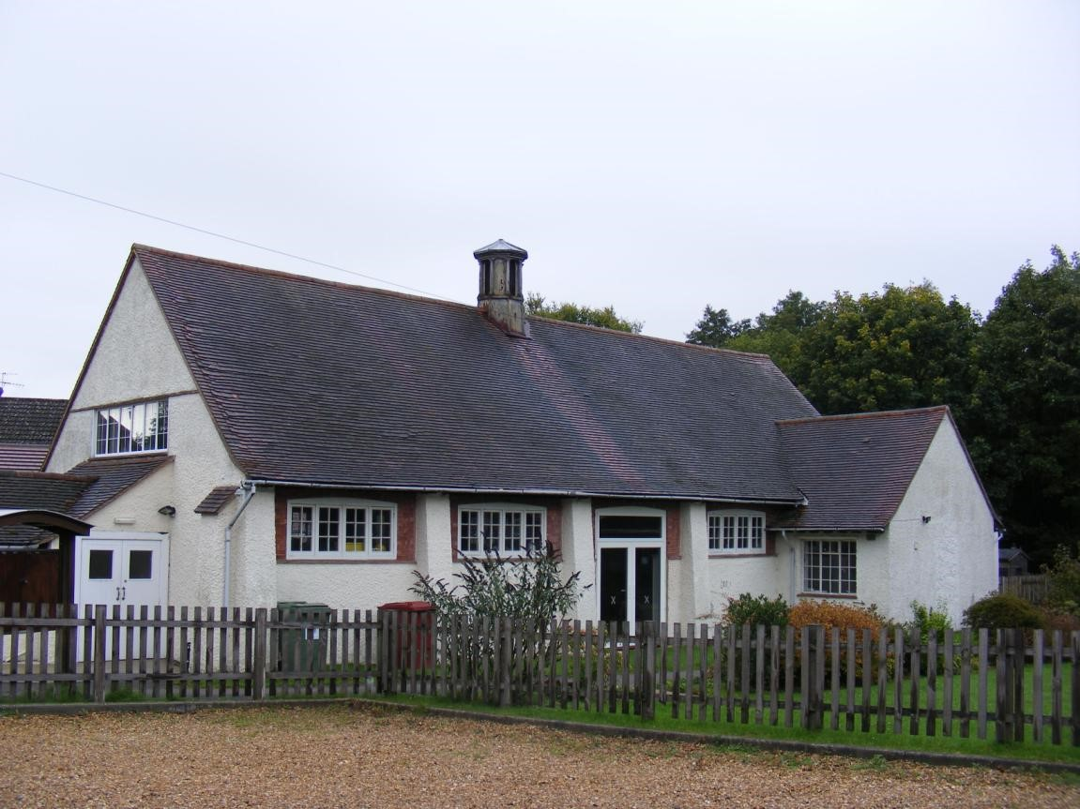

Camelsdale Church Hall

* St Michael’s Hammer, whilst owned by the church, is the subject of a 999 year lease granted to the Parish Council a few years ago, and its running is now entirely the responsibility of the Parish Council.
* Hardman Hoyle Memorial Hall is a village hall occupying the same plot as St Michael’s and is run by the Parish Council.

Other churches in the area:

* Three Counties Vineyard – a popular free church in Hammer
* St Stephen’s Shottermill – an Anglican church close to Camelsdale and Hammer and just over the county border in Guildford diocese
* Methodist Church in Weyhill
* St Christopher’s & St Barts - Anglican churches in Haslemere parish and Guildford diocese
* Our Lady of Lourdes, a Catholic church in Haslemere

# 

# The Vicarage

The Vicarage is in Fernhurst and will be best and fully described in the Fernhurst Parish Profile. Suffice to say that we share the running costs.

# People in the Parish

* We have two Lay Readers who regularly take services and preach. One of the Lay Readers has PTO given their age. Both Lay Readers are also licensed to take funerals with the consent of the deceased's family. One Lay Reader is a talented amateur actor who brings these skills to bear in the services he leads. The other Lay Reader is also the parish (and benefice) Safeguarding Officer. We have been awarded the Simple Quality Protects Level One accreditation by the diocesan safeguarding team. The same Lay Reader is also the Deanery Synod Lay Chair. She also sits on the Diocesan Synod, and the Diocesan Mission and Pastoral Committee (West).
* We have one Churchwarden who is also a Server, and Treasurer of the PCC.
* We have a part-time parish administrator employed on an hourly basis by both parishes. She is also a Server.
* The PCC itself consists of all the above with two additional people “without portfolio”.
* We have an active Flowers Group who regularly fill the church with flowers.
* We have a small group of regular volunteers who act as sidesmen, read lessons and lead intercessions.
* We do not have a full-time organist but are fortunate to have two regular organists for our services and can call on another two when in need.

**The Friends of St Peter’s**

The Friends of St Peter’s, incorporating the 900 Fund, is a separate charity whose remit is raise funds for improvements to the church fabric. The Friends largely pay for all items of capital expenditure and repairs incurred by the church. Over time it has arranged a variety of fundraising events, which are well supported and help to bring the church to the forefront of the community. Most recently they arranged a day of activities on the cricket ground entitled the Olynchpics to coincide with the Olympic games. The Friends have their own committee which is responsible for arranging events.

**Parish Events**

In addition to the annual events such as the pantomime and Nativity play referred to above, every ten years St Peter’s hosts a historical pageant which involves the whole community (including its animals!) and is set in the churchyard. The pageant enacts key local historical moments from Saxon times to the present day. This was most recently held in 2023 (it was delayed from 2020 due to the pandemic).

All events are risk assessed and advice taken from our insurers where necessary.

Lynchmere Pageant 2023

**Outreach**

* Our Nativity collection goes to support the efforts of Stonepillow in Chichester, a charity for the homeless.
* We support the Family Support Network (FSN) by making annual payments, and some of our people will assist at FSN events. This is an important part of our engagement with the wider community.
* From time to time the PCC will make small donations to different Christian charitable groups.
* The Vicar and Lay Readers give communion to elderly and infirm parishioners when required and this is certainly something we would like to continue.
* The Vicar speaks to leavers from Camelsdale Primary School and presents gifts from the parish. He is available to take any ad hoc services or assemblies as required.
* The Lay Readers maintain an informal weekly coffee morning known as The Lantern Café at Camelsdale Primary School during term time for parents at the school. They maintain close links with the school through attending community lunches and assisting at their fairs.

# Finance & Funding

The two churches in the Benefice run entirely separate finances. Until December 2024 Lynchmere and Camelsdale has paid its full Parish Share. Although we have paid our way, our levels of income have not matched our expenditure. Sadly while this state of affairs remains we are simply paying away our reserves, and had we taken no action we would simply run out of cash. At the beginning of 2025 we decided that action should be taken. In discussion with the Diocese, who we kept informed ,we cut back our Parish Share giving. We are of course hoping that our fortunes will change allowing us to up our level of Giving during the year.

Larger repairs to St Peter’s, have to date been generously met by donations from local people to Friends of St Peter’s whose main purpose is to fund repairs and significant maintenance items of the fabric of the building.

Many years ago, a bequest was made to the parish for the benefit of the Incumbent. Subsequently, an agreement was reached with the diocese whereby in exchange for the capital sum being given to the diocese, it was agreed that the Vicar’s stipend plus an additional 25% would be paid ad infinitum by the diocese from the income accruing to the bequest. This arrangement continues to this day and remains a significant benefit to the running of our church’s finances.

**The Future**

St Peter’s has been in existence for over one thousand years with some form of religious activity taking place continually over this time. The church has survived all these years. The wish and hope of the PCC and those who attend the church is that a new vicar will be found who will enjoy working with the existing and evolving style of St Peter’s and help strengthen the church’s place on its journey towards its second millennium. We hope that we and our new vicar will accept this challenge with gusto, and that St Peter’s Lynchmere will continue to leave a positive mark on all who visit and experience God’s work in this place.

# The locality

* Lynchmere & Camelsdale had a population of 2,392 in the 2011 census.
* The parish is in the UK parliamentary constituency of Arundel and South Downs.
* We have excellent transport links north to Guildford and London and south to Chichester and the coast. There are similar services to Portsmouth. There is a bus service to both Midhurst and Guildford, and we are a short drive to the A3.
* The local Primary School is in Camelsdale and is highly regarded [(www.camelsdale.w-sussex.sch.uk)](http://www.camelsdale.w-sussex.sch.uk/).

Secondary schools include Midhurst Rother Valley College, Woolmer Hill, and Bohunt in Liphook. There are also private schools: Highfield and Brookham and the Royal School are local with Churcher’s College, Bedales and King Edward’s Witley within 20 minutes drive. There are excellent state sixth form colleges at Godalming, Alton, Guildford & Winchester.

* We enjoy good leisure facilities: a leisure centre and swimming pool at the Haslemere Leisure Centre, tennis courts at Haslemere & Fernhurst, playgrounds in Camelsdale and Hammer and cinema in Liphook, Farnham and Guildford and excellent theatres in Guildford and Chichester.
* Amateur dramatics at Haslemere Hall and Grayshott.
* Lynchmere has its own cricket club and ground and there is a football club and ground in Camelsdale.
* Liphook and Chiddingfold golf clubs are a short drive away and there is sailing at Frensham Ponds and Chichester Harbour is about 40 minutes drive.
* Some of the parish lies within the South Downs National Park and the whole area is AONB which affords excellent opportunities for walking and country pursuits.
* There is good shopping in both Haslemere, Chichester and Guildford and there is a library in nearby Haslemere.
* There is an excellent variety of food shops and supermarkets in Liphook and Haslemere.

**Conclusion**

This profile, which was approved at a PCC meeting held on March 7th 2025 was prepared by the Churchwarden and other members of the PCC. We hope this profile gives a flavour of St Peter’s in the Parish of Lynchmere & Camelsdale and United Benefice with Fernhurst and we look forward to meeting prospective new vicars who are attracted to our parish. We are happy to deal with any enquiries.

**How to Apply**

For an Application Form please email Imogen at

applications@chichester.anglican.org

For an informal conversation about the vacancy please contact

Acting Archdeacon Russell Dewhurst on Russell.Dewhurst@chichester.Anglican.Org