,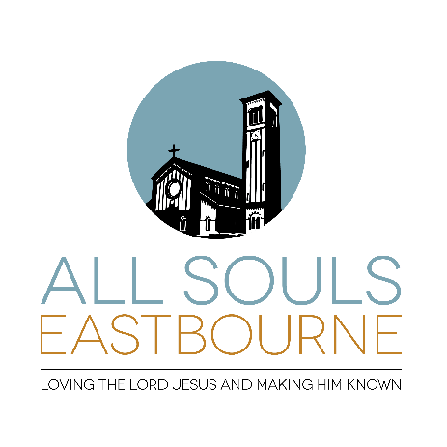
Parish Profile
June 2024
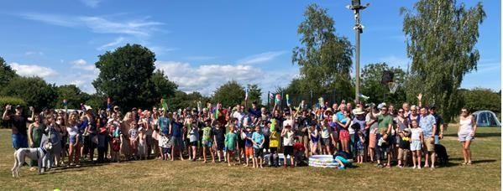

53 Susans Road Eastbourne
East Sussex
BN21 3TH

Registered Charity No, 1149653

INDEX

Page 3 | The Parish Setting and General Information
Page 4 | Personal Profile for Incumbent
Page 5 | Our Position regarding Living and Love in Faith  The Town and surrounding area
Page 6 | Our Parish
Page 7 | The Church Building  The Church Halls
Page 8 | The Vicarage
Page 10 | Other properties
Page 11 | Our Church Family
Page 12 | Weekday Services  Staff Team, Retired Clergy and PT0
Page 13 | Prayer Meetings, Growth Groups, Women on Wednesday (WOW)
 | Other Ministries
Page 14 | Biennial Mission Week
Page 15 | Wider Parish links
Page 16 | Annual Church Diary
Page 17 | Church Family Vision and Life
Page 18 | Appendix 1 The CEEC Declaration of Faith
Page 20 | Appendix 2 Giving for Further Growth Information 2021 Booklet
Page 28 | Appendix 3 Financial Statement (April 2024)

The Parish Setting and General Information

All Souls is a conservative evangelical church, for all nations, all backgrounds, all ages, and found in the centre of Eastbourne.

Our aim is: to honour the Lord Jesus.

Our task is: to make disciples of all nations.

The essentials for this are:
o expository preaching, teaching and obeying God’s Word, the Bible.
- talking to God in prayer o loving one another.
- sharing the gospel and our lives and reaching out to our community

Our strap line is ‘Loving the Lord Jesus and making him known’

Personal Profile for Incumbent

A man who loves the Lord Jesus and wants to make him known.

- A man who will be seeking to live a life pleasing to God and a man who will love and pray for the church family, setting a godly example to those within and without the church family. (Titus 1:6-8) A mature Christian, firm and faithful in his personal relationship with our Lord Jesus Christ which is reflected in a dependency on and a personal walk before God.

- A conservative evangelical in theological conviction, who is able to sign the CEEC Declaration of Faith and the two additional declarations, who is devoted to the apostles’ teaching (Acts 2:42) and who will not tolerate false teaching. (Titus 1:10-15)

- A man who will lead us and grow us in faith by teaching us God’s Word regularly, faithfully, clearly and graciously, and apply it to our life as individual Christians and as a church today. (2 Tim 3:16-17, 2 Tim 4:2-4) Someone who will delight in the scriptures and be excited about passing on the Gospel as originally taught. Someone who will encourage, rebuke and correct us from the Scriptures.

- A man who will be able to proclaim Christ to those who need Him. He should have the heart of and do the work of an evangelist, seeking to present the Gospel clearly, gently and faithfully to those who do not believe the Gospel. (Col 4:3-6)

- A man who will facilitate others in teaching God’s Word. (2 Tim 2:2) This includes ensuring that we have children’s and youth group leaders effective in teaching the Bible, an ability to train home group (“Growth Group”) leaders in handling God’s Word clearly and faithfully with smaller groups, as well as a readiness to work collaboratively with the staff team, retired clergy and evangelists attached to the church family.

- A man who will be able to develop and communicate a vision for the ongoing and further ministry of All Souls Eastbourne. Someone able to see where the Lord is opening up opportunities for evangelism and training and who can lead the church family in making the most of them.

- A man who works in Gospel partnership with others. (Philippians 1:5) He should have a proven track record in leading, training and managing teams and change. He should have a transparent leadership style: open to dialogue, willing to listen, comfortable with graciously giving and receiving feedback. Someone able to evolve the structures required for a growing church, delegating with diligence, love and wisdom. A man who will facilitate others in using their gifts in Christ’s service (1 Corinthians 12) enabling an even larger number of Church members to use their varied gifts in Christ’s service.

- A man who will support Gospel work beyond the parish. We hope that he will wish to continue to support the Sussex Gospel Partnership and maintain our fellowship with the diocese and other local churches as far as it is right and proper according to God’s Word.

- A man who will ensure that there is good pastoral provision within the church family. He will be able to pastor to a wide range of ages, backgrounds, experiences and to diverse needs. He
will need to be committed to best safeguarding practice and ensure that proper safeguarding procedures are in place and applied.

- A man who is prepared for sacrificial living. This includes serving and witnessing in the centre of town, in an area of very mixed income, ages and nationalities.

- A man who will continue to engage with our mission partners both here and overseas

The PCC has passed a resolution under the House of Bishops “Declaration on the Ministry of Bishops and Priests”.

Our Position regarding Living in Love & Faith

The PCC is very conscious of the challenges created by the Church of England’s Living in Love & Faith agenda and we are working together with other evangelical churches in responding to those and supporting those bishops (including our own) who are contending for orthodox doctrine. The PCC would not endorse prayers in PLF that purport to bless same sex unions or standalone services for same sex couples.

The town and surrounding area
A seaside resort at the eastern foot of the South Downs, Eastbourne is a thriving town with a population approaching 100,000. Tourism plays an important part in the local economy of ‘The Sunshine Coast’. In addition to its lovely seafront and Marina, the town has three theatres, the Towner Art Gallery and extensive shopping opportunities, as well as a number of other visitor attractions. Eastbourne is home to a LTA international tennis tournament, Beachy Head Marathon and the Bible by the Beach conference (now in its fourteenth year.) The District General Hospital serves the town and wider area. There are good state schools including both primary and secondary Church of England schools, as well as highly-regarded fee-paying schools. There are rail connections to London Victoria, to Gatwick Airport, Hastings and to Brighton, and plenty of interesting ways in which to enjoy the beautiful Sussex coast and countryside.

Our Parish
The parish of All Souls is in the very centre of Eastbourne and includes the railway station and the Beacon Centre (previously known as the Arndale) – a large shopping centre of 70 shops, restaurants and cinemas, and a multi-storey car park with 1400 spaces.

Most of the housing in the area is Victorian terraces, some of which have been converted into homes of multiple occupancy, maisonettes and bed-sits. There are also a number of large purpose-built blocks of flats.

The parish has a population of 2810, of which 13% is under 18, and 37% is over 60. The local population is multicultural and very mixed, in every sense. Some light industrial units are squeezed behind the terraces and there are several small shops and takeaway restaurants including some that have sprung up in recent years to serve migrant workers. The town’s mosque is situated within the parish and there is a Salvation Army citadel on the edge of the parish. There is an Age Concern centre and two or three retirement homes also within it. There are no schools in the parish, but the church has links with three nearby primary schools.

According to statistics from the Church Urban Fund, on the overall deprivation scale, where 1 is the most deprived in the country, this parish ranks 1251 out of 12,382 parishes in England. This means that the parish is among the most deprived in the country. The most significant poverty-related issue in this parish is the relatively high rate of lone parenthood. The next most significant issue is the relatively high rate of working age poverty. Child poverty, pensioner poverty, working age poverty and lone parenthood in this parish are among the highest in the country. Male life expectancy in this parish is among the lowest nationally. Female life expectancy in this parish is lower than average compared with other parishes nationally. The church congregation, however, comes from throughout the town and broadly reflects the town’s demographics. It is probably younger than average for the population as a whole.

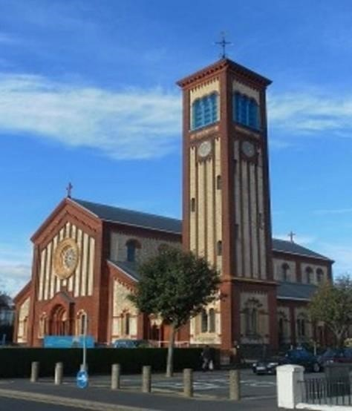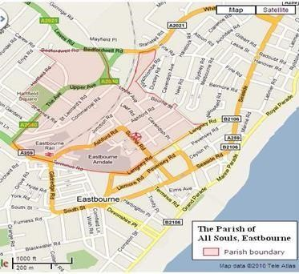

The Church Building

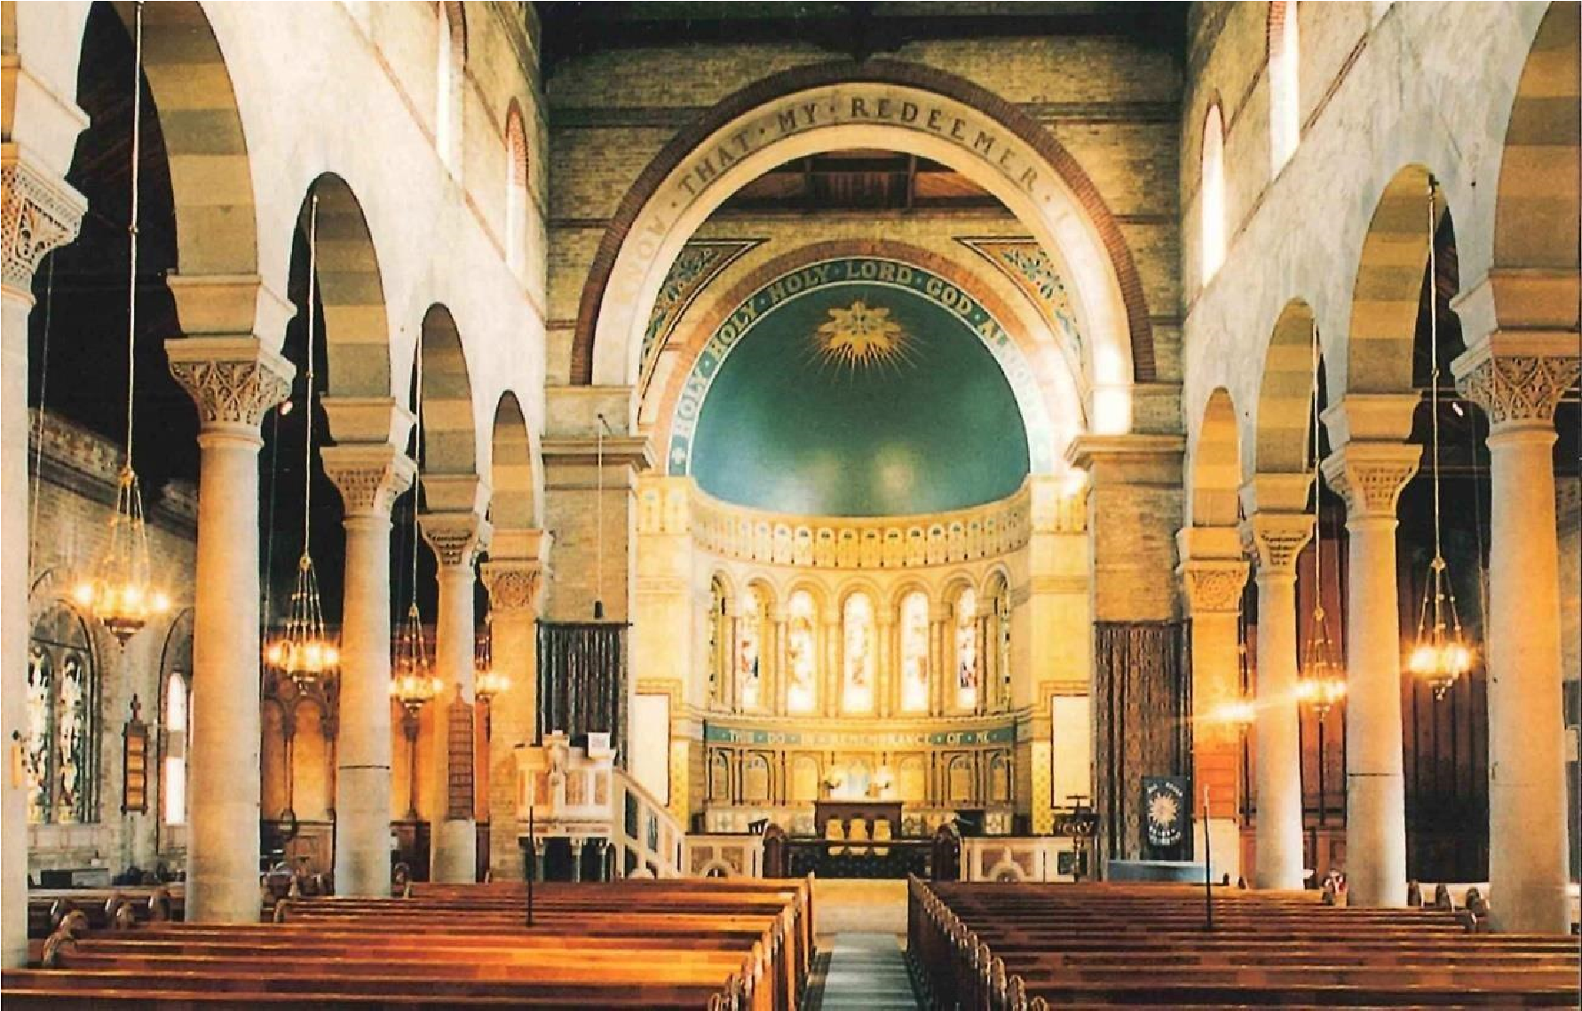

All Souls’ Church is a unique and unusually beautiful Grade II* listed building and was consecrated by the Bishop of Chichester on 6th July 1882. The building is in Italian Romanesque style with its tall, distinctive campanile (bell tower) which is linked to the church building through a porch which is used as the main entrance. There is access for the less mobile. There is an induction loop for the hearing impaired. Three years ago, the sound and vision system was upgraded. A £430,000 extension to the church on the north side (completed 2021) provides generous toilet facilities, one of which is equipped for use by the disabled and also for baby changing.

Following alterations to the ground level of the bell tower, a kitchen was installed which serves the carpeted fellowship and meeting space at the back of the church where there is also a creche room.

The building which is heated by gas heaters is well managed and restored with regular consideration of repair and restoration works.

The Church Halls
The church halls are sited on the same plot of land as the church building. Built in the Victorian era as a church school, and subsequently extended, the halls consist of two large halls, one smaller hall, a basic kitchen, toilets, and plenty of cupboard space for church groups to store equipment, all on the ground floor. Upstairs, there is a small study for the vicar and a larger office used by the administrator and suitable for some of our business meetings. In addition to being used for church activities, the three halls are hired out extensively for community use – martial arts club, a scout group, a food bank, and a sanctuary café for asylum seekers. The halls are managed by a committee. In the future it is planned to reorganise and improve the facilities the halls offer to users.

The Vicarage

The large Victorian vicarage is a Grade II listed building, located adjacent to the church building and designed in a similar style. On the ground floor three reception rooms, a downstairs cloakroom, and a kitchen large enough to eat in are arranged around a central hallway. One of the reception rooms has a connecting door into the kitchen and French windows opening into the mature private garden, which is of a good size. Upstairs are five bedrooms – three large and two small – and a bathroom. The house is centrally heated and has a cellar suitable for limited storage. There is off-road parking for up to three cars. Work will be undertaken on the house during the interregnum, as directed by the diocese. The diocesan property team have recently inspected the house and is committed to maintaining it properly. It promises to be supportive of newly appointed clergy.
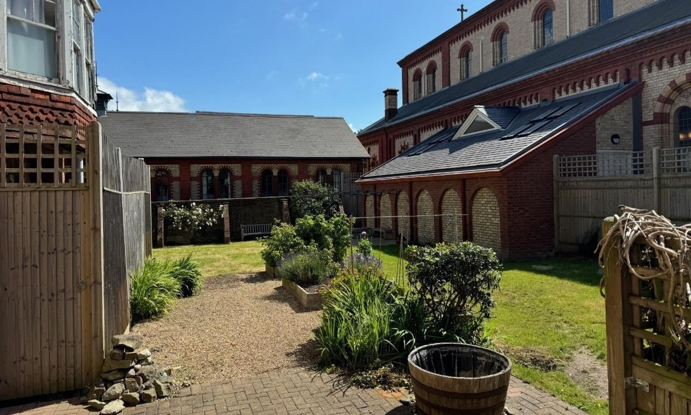
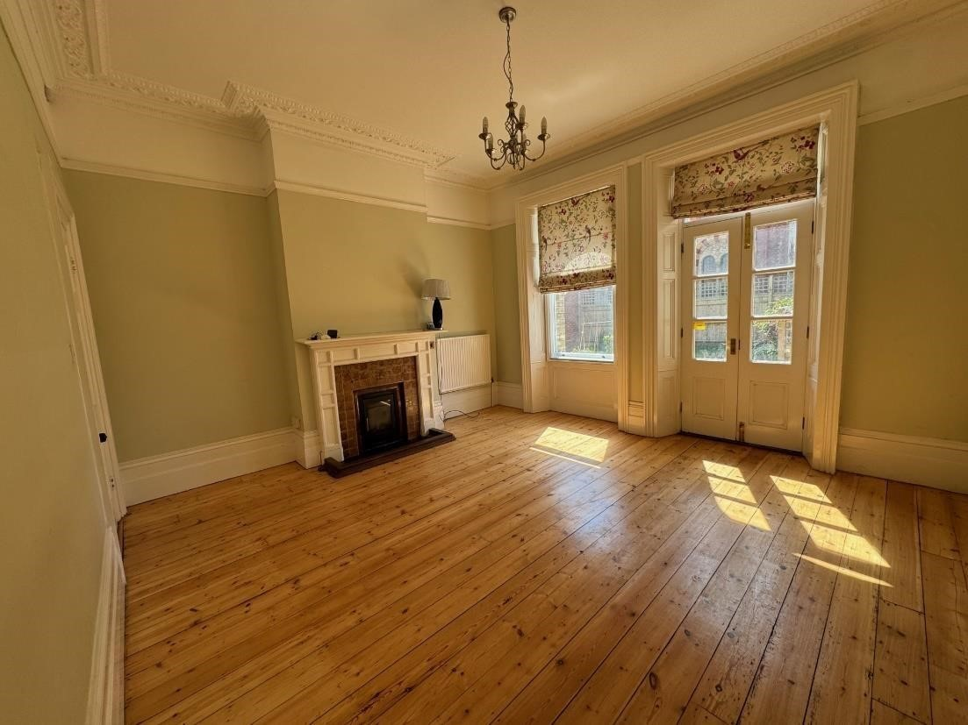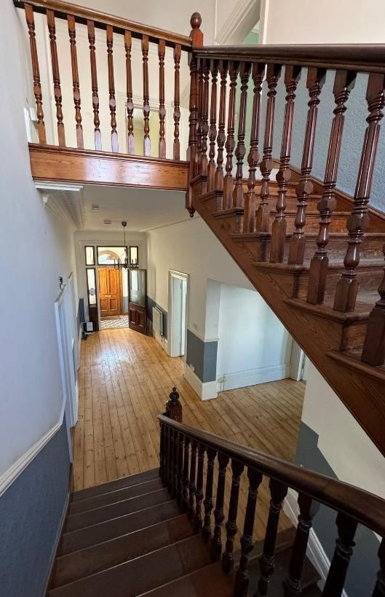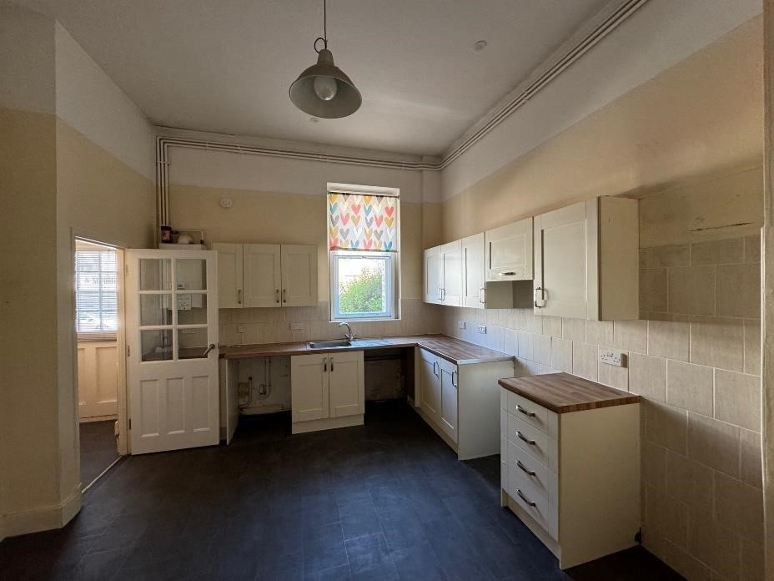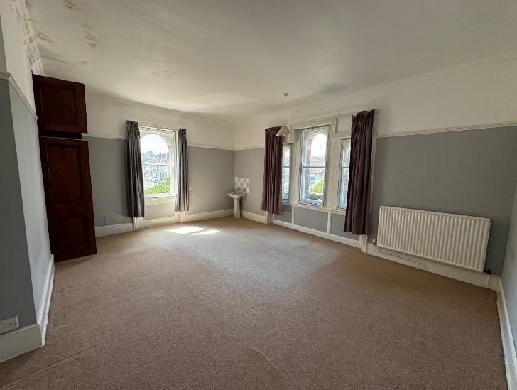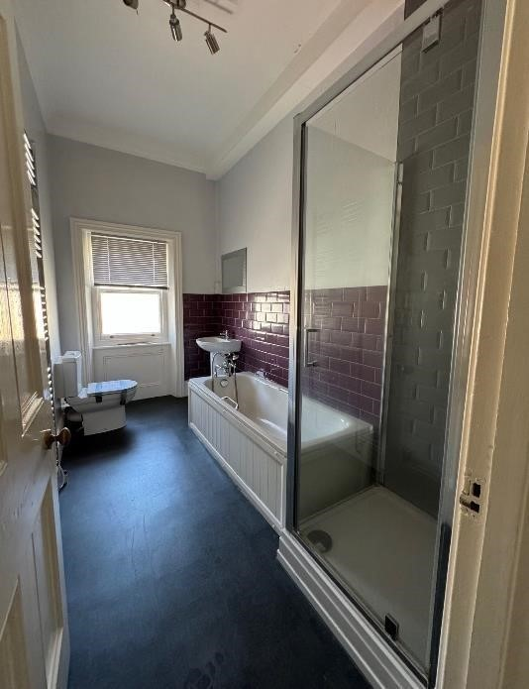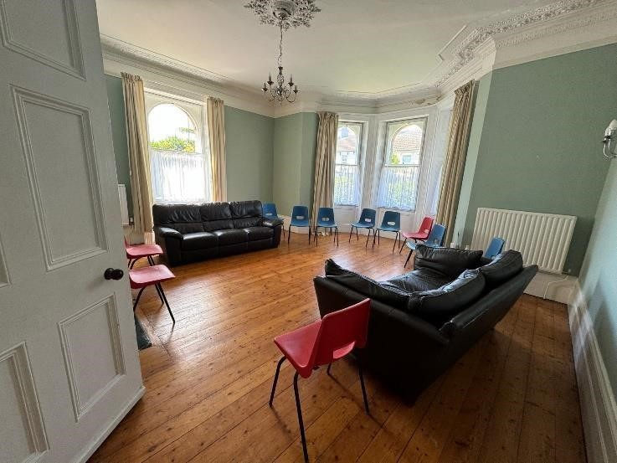

Other Properties

In 1958 the vicarage was sub-divided into two separate properties. The smaller property, named Wellesley House, has three bedrooms, one reception room, a kitchen that is large enough to eat in, a utility room, cloakroom and a small garden. The property is owned by the diocese and currently occupied by the Associate Vicar.

Thanks to a past substantial legacy, plans are in hand to purchase a two-bedroom property for church use.

Our Church Family
The concept of the ‘’church family’’ is an important one for us and friendships between generations are excellent. This, the priority placed on Biblical teaching, and the enthusiastic commitment of many members, are perhaps the strongest features of our life together. Several of our members discovered All Souls when they moved to Eastbourne, others have been church members all their lives. Wonderfully, some individuals have joined the church following their conversion to Christ and recently we have been excited to see the number of young families and teenagers growing. Over the last 13 years All Souls has grown. We are regularly attracting newcomers but need to find ways to keep them. We have approximately 60-70 children and young people connected to Sunday ministry.

Sunday
The average Sunday morning congregation ranges from 170-220 (plus approximately 20 online). This includes 50-60 children/young people. The age range is broad, and most age groups, with the possible exception of those in their 20’s, are well represented, including a large number of young families. We also have a good number of young men whom we have the responsibility to disciple well. The church has people from a huge range of backgrounds and we are genuinely a loving, content and unified church family.

The morning service begins at 10.30 a.m. We consider ourselves a friendly and welcoming church. Sung worship is led by a music group. During “kneeler time” the children are encouraged to bring kneelers from the pews to sit on at the front to be able to see and hear the children’s talk better. The congregation is encouraged to make use of the pew Bibles (NIV 2011) during the Bible readings and the sermon. Intercessory prayers are led by a church member, and “Church Family News” provides an opportunity for the service leader to share any important announcements. The sermon lasts approximately twenty-five minutes. Refreshments are served at the back after all services. On the first Sunday of the month, we hold an All-Age service. We endeavour to make the talk shorter and more accessible. The songs are familiar to the children and led by our Youth Band. Three times a year, the number attending family services is boosted by the attendance of the parish’s uniformed organisations. On the second Sunday representatives from the Royal Engineers attend to turn a page in their Book of Remembrance. A shortened service of Holy Communion takes place immediately after the main service. On the fourth Sunday the children join their parents and carers for a short service of Holy Communion. Authorised lay members assist with communion. The average number of communicants over the past year was just over 150. Our morning service is livestreamed and kept on a service archive on our YouTube channel.

Discoverers, Explorers and Adventures are the names of the groups for children between the ages of 0 and 10. After a short time in the morning service, the groups go out to the halls together to look at the Bible where they use material produced by Faith in Kids or Mustard Seeds.

All Souled Out is for 10-14 year-olds. This group which is growing in number currently meets in the vicarage for age-appropriate teaching during the service. Soulder is for 14–18 year-olds and meets once a month on a Sunday and on the other weeks they attend the morning service.

Souls@Seven is the name of the evening service at 7p.m. each Sunday. The average attendance is 40 and there is a broad age range present from young adults to mature saints! Communion is taken together on the first Sunday of the month, and – when there is one – on the fifth Sunday too.

Both morning and evening services are preceded by a time of prayer for those leading and taking part.

Weekday Services

Communion is taken to a sheltered accommodation and rest homes monthly

Occasional Offices

Baptism and thanksgivings 6-8 per year: Funerals 5-8 per year: Weddings 2-3 per year

Staff Team; Retired Clergy with PTO, Church Family Serving

Associate Vicar Revd Stephen Finch Main responsibilities are:
- Preaching and teaching in a number of settings, including church family life, schools, care and rest homes.
- Heading up our regular evangelistic outreach events. To be part of the team that runs and delivers evangelistic courses - Christianity Explored, Life Explored and 321. To take the lead in our biennial parish wide mission.
- To support our teenage youth leaders and to disciple the 10-18 year-olds. To co-lead youth evenings.
- To facilitate the multiplication of ministry as people are trained individually and corporately in sharing the good news of Jesus and handling God’s word well.
- To train in evangelism and support the church family who work in a variety of Christian community projects based on our church premises. This includes supporting refugees and food bank projects and to review the ways in which outreach courses for those attending the projects are facilitated.

Children’s lead - Cat Morgan Locke 15 hours per week, directing, training and coordinating the teams working with Discoverers, Explorers and Adventures as well as All Souled Out.

Church operations manager - Clare Parker 25 hour per week managing the running of the church buildings, finances and various administrative responsibilities.

Assistant administrator - Abs Bissett 8 hours per week taking responsibility for producing much of our printed and power point material, e.g. service orders, church family news sheets and service power point presentations. She is also responsible for the administrative support of our Safeguarding team.

Preaching Team: We are enriched by the preaching of the ministry team including Andrew Cornes,
David Bourne, (both are retired clergy), and in addition Glen Scrivener, Nate Morgan Locke, Martin Povey, and occasional preachers Tim Burden, Graham Harter and Peter Staley

Extent of lay involvement in the church: We currently average approximately 240 - 280 attendances across our Sunday Services. Of these another 200 or so are on our books for midweek study groups and youth activities. To maintain and grow this takes a very high level of lay involvement. We are blessed to have many people involved in a whole range of ministries. We take supporting and training the Church Family very seriously, but there are many in the Church Family not currently involved in any significant ministry. This is a major area in need of development.

Prayer Meetings, Growth Groups, Women on Wednesdays (WOW) Other Ministries

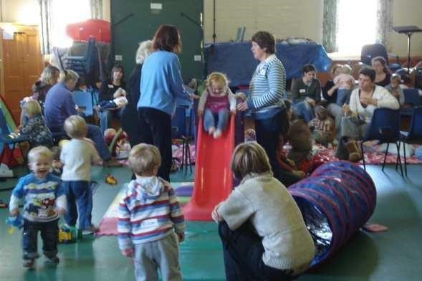
Other ministry areas include:
- Regular women’s events, often featuring a speaker
- Women on Wednesdays: a weekly Bible study for about 15 women with crèche facilities.
- Regular men’s events, some social, some containing an appropriate evangelistic talk.
- Mid-week ‘All Souled Out and Soulder’ youth group for teenagers. This currently has 30 teenagers on the register with an average attendance of approximately 24. This year 24 of the group went on a weekend away in January and this is intended to become an annual event.
- Many of our young people attend CPAS camps in the summer holidays
- Church Family weekend camp every July. A great time away for people of all ages.
- ‘Little Souls’, a weekly toddler group that meets in the church halls and attracts local families.
- Christianity Explored, Hope Explored, Life Explored and 321 are evangelistic courses run several times a year.
- Door to Door visiting takes place normally twice year over several when every home in the parish is visited. We offer literature and listen to the parishioner’s opinions on what we could/should be offering the community. We also distribute Easter and Christmas literature to every home in the parish.
- We are also active members of Bible by the Beach, an annual conference based in Eastbourne on the first weekend of May.
- We have Church Family members who support both the work of the food bank, and Sanctuary Eastbourne - a drop-in centre, based in our hall, for people seeking refuge in the UK.
- We take Safeguarding very seriously at All Souls. The Safeguarding team meets six-weekly. All church activities both on and off site are rigorously risk assessed.

These ministries have all been running for several years and need rethinking. Many will then be reaffirmed, while others may be changed or re energised.

Biennial Mission Week
We aim to hold a major mission initiative every 2-3 years. This pattern was impacted by covid. In November 2019 Glen Scrivener was our mission leader and the mission involved three main sections.

During the first week of November every church group, was encouraged to run an attractive, low-key outreach event to which their family, friends, and colleagues were invited.

The second week of November was an intense week of prayer which involved nine different prayer meetings.

In the third week of November, we had four main events. These were hosted by Glen Scrivener, who interviewed various guest speakers. These included Rachel Newham, Andy Kind, Major General Tim Cross, and Bertie Pierce. The mission was entitled ‘More 2019’.

The flier below gives a flavour of the events. During the week we had over 800 attendances. Just over 20 people have attended Christianity Explored or 3-2-1 courses as result of the mission.

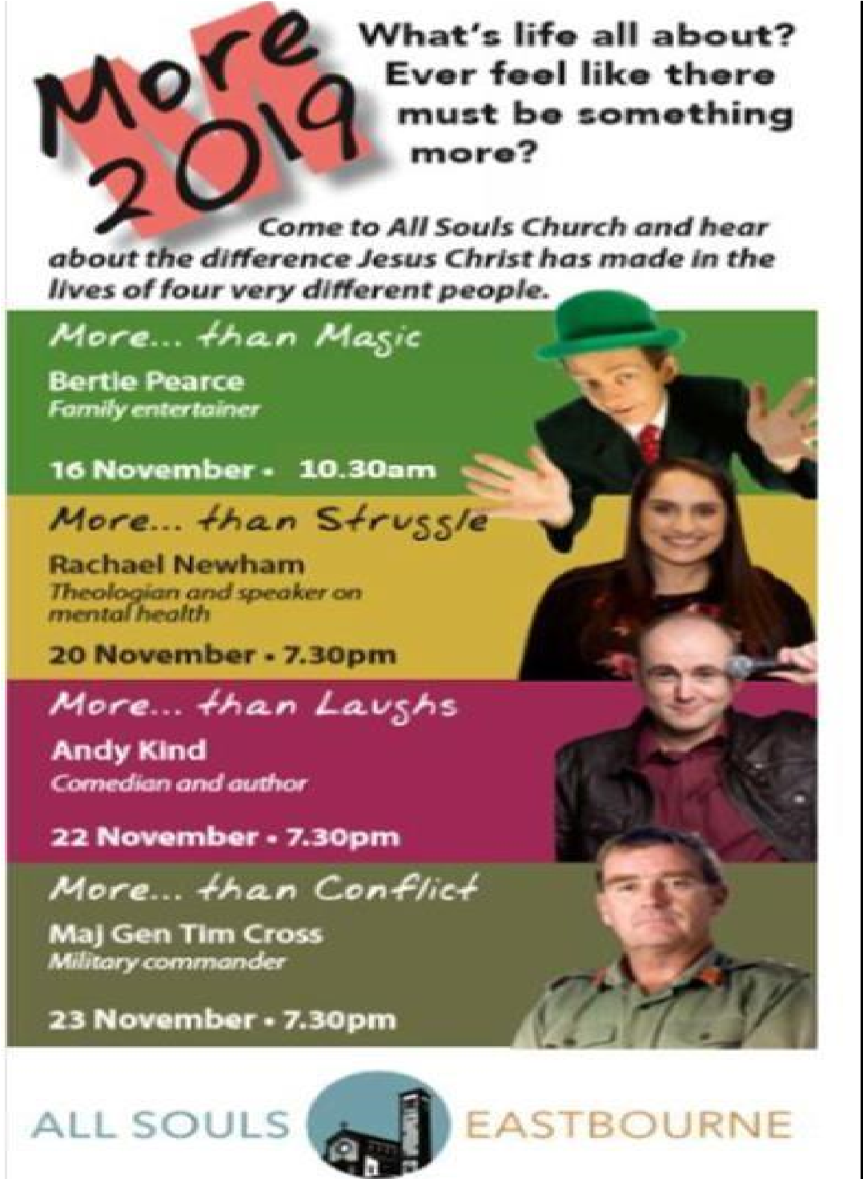
In 2022 we used the ‘Passion for Life’ training resources to help equip us as a Church Family for mission. We also held guest services.

Our 2024 mission is scheduled for November. This will be led by Bill Bygroves, Chaplain to Liverpool FC, who led a mini mission in 2023. Sir Matt Baggott ex Chief Constable of Northern Ireland will also be taking part in the Mission week.

Wider Parish Links

Several church members are involved in ministries and parachurch groups in Eastbourne and beyond, including the following:

- Martin Povey works with the Association of Evangelists. Martin heads up our door-to-door work and his wife Claire works part-time with Festive, an organisation affiliated with Scripture Union and UCCF, seeking to provide resources to help reach Further Education colleges

- Glen Scrivener, Nate Morgan Locke, Thomas Thorogood and James Place work with ‘Speak Life’, a national evangelistic organisation.

- All Souls supports financially and in prayer International Needs, Martin and Claire Povey,
Spinnaker Trust working with schools in Eastbourne, Speak Life, Living Out and Church Society

- Water Sanitation Hygiene and child sponsorship programmes in Uganda

- All Souls is a founder member of the Sussex Gospel Partnership, an evangelical, interdenominational initiative which provides training, fellowship and partnership with other similar churches. There is the possibility of a joint church plant within Eastbourne.

- School assemblies and Christmas Carol services. We currently take assemblies regularly in a local school and at Christmas three schools come to our building for their Christmas events. Attendance numbers from schools over Christmas are between 1,500 and 1,700.

- Members of the Church Family occasionally run the CAP money management course.

- Please also see our website www.allsoulseastbourne.com for up-to-date and further information

Annual Church Family Diary

Every year we produce an events diary. This is distributed at Christmas time and gives people a flavour of the year to come.

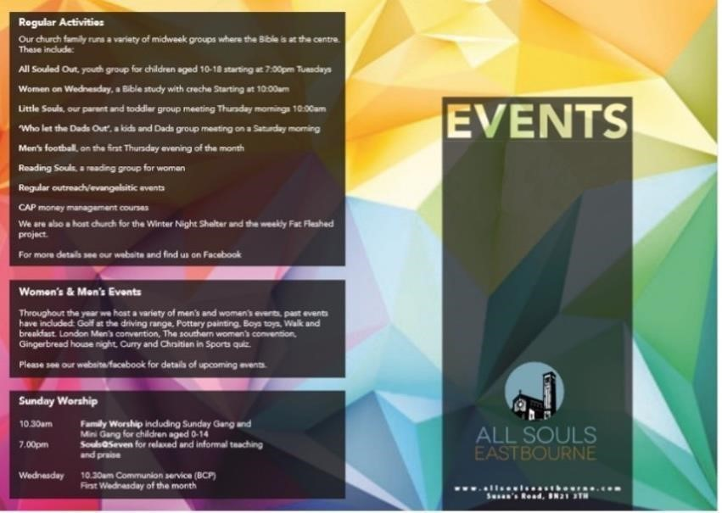

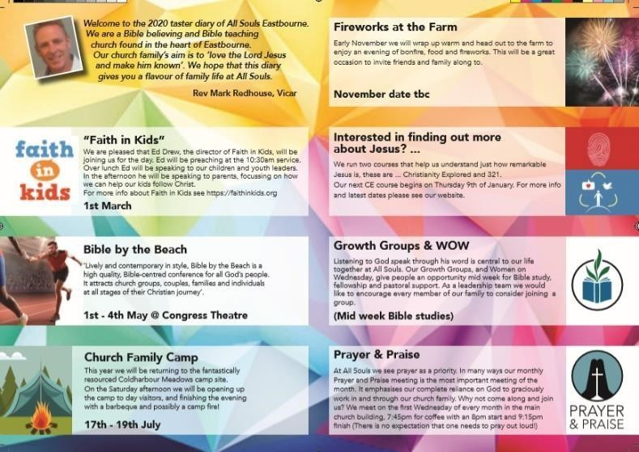

Mission Action Plans
The Parochial Church Council produces a Mission Action Plan every two to three years. The most recent addition (‘Giving for Growth’) appears as Appendix 2.

Church Family Vision

As you have read through all the preceding information, we trust that you have seen that we are genuinely a Church Family which, as our strap line says, ‘loves the Lord Jesus and wants to make Him known’. We believe that this can be done in a variety of ways. We are seeking to love and care for everyone and anyone in, and around, our parish as we ‘hold out the word of life’. (Philippians 2:16) We are impacting local parish life through schools’ involvement, our parent and toddler group, our work with the homeless, our increasingly large Christmas celebrations and just the everyday friendship and witness of the church family. Nevertheless, there is certainly room for further engagement with people living in the parish.

We are a congregation who rejoice in the grace shown us through Christ. We are a united and joyful family with a desire that those around us will come to know Jesus Christ as their Lord and Saviour.

The leadership of the church is united. We have great church wardens, a hardworking and happy Parochial Church Council, as well as others sacrificially involved in lay leadership. We have a desire to help each other grow and mature in our discipleship and are passionate about living for Christ and presenting him clearly to the world around us. However, we all have a long way to go in our walk with Christ.

Over the last 5-8 years there has been a significant increase in the level of staffing both serving our family and continuing to reach out to the community. The areas of ministry we especially want to develop are:-

- Discipleship. We want to hear God’s word taught in all its fulness. We all hope to grow in loving the Lord our God with all our heart, soul, mind and strength and our neighbour as ourselves.

- Training for ministry. Our aim at All Souls is to facilitate ‘every member ministry’. Many are involved in ministry but many more could be. We would love to see more servant hearted volunteers coming forward to serve the church and share the load alongside some very committed members.

- Each Sunday our worship services are led by a willing group of musicians who are keen for this ministry to be developed.

- The church has intentionally and understandably prioritised children and youth work. We hope to develop ministry opportunities with other age groups.

- Evangelistic opportunities. We have the possibility of developing our links with schools and other agencies in the area and along with a growing Church Family we have increasing evangelistic opportunities. We are keen to continue to work on our evangelistic strategy and develop the confidence in evangelism of all our church members. For example, over the Christmas period we had the privilege of having approximately 2500 people through our doors at our main Christmas events. This has given us a significant number of contacts to follow up and mission opportunities to develop, particularly in local non-church schools.

- At present the primary means of delivering pastoral care is through the ministry of growth groups. We realise that this could have limitations because not everyone participates in them. We hope to revise our present strategy to ensure effective pastoral care for everyone.

APPENDIX 1 The CEEC Declaration of Faith

The Basis of Faith of the Council shall be:

- As members of the Church of England within the one, holy, catholic and apostolic church we affirm the faith uniquely revealed in the Holy Scriptures and set forth in the catholic creeds, of which the Thirty-Nine Articles of Religion are a general exposition. Standing in the Reformation tradition we lay especial emphasis on the grace of God – his unmerited mercy – as expressed in the doctrines which follow.

- God as the Source of Grace – In continuity with the teaching of Holy Scripture and the Christian creeds, we worship one God in three persons – Father, Son and Holy Spirit. God has created all things, and us in his own image: all life, truth, holiness and beauty come from him. His Son Jesus Christ, fully God and fully man, was conceived through the Holy Spirit and born of the virgin Mary, was crucified, died, rose and ascended to reign in glory.

- The Bible as the Revelation of Grace – We receive the canonical books of the Old and New Testaments as the wholly reliable revelation and record of God’s grace, given by the Holy Spirit as the true word of God written. The Bible has been given to lead us to salvation, to be the ultimate rule for Christian faith and conduct, and the supreme authority by which the Church must ever reform itself and judge its traditions.

- The Atonement as the Work of Grace – We believe that Jesus Christ came to save lost sinners. Though sinless, he bore our sins, and their judgement, on the cross, thus accomplishing our salvation. By raising Christ bodily from the dead, God vindicated him as Lord and Saviour and proclaimed his victory. Salvation is in Christ alone.

- The Church as the Community of Grace – We hold that the Church is God’s covenant community, whose members, drawn from every nation, having been justified by grace through faith, inherit the promises made to Abraham and fulfilled in Christ. As a fellowship of the Spirit manifesting his fruit and exercising his gifts, it is called to worship God, grow in grace, and bear witness to him and his Kingdom. God’s Church is one body and must ever strive to discover and experience that unity in truth and love which it has in Christ, especially through its confession of the apostolic faith and in its observance of the dominical sacraments.

- The Sacraments as the Signs of Grace – We maintain that the Sacraments of Baptism and Holy Communion proclaim the Gospel as effective and visible signs of our justification and sanctification, and as true means of God’s grace to those who repent and believe. Baptism is the sign of forgiveness of sin, the gift of the Spirit, new birth to righteousness and entry into the fellowship of the People of God. Holy Communion is the sign of the living, nourishing presence of Christ through his Spirit to his people: the memorial of his one, perfect, completed and all-sufficient sacrifice for sin, from whose achievement all may benefit but in whose offering none can share; and an expression of our corporate life of sacrificial thanksgiving and service.

- Ministry as the Stewardship of Grace – We share, as the People of God, in a royal priesthood common to the whole Church, and in the community of the Suffering Servant. Our mission is the proclamation of the Gospel by the preaching of the word, as well as by caring for the needy, challenging evil and promoting justice and a more responsible use of the world’s resources. It
is the particular vocation of bishops and presbyters, together with deacons, to build up the body of Christ in truth and love, as pastors, teachers, and servants of the servants of God.

- Christ’s Return as the Triumph of Grace – We look forward expectantly to the final manifestation of Christ’s grace and glory when he comes again to raise the dead, judge the world, vindicate His chosen and bring his Kingdom to its eternal fulfilment in the new heaven and the new earth.

Additional Declarations
(Taken from the Constitution)

- (4.1.1.) We gladly proclaim and submit to the unique and universal Lordship of Jesus Christ, the Son of God, humanity’s only Saviour from sin, judgement and hell, who lived the life we could not live and died the death that we deserve. By his atoning death and glorious resurrection, he secured the redemption of all who come to him in repentance and faith.

- (4.1.2.) We acknowledge God’s creation of humankind as male and female and the unchangeable standard of Christian marriage between one man and one woman as the proper place for sexual intimacy and the basis of the family. We repent of our failures to maintain this standard and call for a renewed commitment to lifelong fidelity in marriage and abstinence for those who are not married.
https://ceec.info/basis-of-faith/

APPENDIX 2 Giving for Further Growth Information 2021 Booklet

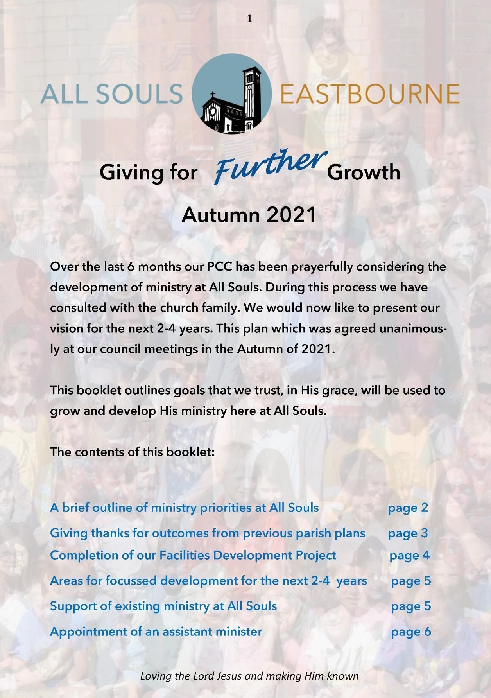

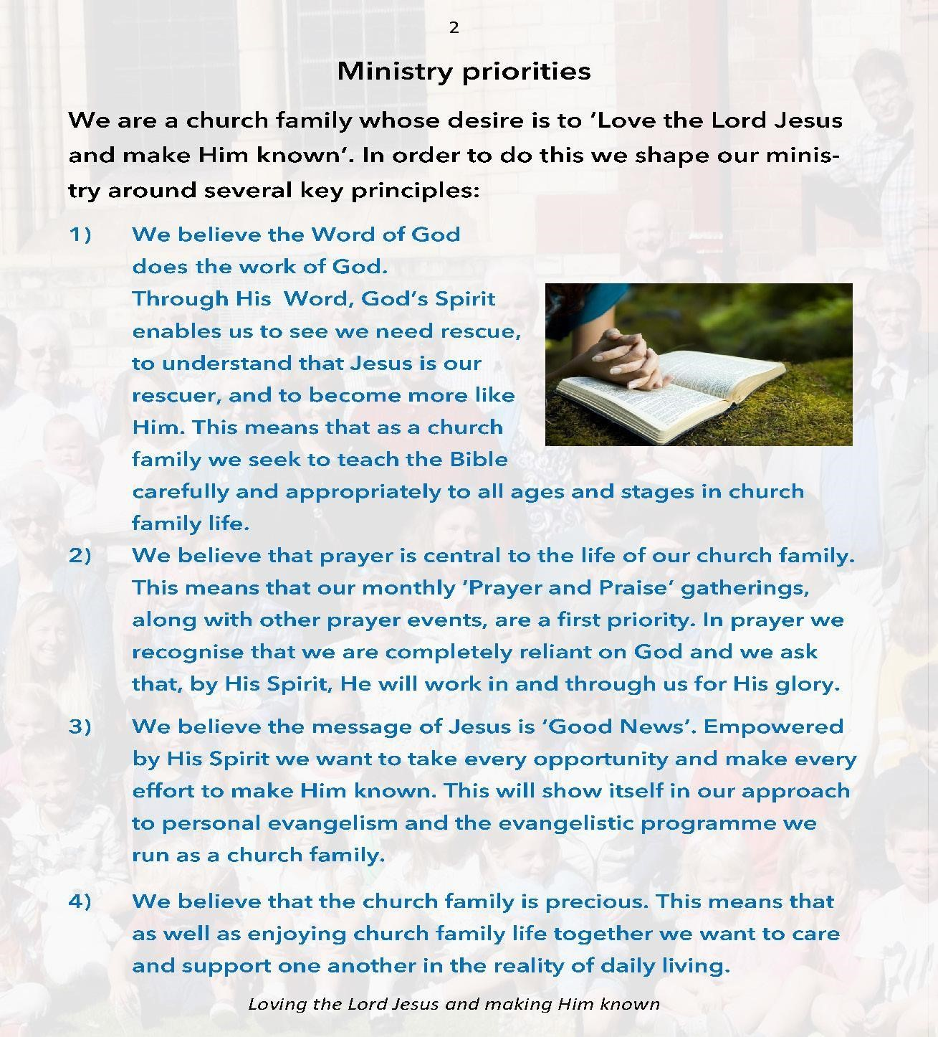

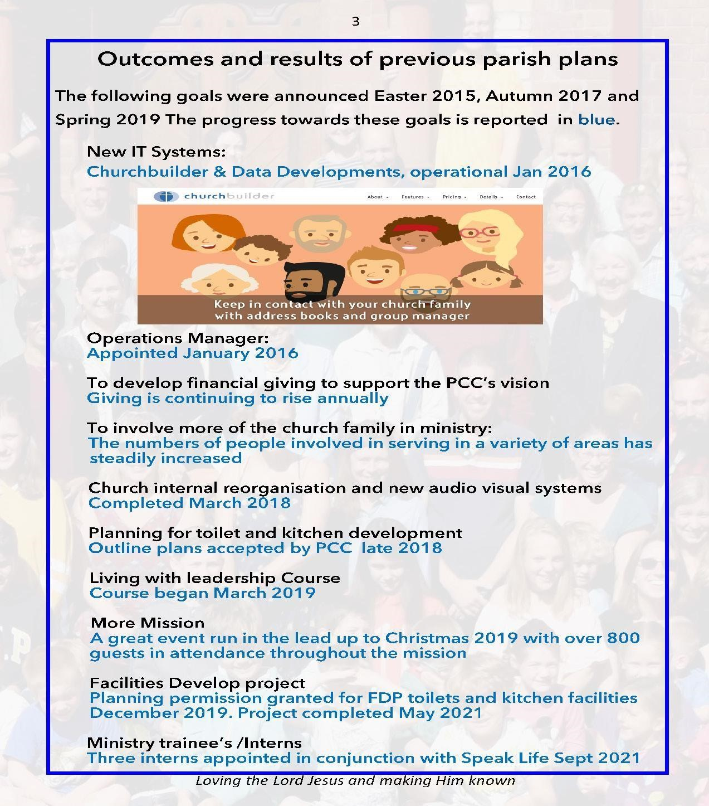

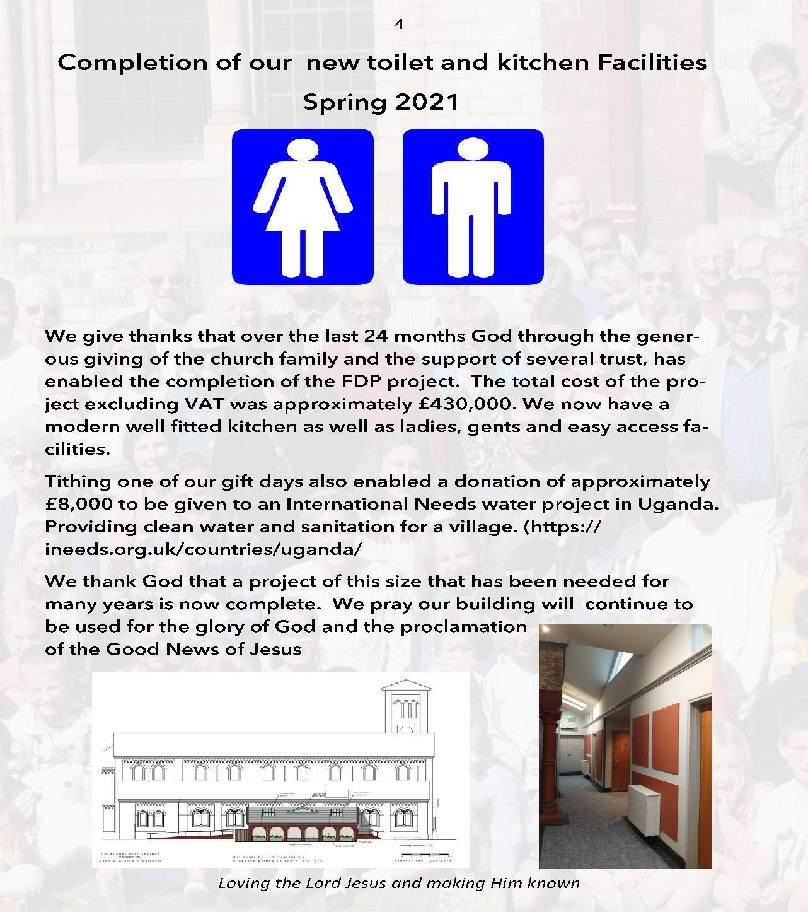

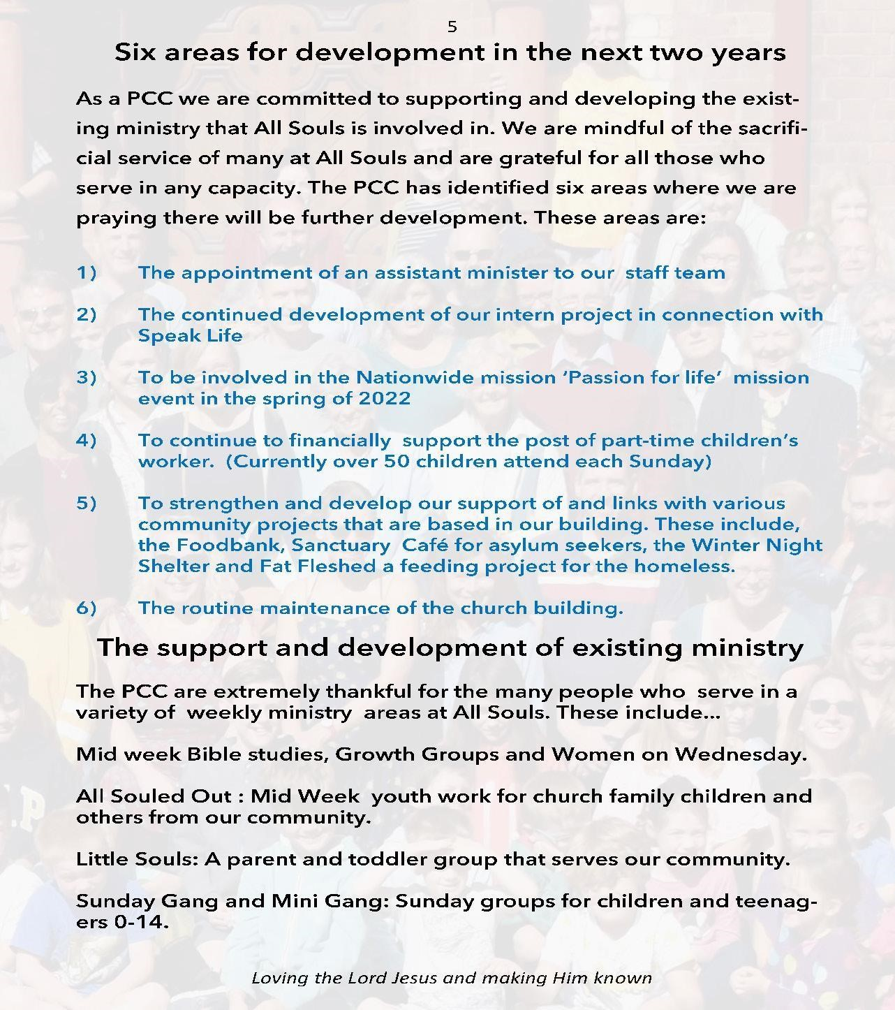

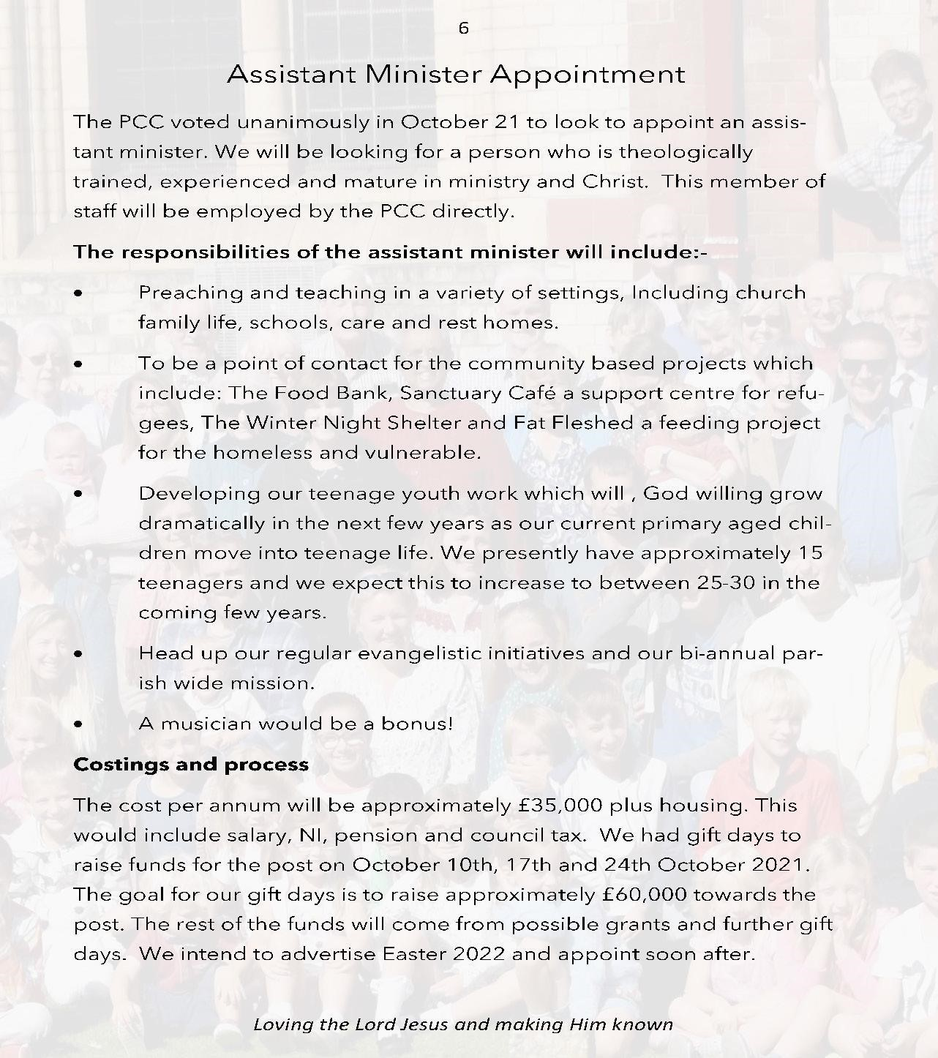

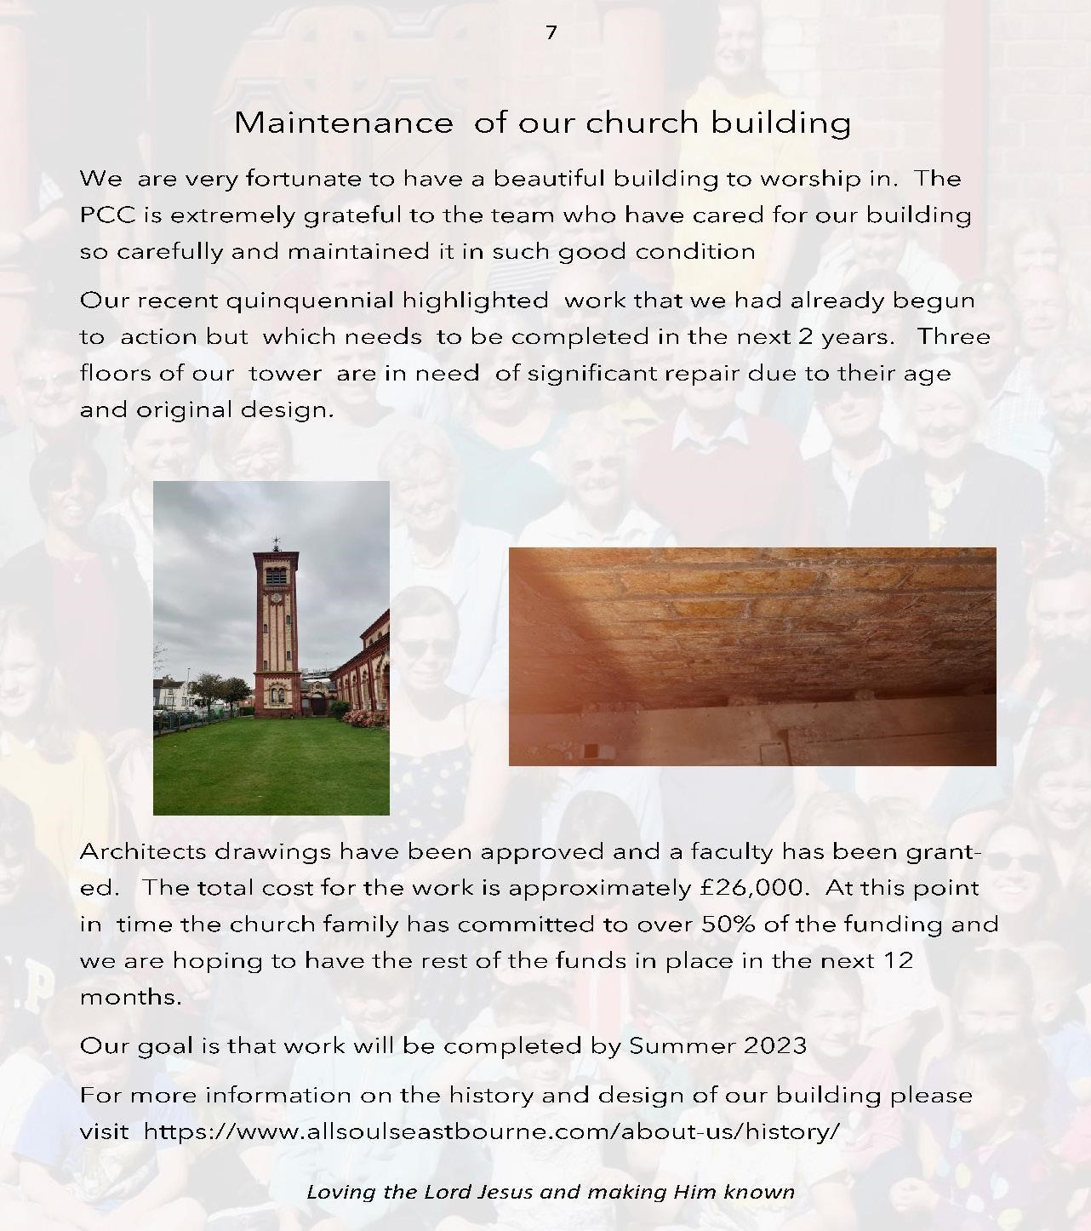

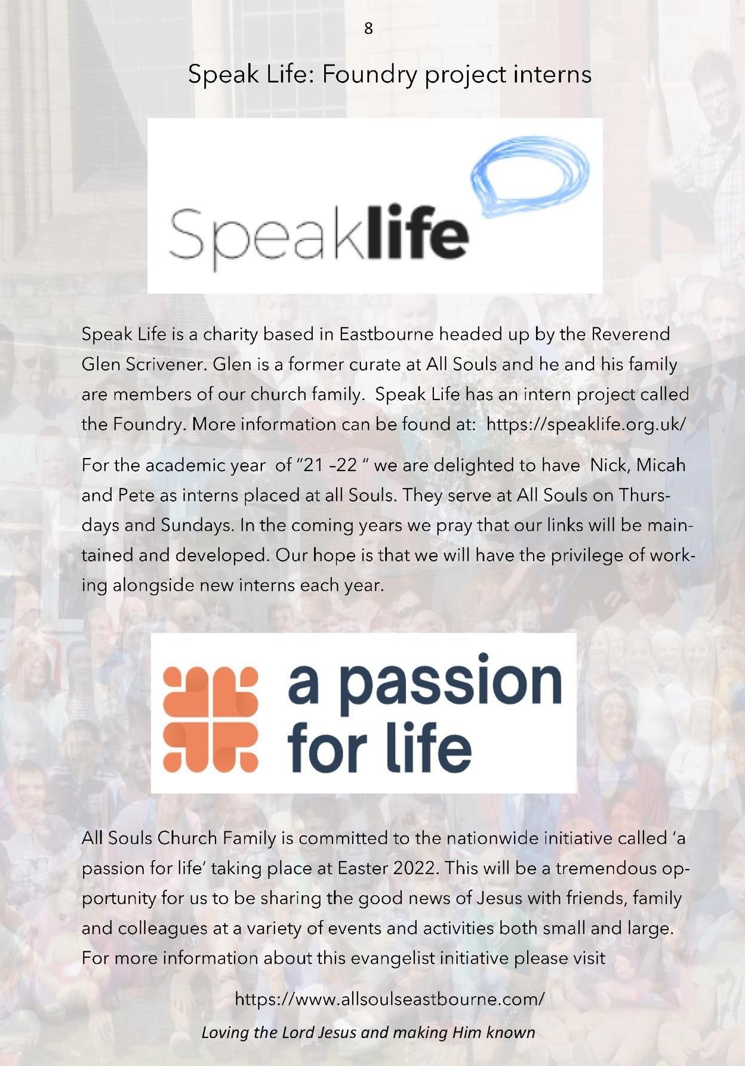

APPENDIX 3 Financial Statement (April 2024)

Income

The vast majority of the church’s regular income comes from planned giving by the church family. Approximately 80 units (families and individuals) give regularly, mainly by standing order; some use an envelope scheme. Many members give very generously of their time, expertise and personal resources fulfilling roles and undertaking tasks that might otherwise require funding.

Church hall lettings also bring in some income. The rates are set to cover costs rather than to make a profit. Between 2021 and 2023 a property owned by the PCC was let out commercially. This property was sold in 2024, on the advice of our property manager, and the intention is to use the proceeds of the sale to purchase another residential property.

Particular capital projects have traditionally been the focus of specific gift days, held once a year. Although our levels of regular income have been resilient despite the challenges of the last few years, they have not increased in line with expenditure. It is anticipated that gift days over the next couple of years will be used, at least in part, to help cover routine expenditure.

The PCC is aware of the need to seek to increase our planned giving and pray to our loving and generous God for provision. It is the testimony of a previous generation of PCC members that the Lord has always provided for All Souls in the past, including through financially challenging times.

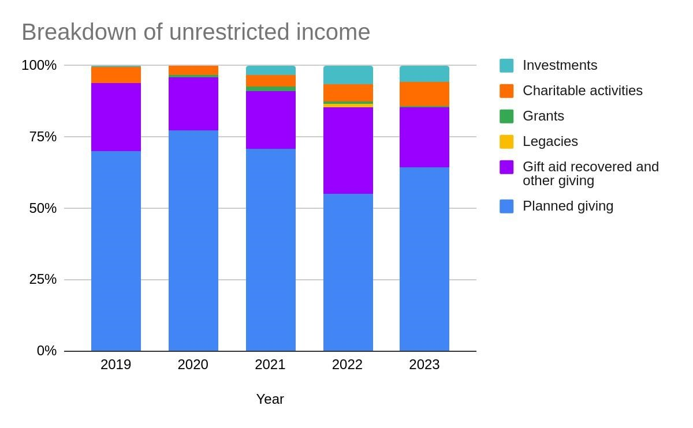

Expenditure

The PCC and staff team has worked diligently to control costs during the recent inflationary period. Ministry has been prioritised. In 2021, a part-time paid children’s worker, funded by regular income, was added to the staff team and the role was expanded in 2022. In 2023 an associate vicar was appointed, with funding for multiple years collected in advance (in a restricted fund) through prior gift days and grants. Since 2020 the church has been paying off loans taken out as part of a major project to improve facilities in the church building. A final repayment of £5,000 is due to be made in 2025.

10% of annual income from planned giving is used to provide financial support for our mission partners.

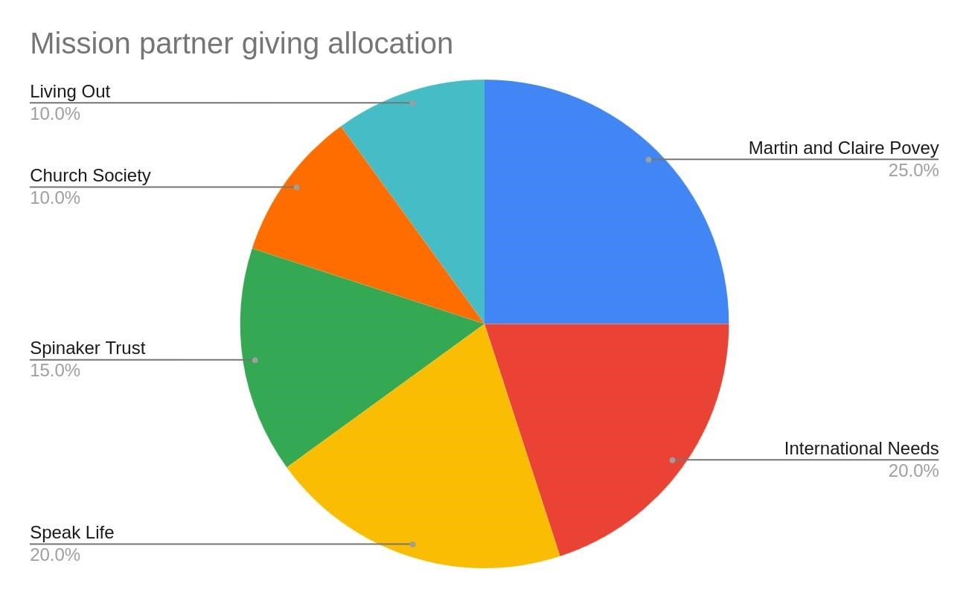
Fluctuations in unrestricted and designated income and expenditure in recent years are largely attributable to one-off events. In 2021, around £20,000 was spent refurbishing a property owned by the PCC. An unrestricted gift day was held in 2022 for the first time in several years; the amount raised significantly exceeded the target. Following decisions made about Living in Love in Faith in 2023, the PCC decided to withhold approximately £22,000 of our parish share pledge and curtailed plans to seek an increase of £8,000 in regular annual giving. A small number of the church family have felt unable to give to All Souls because of LLF. This led to a decrease in income of over £10,000 in 2023.

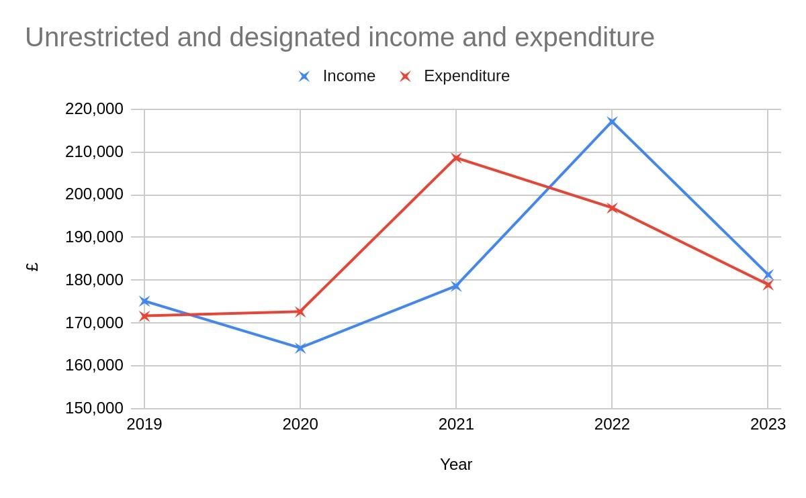
A set of accounts for the last year is available to give a fuller picture.

