The Parish Church of Saint Luke
Stone Cross with North Langney

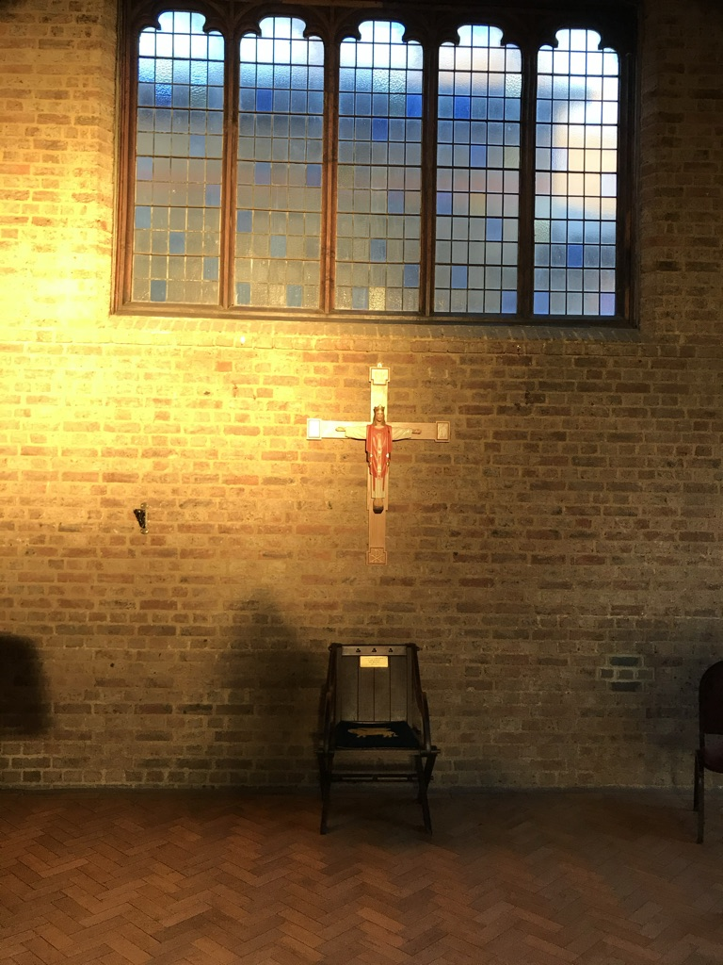

Parish Profile Summer 2023

Thank you for taking the time to read this profile document. We hope that it will both inform you and enable you to get to know us a little better.

Where we are:
The Parish, (In Red) and the Church:
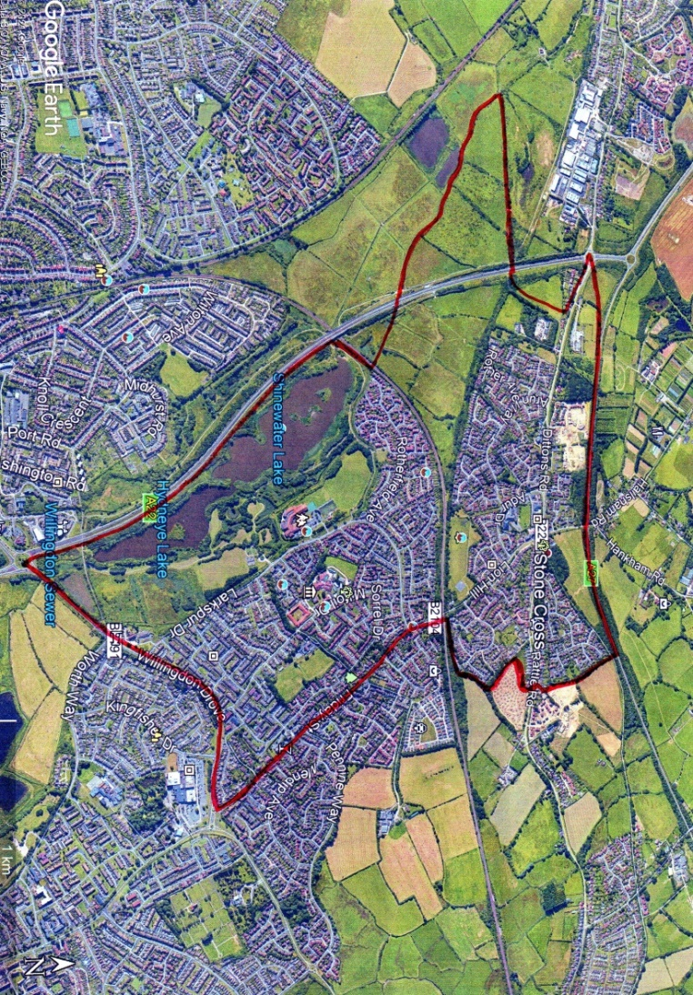

About us:
We are a friendly and welcoming parish church on the outskirts of Eastbourne, situated to the North East of the Stone Cross crossroads, opposite the Red Lion pub. (With whom we have an excellent relationship!) We have an attached Parish Centre which is well used by the local community.
Stone Cross is an excellent place to build a ministry, which needs to meet the needs of a broad age range of worshippers who are drawn from a large parish population of some 12,000 people.

Church Life:
Our style of worship is at the Catholic end of the Church of England, but we are free and flexible in our views, and we feel that the Church should not be bogged down in dogma, but doing the work of Jesus with care for others, love, and community as our central tenet.

Services:
We worship in a relaxed modern catholic tradition and are fully affirming of all three orders of women’s ministry. We have a keen, well trained and capable young serving team, who we feel are a credit to the church.
Currently our Sunday Sung Parish Mass is celebrated at 09.45. On the 2nd Sunday of each month, an all-age Eucharist is celebrated at 10.30 followed by a shared lunch in the Parish Centre. However, we would be very happy to return to regular masses being at 10.30. as they were before. The congregation play a full part in masses, reading, singing the psalm, praying the intercessions, welcoming people to the services, etc.
The Eucharist is also celebrated at 19.30 on Tuesday Evenings and 10.30 on Wednesday Mornings. Also, Morning Prayer on Friday at 09.30am. We would like to see the re-introduction of the monthly healing service, which lapsed during covid.
Compline is sung at 20.00 on the First Sunday of each month.

The Garden of Repose, Maundy Thursday
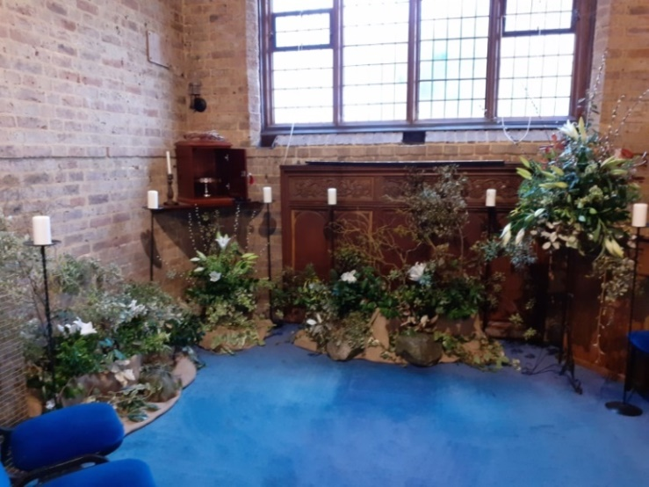

The Church on Good Friday
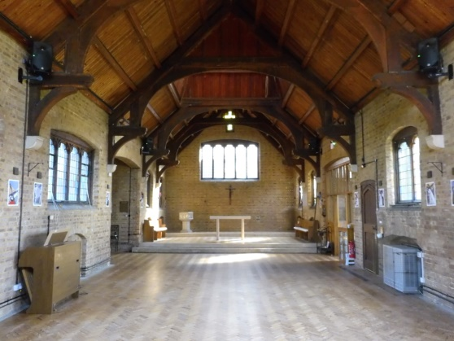

Compline
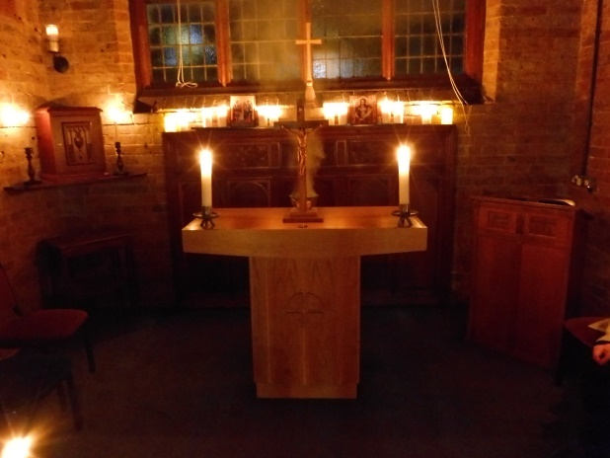

We have Lent Group and Advent Group for our increased learning.

Christmas
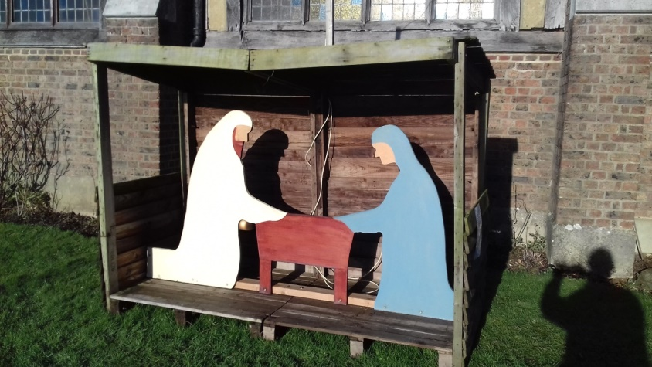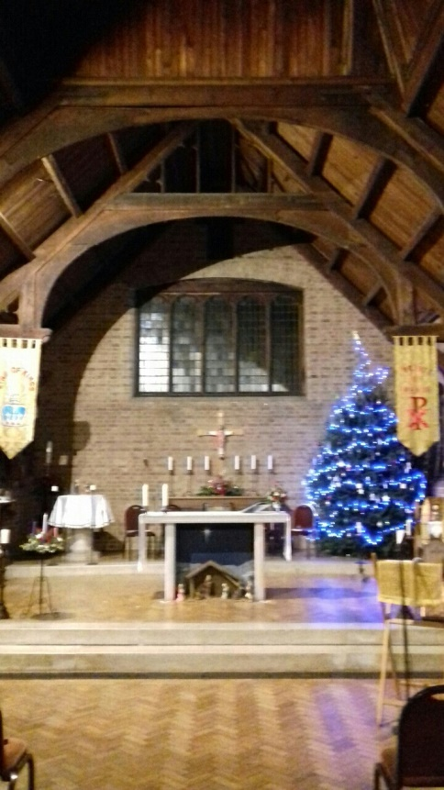

Crib Service
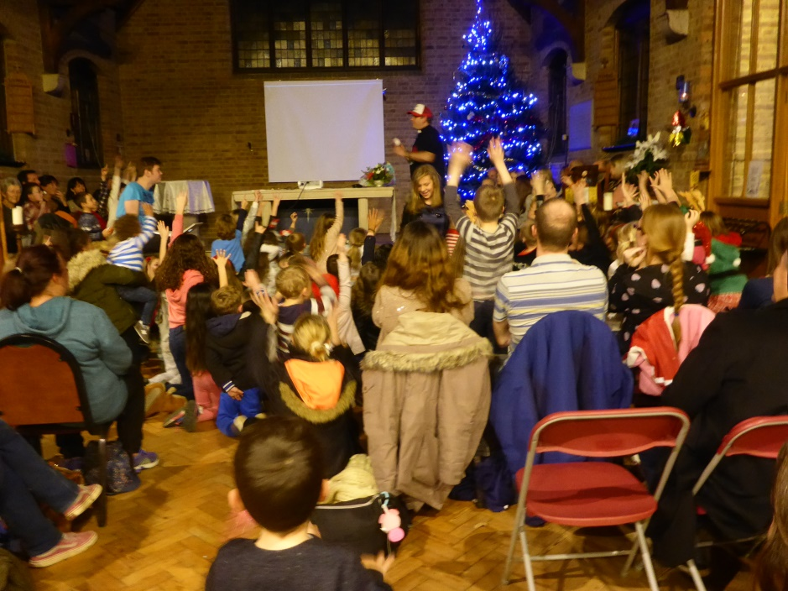

The Church Building
St. Luke’s Church was built in 1923/5 as a daughter church to St Mary’s Westham, in the ‘Arts and Crafts’ Style. It was closed in 1976 because of some cracking caused by a hot dry summer. In 1988 it was re-opened by the Bishop of Lewes to serve the massive burgeoning of the population of Stone Cross and North Langney areas. This has led to us being one of the largest (by population) of the Sussex Parishes.
There are some ongoing and long-standing problems with the church building, but these are slowly being addressed. The Church is however watertight and warm!! We have had some severe cracking at the West End of the Church, for which we are awaiting quotes to repair, and then we will apply for Grants to cover the cost.
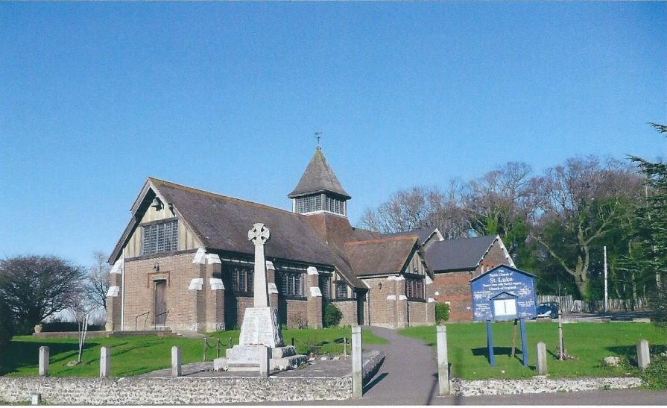

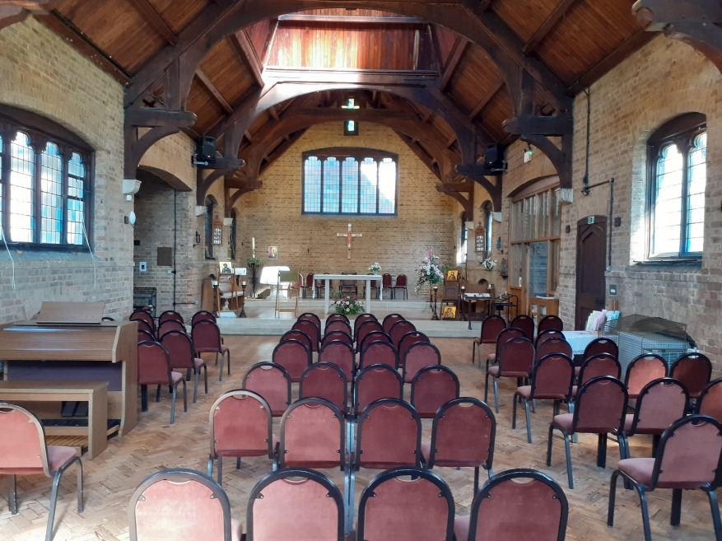

Parish Centre:
We are blessed to have a large and attractive Parish Centre which comprises a Main Hall, a Meeting Room, the Parish Office, and two commercial offices upstairs. The Hall hosts Dancing, Tai Chi, Beavers, Cubs, Scouts, Good Companions (A Club for the over 50s), the Little Luke’s Mother and Toddler group, an NHS group for older people, a Friday morning coffee morning with crafters and St. Luke’s Pantry (a free resource to support our local community), Children’s and adult parties among others. In the Meeting Room, we have NHS Driveability, Moviemakers and various intermittent activities. We have an osteopath who works in one of the upstairs offices, so we feel that we are an asset to the community.

The Entrance
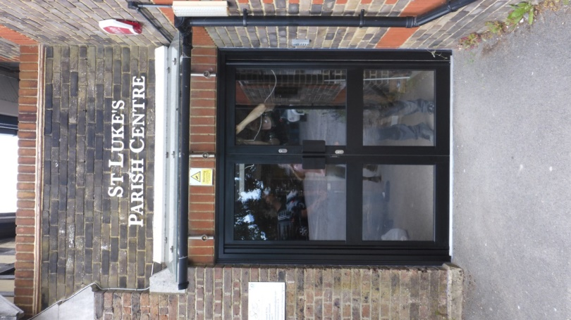

The Main Hall in action
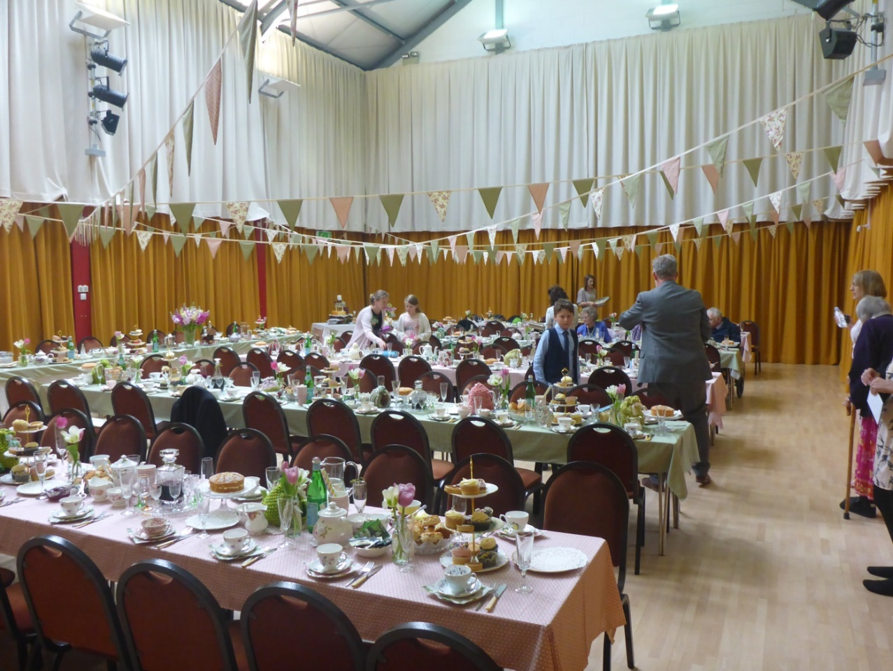

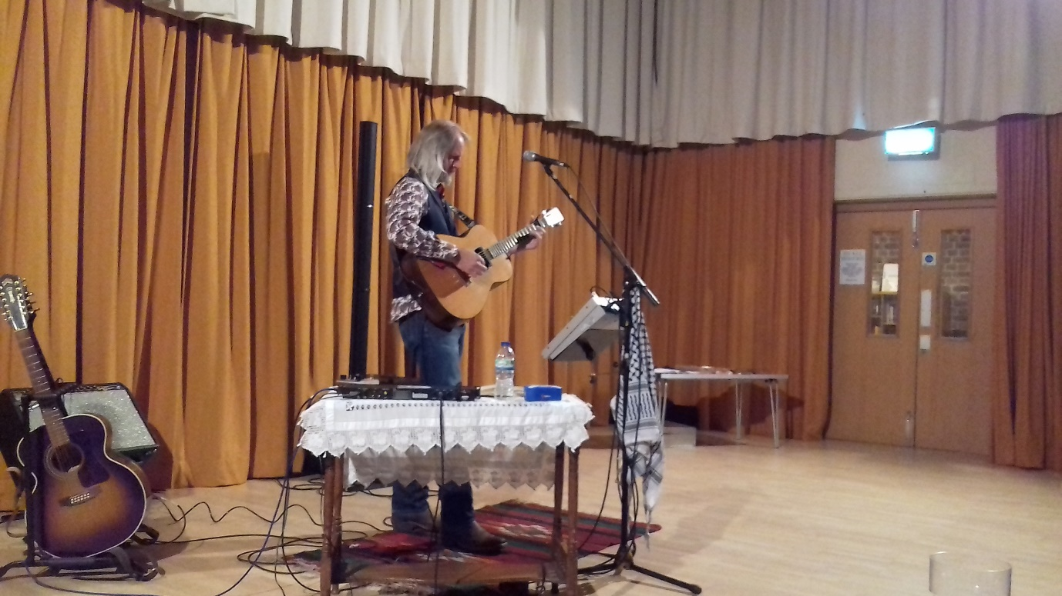

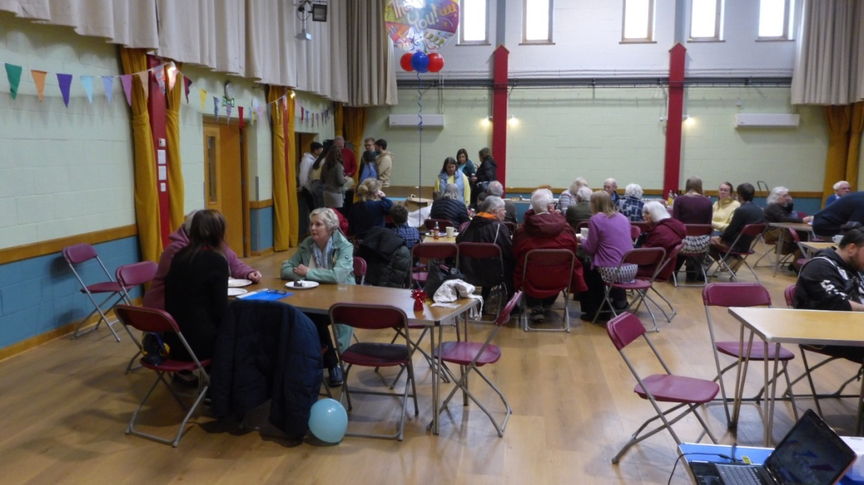

The Meeting Room
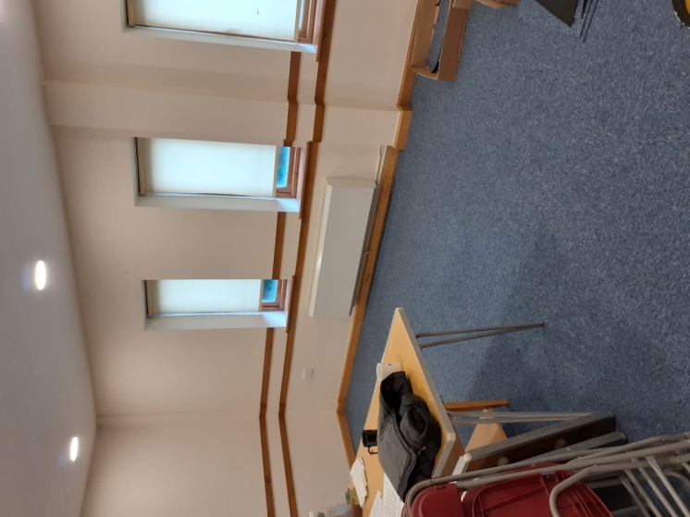

Finance:
We are very conscious that we are part of the family of the diocese, and we are determined to move to a position where we are able to contribute our full Parish Share. However, we have been hit by a number of problems: major repairs to the roof and tower of the Church; necessary redecoration and refurbishment of the Parish Centre; and worrying cracks to the North West end of the Church, for which we are in process of obtaining estimates for repair, and which called for expensive investigative work.
Although we have been successful in obtaining grants toward the major works, our general income has fallen, mainly due to clubs and societies having ceased to use the Parish Centre, following Covid. We are taking active steps to attract new users of the Hall and Meeting Room.
In addition we have recently formed a Fund Raising Group, which is already showing results; but there will always be real challenges.

The ‘Staff’
We have a very hard working and capable Parish Administrator, and an equally hard working Treasurer, we have a Safeguarding Officer, and two churchwardens. During our Interregnum, our spiritual needs are mainly looked after by the amazing retired Rev Pat (to whom we are all deeply indebted!), and the equally superb Maeve, our Reader.

Rev Pat Gibbs Maeve Mathew
(Our Reader)
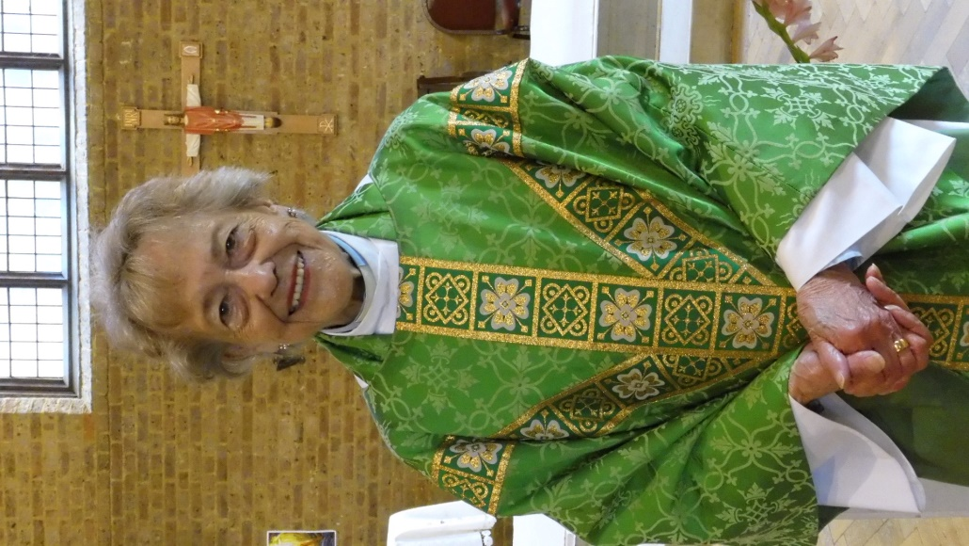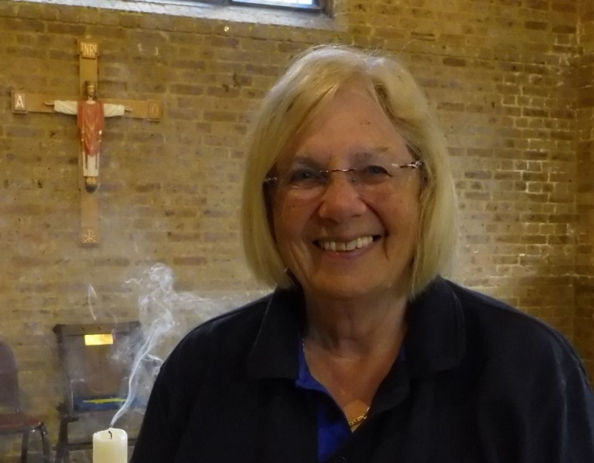

Our Parish Administrator (Chrissy Norris) Our Treasurer (Roy Maryan)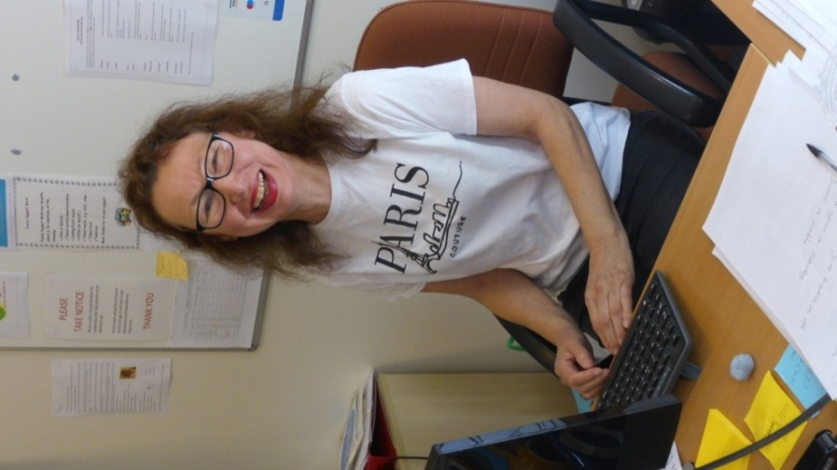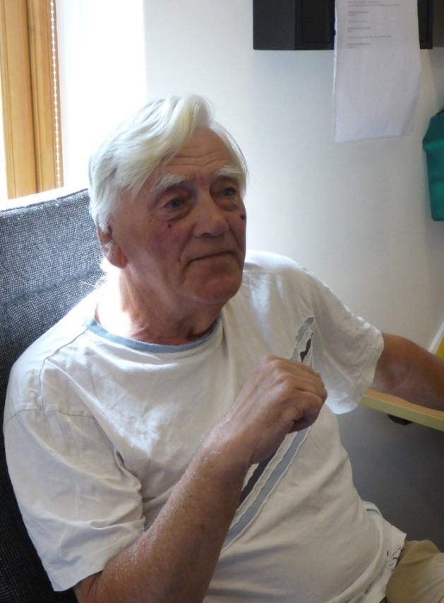

Our Safeguarding Officer (Louise Smith)
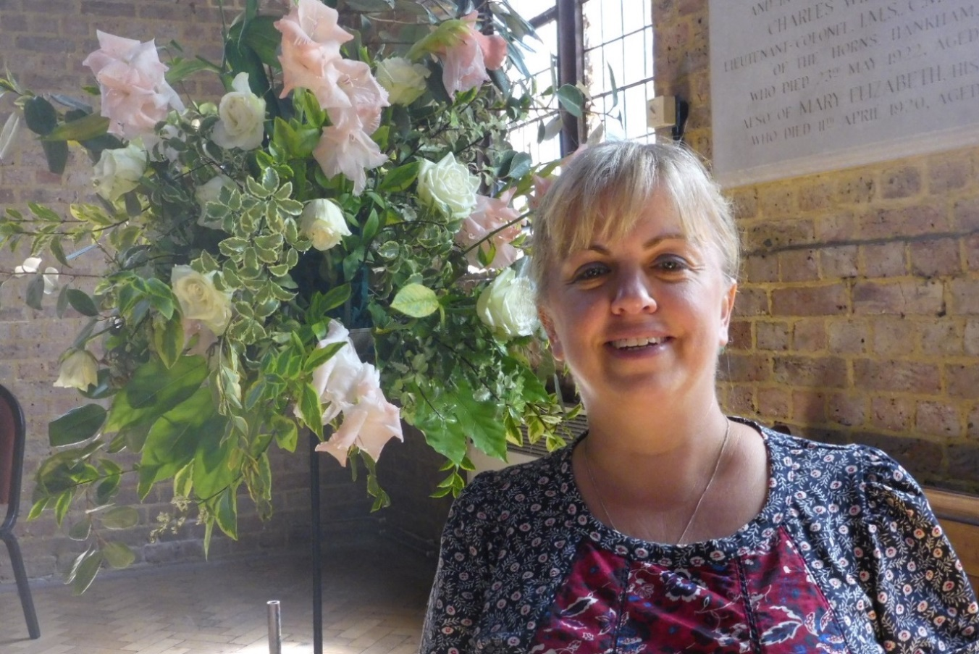

Our Organist (Cheryl Gibson)
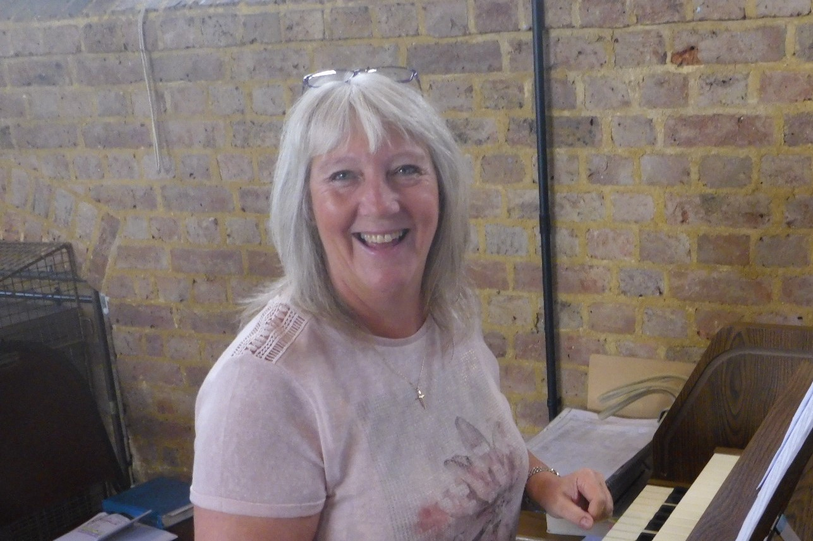

Our PCC Secretary (Yvonne Corbishley)
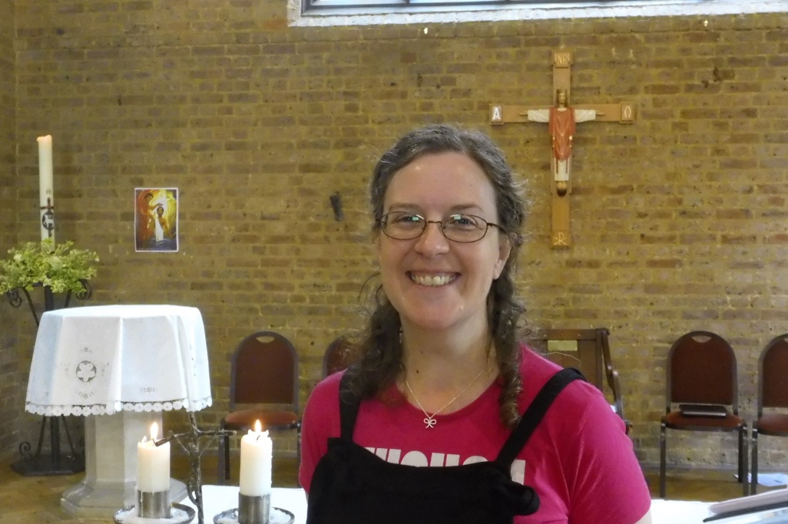

Churchwardens; (Zac Hayns and David Hanraty)
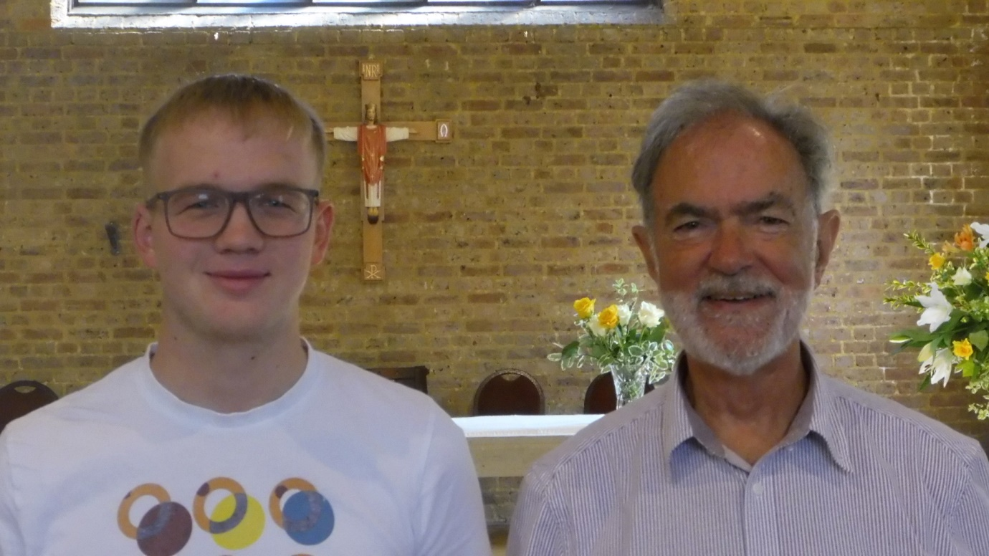

Music:
St. Luke’s has a strong musical tradition! Our congregational singing is excellent and is supported by a small group of ‘cantors’. We have a more than adequate Viscount Digital Organ and are very grateful for the services of our talented volunteer organist. We sing from the ‘Celebration Hymnal for Everyone’ and sing all the parts of the Parish Mass.
We have a good sound system, and stable WiFi is available across the whole site.

Stone Cross Windmill
We have good links with the Stone Cross Windmill and celebrate Harvest and Christmas with them at the mill or in Church. (We feel that our proximity on the same hill, and our relationship to bread, makes us good companions.) The Windmill is a five storey Tower Mill, that has been fully restored, and is open to the public.
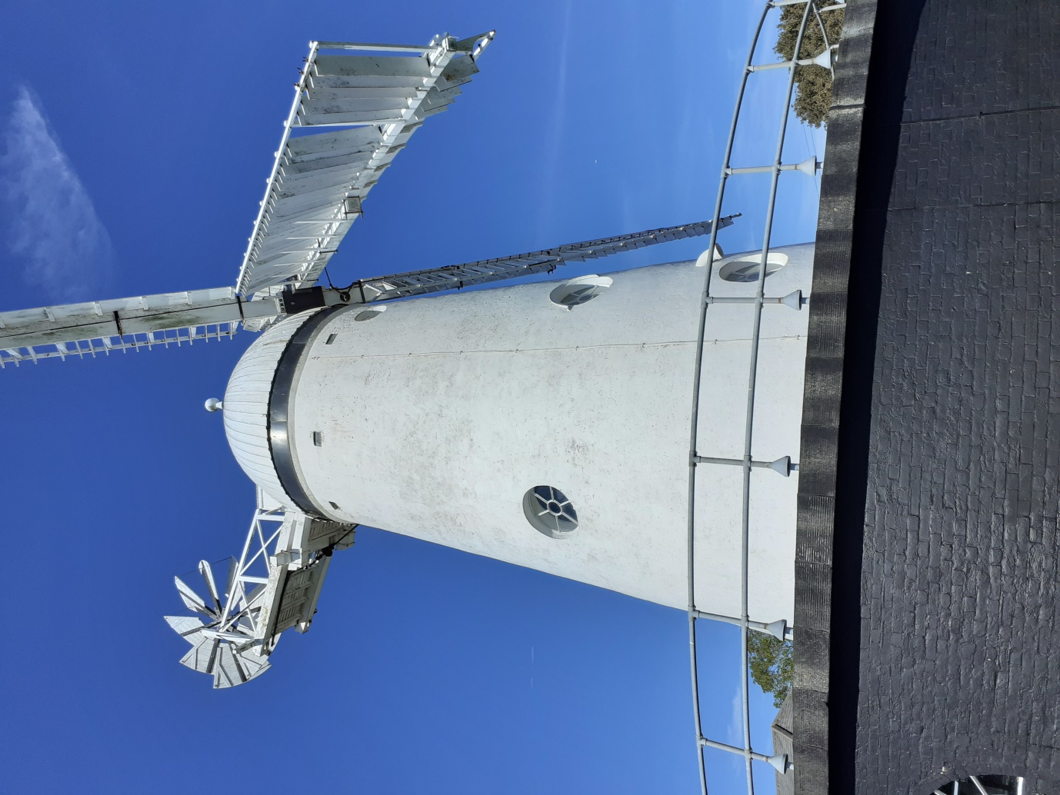

The Red Lion Pub
We have a good relationship with the Red Lion and we Carol sing there every year. We also go there for coffee after Wednesday Morning mass and they have always been willing to help us out with catering – for instance, for our previous incumbent’s leaving party.

The Vicarage:
The Vicarage is a fairly modern (1985) four-bedroomed family house about half a mile from the church, situated in a quiet Cul-de-sac. The kitchen has just been replaced, as have all the windows and doors. The garden is easily manageable with mature shrubs and trees.
It is situated about half a mile from the Langney Shopping Precinct, and about 200 yards from a Co-op store. There are Railway Stations in Polegate (2½ miles) and Westham (2 miles) with good links to London, Brighton, Eastbourne and Hastings.
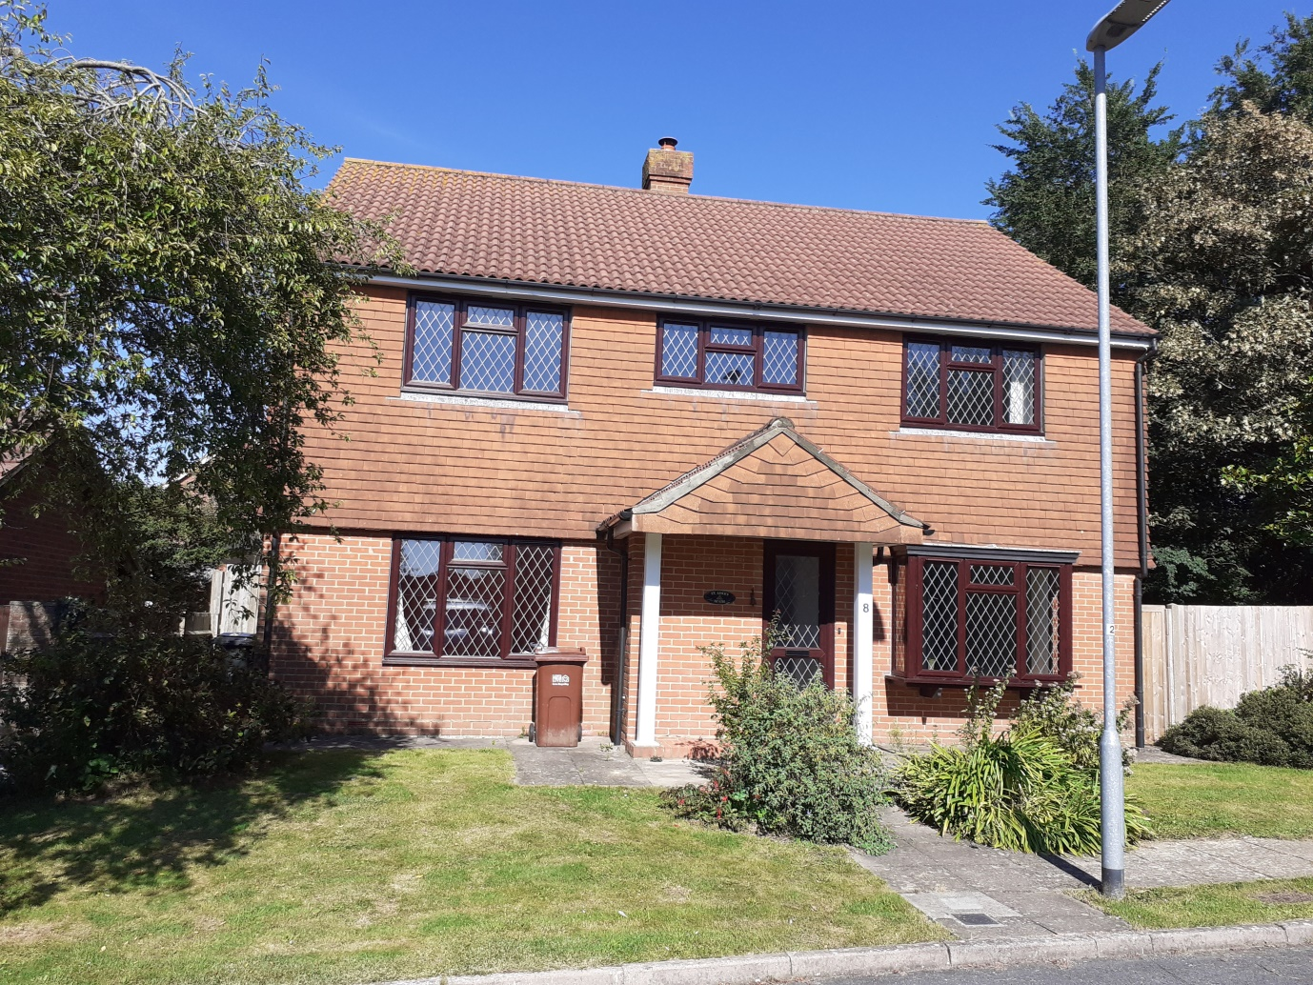

Vicarage Kitchen
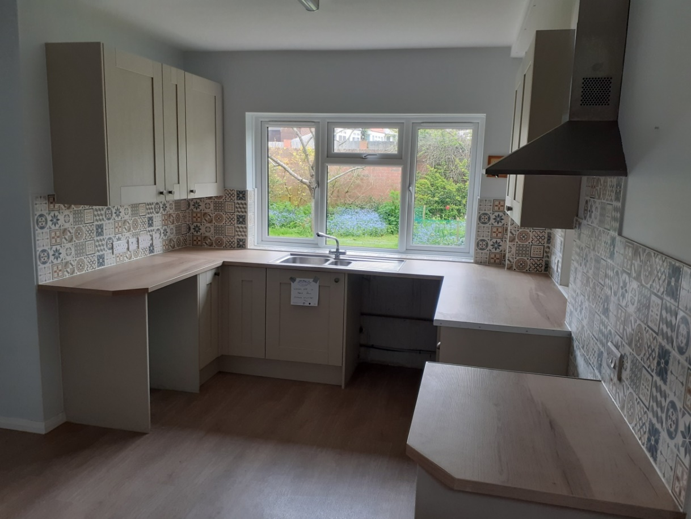

Pastoral Care: We had a pastoral group, which really stopped functioning
during the pandemic, but we are in the process of restarting this, because we strongly believe in being outward looking.

The Numbers: There are currently 97 members on the electoral roll. The attendance at the main morning service ranges between 25 and 55. We tend to average about forty at present. On special occasions, numbers have risen to over 100, including a large number of children. The crib service has been known to have over 200 present!

Young People
On Tuesday morning we have ‘Little Luke’s’; an amazing mother and toddler group in the Parish Centre, run by Imogen Lade. This attracts a good crowd, and is very lively.

Imogen (Little Luke’s)
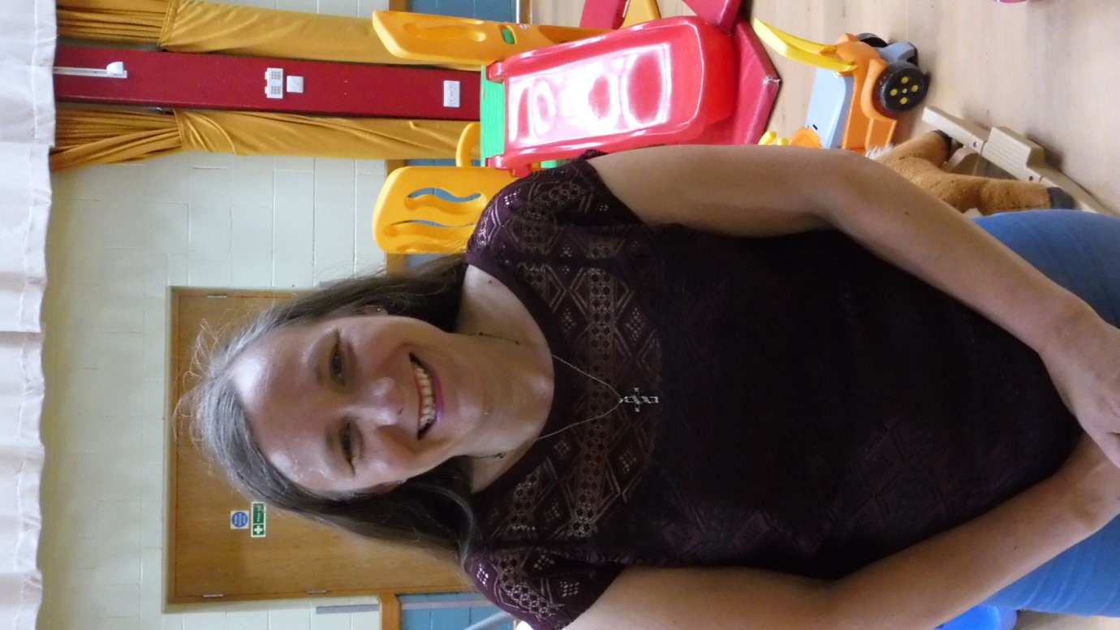

Every two weeks there is a Youth Fellowship meeting in their own room above the Sacristy.
As mentioned before we have a group of dedicated and very well organised servers at Mass. However it would be lovely to encourage some more young people to become part of this wonderful team.
On the second Sunday of the month, there is an emphasis on younger people and families, and we all bring and share a light lunch after the service.

Uniformed Groups
We have Beavers, Cubs and Scouts who meet in the Parish Centre, and we are striving to deepen the link with them. They attend Remembrance Sunday, and other services, and it is always a pleasure to see them. Some of the congregation are Scout Leaders, and this enables us to work closely together.
We are also deeply honoured to enjoy the presence of the local Royal British Legion for our Remembrance Day Service, and we fly their Standard in the Memorial Chapel.

Remembrance Day
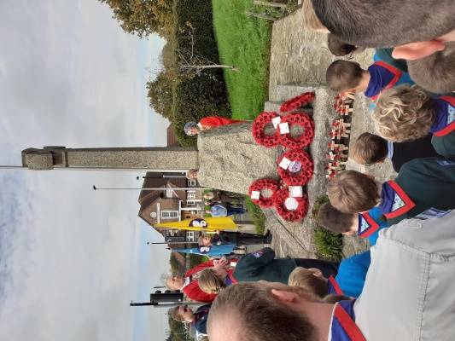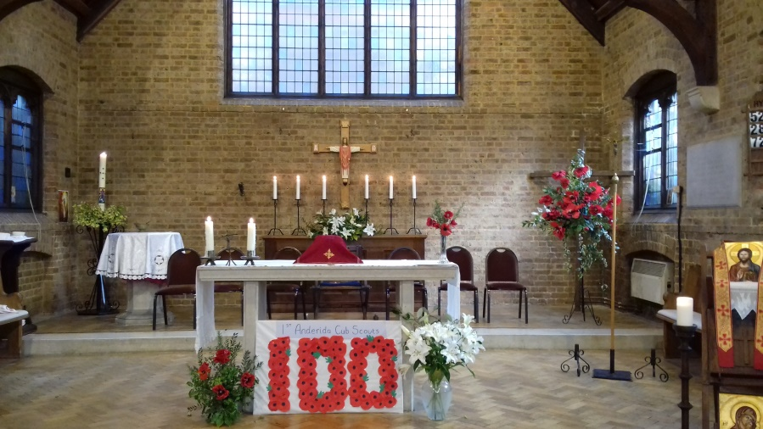

Schools
There are established links with several local schools, including Hankham, St. Catherine’s, and Stone Cross School, who, in particular is keen to be involved in activities throughout the church and school year. Our previous incumbent was on the Governors of both Hankham and Stone Cross, and was involved with St. Catherine’s (C of E) Secondary School. Additionally, he used to carry out assemblies each term and they seem to have been very well received. The children Stone Cross, Hankham and Hazel Court School have their Christmas services at the Church, and also come to other services as well.

‘ Second Sunday Mass’
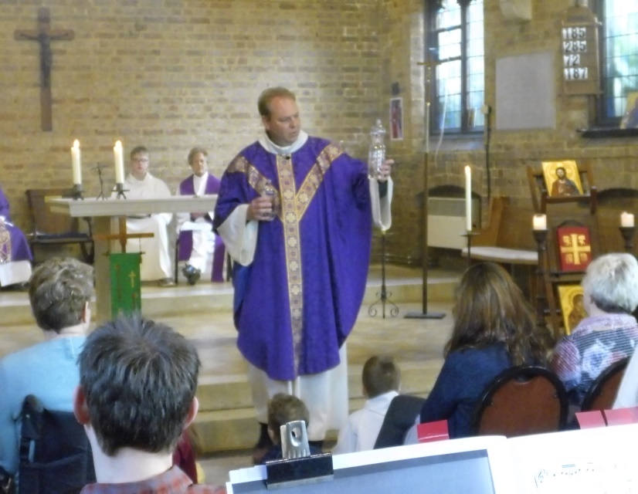

The PCC currently meets monthly with extraordinary meetings being called as required.

Relationships with other Churches
We are re-joining the ‘East Side Churches’ which has been non-functioning since the advent of Covid. This is a loose affiliation of some of the Churches in the East of the Deanery and we have had ties with several other denominations in the area.

We have been sharing our Priest with St. Nicholas’ Church in Pevensey and St. Wilfrid’s Church in Pevensey Bay, the latter have been well served by Rev Merriel, and her Husband Rev Clive Woodward.

We have been on walking Pilgrimage with members of other Churches to Chichester, and have close ties with St. Mary’s Church Willingdon and St. Peter’s Church in the Hydneye.

Pilgrimage to Chichester
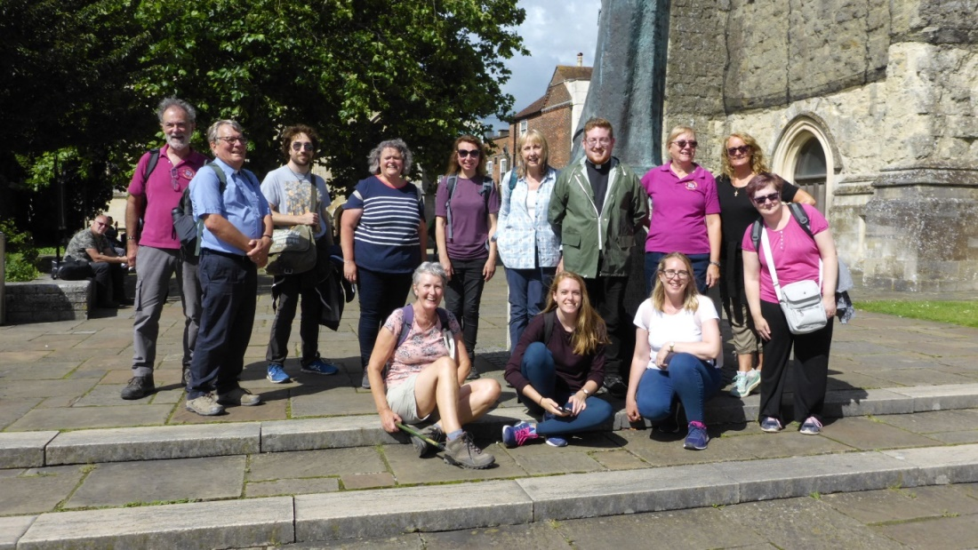
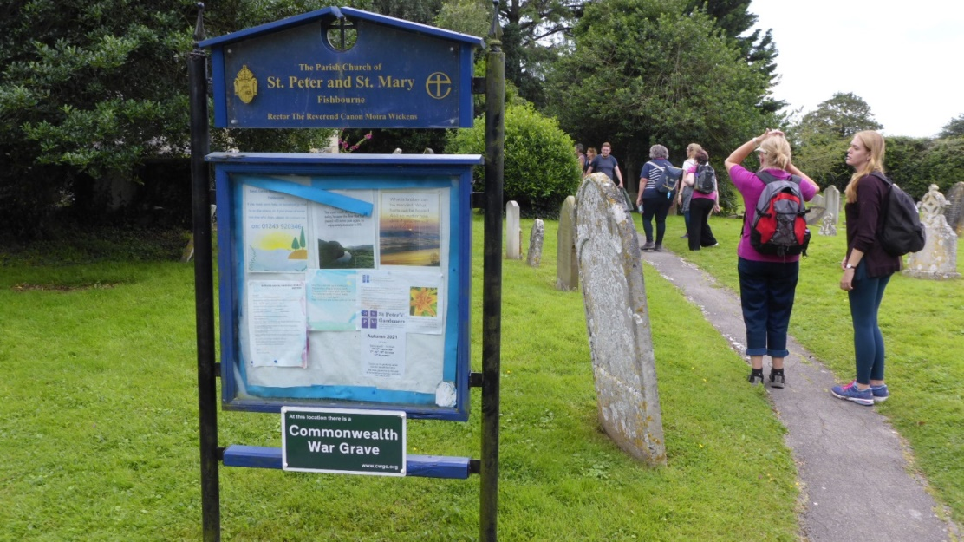

I.T.:
The Church has a comprehensive website www.saintlukestonecross.org.uk and we are also on Facebook at ‘Saint Lukes Church & Parish Centre – Stone Cross’ and Twitter. A Church WhatsApp group keeps parishioners in touch with each other and up to date on church news, events and concerns.

The Centenary:
Work on building the church took place between 1923 and 1924, the consecration took place in January 1925. We are going to hold a joint day of celebration with the Red Lion Pub on 20th July 2024, with live music, bar, food and much more, so this should be a wonderful introduction to the Parish.

Other recent church events and charity support:
We strive to reach out and help others in this unequal world, and are involved in raising money for charitable purposes in the country and in other places in the world.

Sleepover for funds for the Homeless
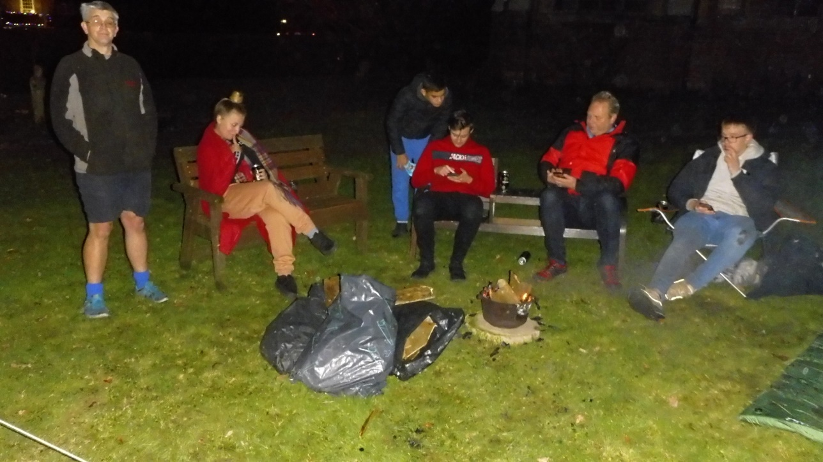

Cycling to raise funds for the Historic Churches Trust Ride and stride.
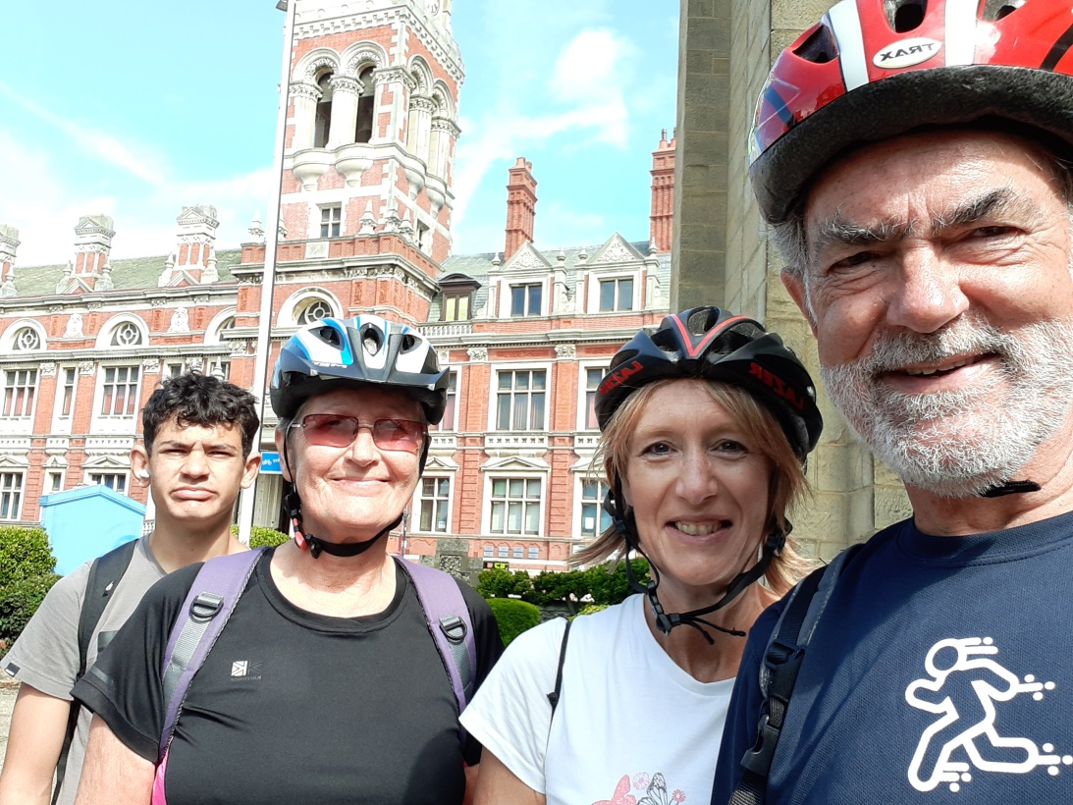

A Visitor in church
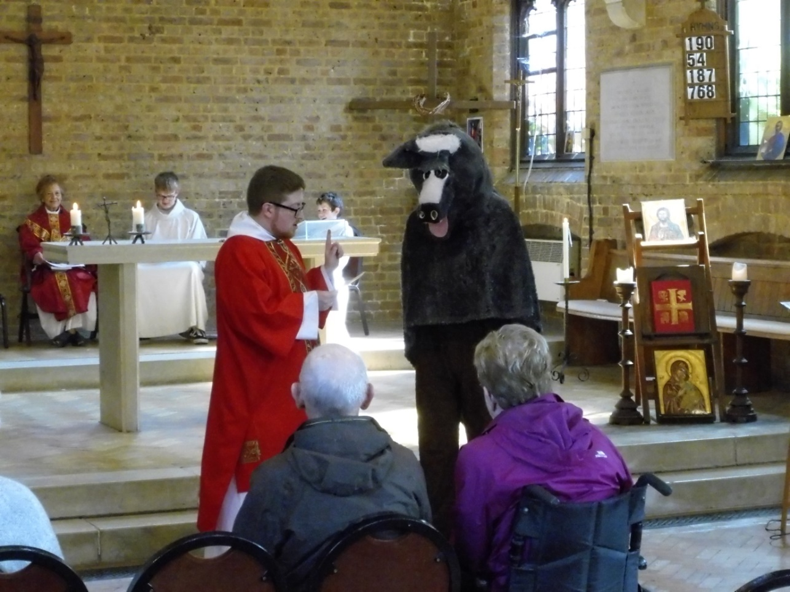

Parish Fete.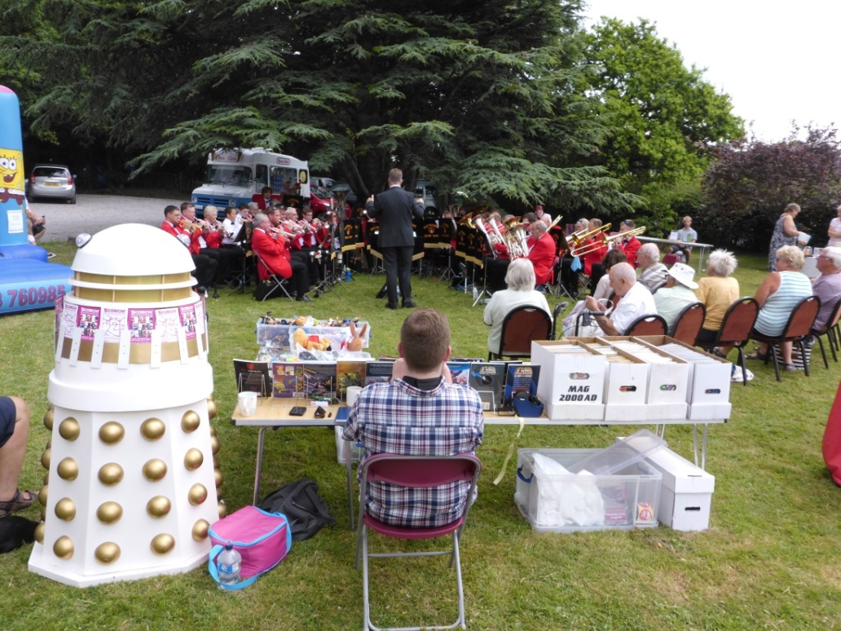

Our New Incumbent
We are looking for a Priest to continue walking with our Church family. He / She will need;
- An engaging personal faith, and the commitment to celebrating the Liturgy in the modern catholic tradition of the parish –and imaginatively commending this to others,
- A commitment to community ministry and outreach to people of all ages,
- Strong pastoral skills,
- And Personal resilience, warmth and good humour.
We feel that the parish is a lively environment and we would love to see it grow, the potential is enormous, and we feel that with enthusiasm and work we can again raise our profile in the area.
We have seen a reduction in young people attending since the pandemic and with so many sports being held on a Sunday, and we will need someone who will be happy to visit the local schools and attract more young families. Also we need someone to encourage the spiritual life of the Church, with activities such as prayer groups, Bible studies, quiet days, and retreats. We already booked and are looking forward to our Parish retreat to Sint Andries’ Abbey near Bruges next May.
Sint Andries Abdij
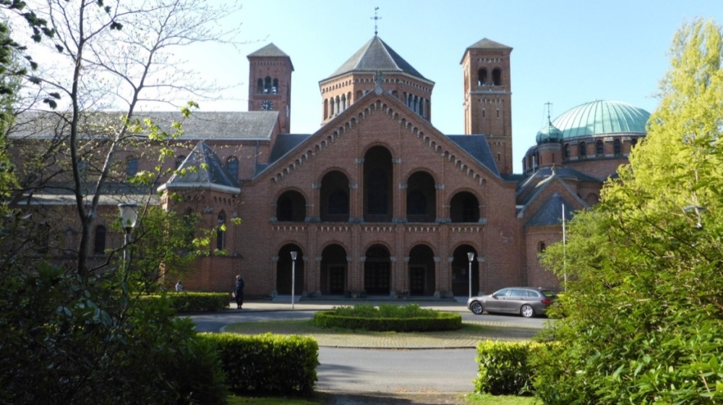
Pilgrimage 2023 (Sint Andries Abbey with the Abbot)
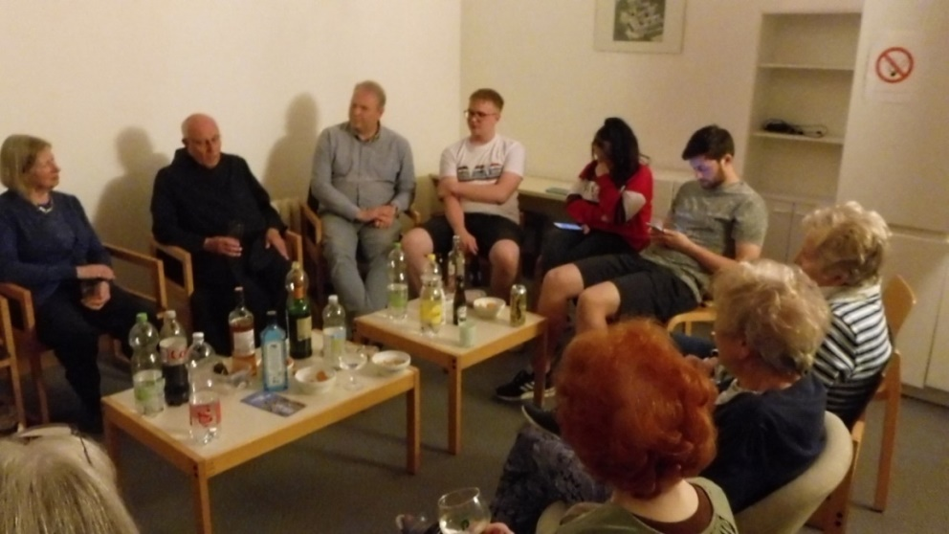

We hope that you have found this a useful insight into our wonderful parish and all that we have to offer so far.

Please do pray about this post and discern if God is calling you to join us here in Stone Cross & North Langney. We’d love to meet you!

