LENT Letter 2026
  - 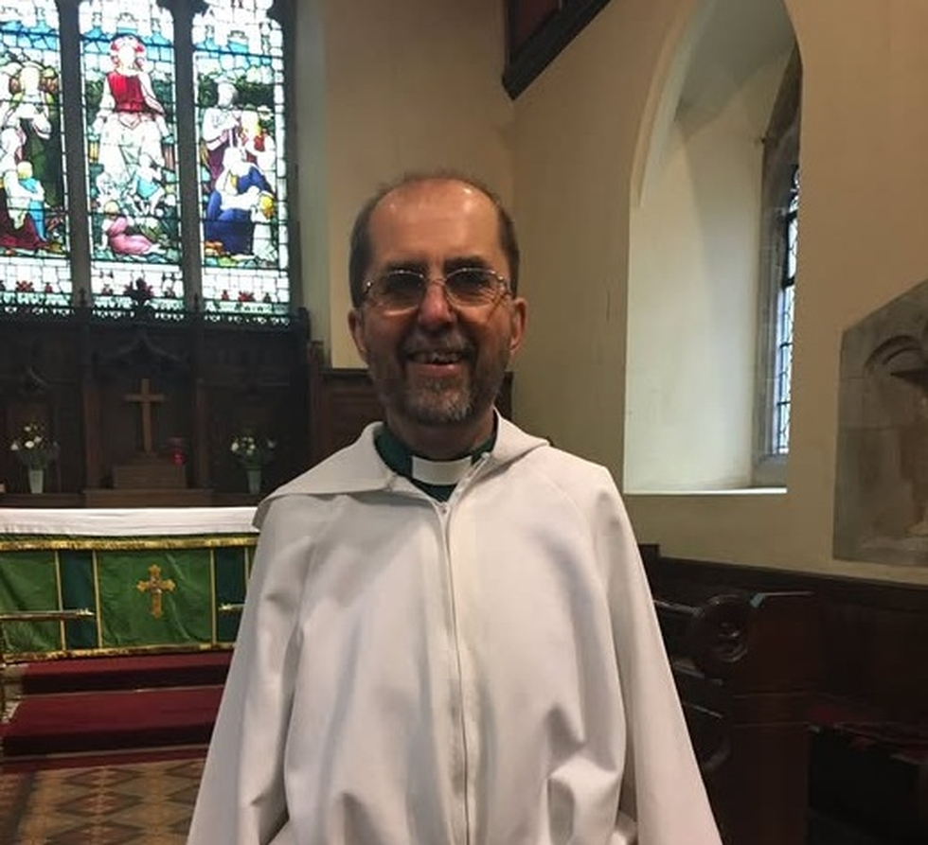
In this issue:
News from around the Diocese
Information from The Church
Of England Pensions Board
Contact Details

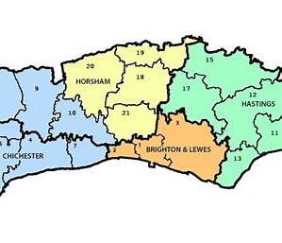
Tap here to add a caption
Dear Friends,
It is a prviliege to have been appointed Bishop’s Chaplain to the Retired Clergy and their families, and as this is my first newsletter, may I just take a few moments to introduce myself.
My early life was spent in Eastbourne and most of my ministry was spent in the Diocese of Carlisle where I was ordained in 1981. After a curacy on the west coast of Cumbria I was Rector of eight rural parishes to the East of Penrith in an area known as the Eden Valley. For part of that time I was also Rural Dean of Penrith. I returned south in 2013 upon my appointment as Vicar of St. Anne’s, St. Michael’s and St. Thomas Cliffe in Lewes. I retired from full time ministry in March 2020. Since my appointment in October 2025 it has been a joy to visit many deaneries and meet with retired clergy groups and widows groups and hear about the many activities that are taking place. I have also been reminded of the wonderful ministry that many retired clergy fulfill often with the ongoing support of family.
News of activities from around the Diocese.

Revd Tim Edge Brighton Deanery PTO Rep writes:
The “PTO and retiree Chapter” began in 2024 after I became PTO member of Brighton Deanery Synod. Our Rural Dean Emma Ham-Riche has always attended and hosted the meetings at her church St John the Evangelist, Knoyle Road, Brighton, and I convene and take notes. The venue is well connected, close to bus routes and meetings are held during free on-street parking times.
By 2025, we included Hove PTO and retirees and later Lewes PTOs, and so now the meetings include PTO and retirees of the Brighton and Lewes Archdeaconry, though socials remain per Deanery. Nevertheless, despite over 40 PTOs listed in the area, we have had attendance of 10 per meeting: business and illness preventing some. Lewes PTOs and clergy retirees enjoy regular social events, either coffee or lunch together, and Brighton PTOs were asked if they would like this too, but none responded.
In 2025 we had two “business meetings” and one social in Brighton, and that social was an Autumn evening shared with Deanery Chapter clergy. The February meeting gave rise to questions about safeguarding courses, and the issue of safeguarding requirements for Church Wardens and any PTOs who were recognised as church leaders during an interregnum. The Deputy Diocesan Safeguarding Adviser Vicky Taylor attended the September meeting and gave a very helpful guide to safeguarding in this Diocese, and answered questions, taking away comments for consideration. We felt the meeting to have been mutually beneficial.
Our first meeting for 2026 was on February 12th when we met for fellowship and to plan the next meetings, reviewing pastoral care of retired clergy and safeguarding, and considering any further concerns we may have that may be usefully discussed later in the year.
Lewes and Seaford Deanery
Revd. Colin Pritchard writes:

I have contact with thirty one retired clergy including Church Army Captains as they are on the Pensions Board payroll. I must admit that I have difficulty in keeping in touch with those in Lewes; I have only twice heard of new retirees moving there and only by hearsay of those who have died, moved away or into a home. I must soon repeat my appeal at Deanery Synod for members, especially laity, to keep their eyes peeled to watch folk that might be retired clergy as members of their congregations.
I continue to organise a lunch on alternate months in one of the local pubs (The Wellington Hotel in Seaford) for all retired clergy of whom I know together with their spouse, partner or chauffeur, sending an email invitation about a week before. Together with Anglican clergy my list now includes two retired missionaries and two Baptist ministers who are members of our congregations. The numbers attending creep up slowly but number now between thirteen and sixteen.
I am not clear as to what it is about the town of Seaford but we seem to be getting an increasing number of clergy retiring here; the latest to move in and attend our churches came as two, husband and wife, both priests. There are ten retired clergy in our parish and another retiring to the parish in the Summer; the other parish in the town has three. One Priest in Seaford has died in 2025.

Chichester Retired Clergy Group

Rev. Clive Rogers writes:

Our ‘Retired Clergy Companions For Support’ (RCCFS) group has enjoyed a varied and successful programme of informal meetings and events over the past year. One of our core intentions, in order to get to know each other at a deeper level especially when new members join, is to share our Path to Ordination. At two meetings in the past year new members have done so and at another meeting our new Rural Dean joined us similarly to share. There is always more to learn from each other’s experience. In March our annual quiet day was led for us by the new Dean of Chichester, The Very Reverend Dr Edward Dowler.
One of our group members, drawing on his years of experience working with CMJ, gave two talks, in costume, one titled ‘Aaron the Priest’ and the other ‘Rev. Lewis Way’ , the priest and philanthropist noted for his Christian outreach to Jews.
Getting out and about in August we hired two minibuses to take a group of 20 of us on a day trip to Stansted Park near Havant, where in particular we could visit the Grade 1 listed Chapel, built by Lewis Way and consecrated in 1819. The Chapel contains a unique East window with Christian/Jewish iconography and Hebrew Tablets of the Ten commandments. John Keats attended the consecration service, along with 300 people and like many of them, is rumoured to have stood at the back. He used the Chapel's imagery in his poems The Eve of St Agnes and The Eve of St Mark.
On our journey to Stansted, we stopped to visit two Downland churches, St Peter’s Racton dating from the 12th and 13th centuries, and St Mary’s Stoughton which dates from the 11th century. At both we were warmly welcomed and introduced to the history of these Mediaeval buildings.
Other events included a Guided tour of the Cathedral, and a guided walk led by Local Historian and Writer Alan Green around the Pallants area of Chichester. Particularly we visited St John’s chapel, an octagonal building, which is a rare example of a Georgian proprietary chapel, now in the care of the Churches Conservation Trust. The organ has been recently restored, and we were treated to a demonstration of its capabilities with a short recital from Alan Thurlow, who for 28 years was Organist and Master of the Choristers at Chichester Cathedral.
We concluded our 2025 meetings with a Cornish Cream Tea at which our guest speaker, Rev Canon Rebecca Swyer, spoke on the difference between the Ministry of a Deacon and a Priest.
For 2026 our program so far includes talks on Hospice Chaplaincy, Migration, and the Vicar’s Hall in the Cathedral complex. Our Quiet day will be led by Revd Dr Earl Collins, Residentiary Canon and Chancellor of Chichester Cathedral. A guided walk looking at the history of the Somerstown area of Chichester will be led by Alan Green. And another Cornish Cream Tea is planned for the end of the year, at which our speaker will be Richard Moatt, the Bishop’s Chaplain for Retired Clergy.
If anyone wishes contact to know more, you are welcome to do so at email: clivettrogers@gmail.com

Information from The Pensions Board:
Following the change to Pensions agreed at Synod the following will be in place.
If you retired before 2011 your pension will continue as usual. If you retired after 2011 you will receive information in the autumn as regards your pension. A super pension will then be paid, hopefully beginning towards the end of the year.
If you know someone who wants to make a move in retirement and is living in one of our homes, please encourage them to get in touch with us. We are here to help residents explore all their options. This can include exploring aids and adaptations to help them stay in their current home, or connecting them with other services to help them manage more ably (e.g. cleaning, gardening, decluttering). Or if they want to make a move, we will help them to find the right option considering choices with the Church and other providers.
Did you know the Pensions Board supports its members with welfare advice and offers charitable grants? Our Welfare Benefits Advisor can help retired clergy with their benefit claims, checking their eligibility of benefits, maximising their income, accessing grants from clergy charities, and providing advice around care, and funding for care. For retired clergy with a very low income and with limited savings or assets, we might be able to offer further help with a charitable grant.
We hope this newsletter reaches as many as possible. If you do know of someone who would like to receive this newsletter (especially those who do not have PTO) please feel free to pass on. Also, if you would like to contribute to the newsletter please contact me. We are always grateful to receive articles.
My contact e mail is:
retiredclergy@chichester.anglican.org
With all good wishes,
Richard

