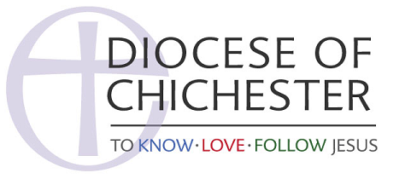

__________________________________

Social Media Policy for Churches

The churches in the parish/benefice of XXXX have pledged to abide by the Social Media Community Guidelines of the Church of England.

This policy, which sets out how this parish Church uses Social Media, will be agreed by the PCC and will be shared among the congregation and wide community through the church website, noticeboard, and other regular communication.

This policy will tell you what you can expect from us if you follow the XXX Church official accounts on Twitter and Facebook/Instagram.
Our social media accounts are the responsibility of the vicar and managed by the XXX.
We do/do not use automation to post content, such as tools that generate tweets from RSS feeds. If you follow us, you can generally expect no more than XXX tweets or posts a day at this time, usually less, covering the following:
- alerts about new content relating to the Church (news, events, publicity campaigns, etc)
- alerts about new content/resources relating to the wider Church/diocese or partner charities/charitable concerns supported by the Parish.

Following
We follow organisations and public individuals which share in or represent the ministry of the Church in the Diocese of Chichester. They include (but are not exclusively limited to) other parishes, Christians, the local church community and charitable organisations which they support. We do not automatically follow back new followers. Due to resource of time, we infrequently review our follower list. Being followed back does not imply endorsement of any kind.

Availability
We will update and monitor our social media accounts as often as we can. We accept no responsibility for lack of service due to third party downtime.

@Replies, Direct Messages, Comments
We welcome feedback from all our followers and endeavour to join the conversation where possible. However, we are not able to reply individually to all the messages we receive.
The Vicar or representative reads all posts, comments, @replies and Direct Messages. We do not engage on issues of party politics or answer questions which may infringe personal privacy.
Communicating directly online is not encouraged. We may send messages to groups, rather than individuals, or share them publicly. If content relating to the parish or individuals is unwelcome or offensive it may be removed and reported. Social media users should be aware that the Parish Office is the point of contact for all enquiries relating to the Parish. The usual ways of contacting the office are detailed in the Contact section of our website (link here)

Safeguarding

Twitter, Facebook or any social media platform is not the place to report any safeguarding issue. Any serious concerns relating to individuals (past or present) should go to Sussex Police. The Diocese of Chichester safeguarding officers are available to speak to anyone who wishes to talk in confidence. 01273 421021

Legal considerations

Posts on social media can often be publicly accessed and you may be seen to be putting material into the public domain. Issues of defamation, libel, copyright and data protection may arise and that must always be borne in mind when posting material or information or allowing material or information to be posted or remain on the page. If you wouldn’t say something in a public meeting or to someone’s face or write it in a newspaper or on headed paper – please don’t say it online.

_________________________________________________________________________

Additional Information

Charity Commission - Charities and Social Media Guidance here

Charity Commission – Checklist for developing a Social Media Policy - here
Church of England Social Media Community Guidelines here
The Diocese of Chichester Social Media Policy TBC
Guidelines for the Professional Conduct of the Clergy – here
The Diocese of Chichester official social media accounts are:
- Twitter: @chichesterdio
- Facebook: https://www.chichester.anglican.org/

