Racial Justice: Why Bother?
This is the second in the series.
Why Bother? Because racism demeans and dehumanises both the victim and the racist; it creates conditions in which humans are discriminated against, despised and humiliated. As such we cannot countenance it. We made our new home in England in 2004. It didn’t take long before I realised that I was amongst the minority ethnic groups here. Initially I did wonder if we were all the same. However, it didn’t take long before I made many new friends among white people, black people, brown people (like me) and people of all other shades in between. My close friendship with people of diverse ethnicities and backgrounds taught me that we are all similar and convinced me of the truth of the biblical understanding that we are all created in God’s image. Of course, we are all made differently but at the core of being a human we are all the same kind. Skin colour is shallow. Pigmentation does not make or define a human. We share our humanity with others. There is a cohesion and togetherness in our innermost existence. Our consciousness of this should inspire us to stand against racism or any other discrimination which is antithetical to the notion of our common humanity. Such healthy teaching is needed as it fosters essential values of kindness, compassion and empathy amongst humankind.

Why Bother? Because Racism is irrational. Racism must be unacceptable because you don’t have a choice to pick up your features or colour. There is no logic in discriminating against someone based on something that the individual did not choose in the first place or cannot change subsequently. From this Racial Justice Week, we can begin to appreciate that there is only one race – the human race. The modern genetic studies show that we are all the same under the skin. God looks at the heart and we must learn to do the same. God created us to live cheek by jowl with others in communities and societies. While we all need our own space to live as individuals, we also need to know that we are one, in Christ, despite differences in our features or skin colour.

Why Bother? Because racism is founded on quasi hierarchy. It is based on the notions of superiority and inferiority. But then the scripture teaches us that all humanity is fearfully and wonderfully made (Psalm 139.14). It should follow from this that educational and job opportunities must be provided to all, irrespective of their colour. Structures in companies, industries, offices and churches should be seen as functional necessities; they should not be there to validate or reinforce hierarchical powers. This might appear to be an unachievable goal but we can certainly achieve it if we succeed in adopting inclusive strategies and a broader vision with the help of God.

Why Bother? Because real beauty is inside. Many people even at a younger age worry about their ‘good looks’ fading away. Many do their best to help themselves look young and beautiful. The bigger question we need to ask ourselves is if we look beautiful before the eyes of God. And we win if the answer is in the affirmative. Just as a parent thinks her/his child is beautiful God thinks we are all beautiful as we are.

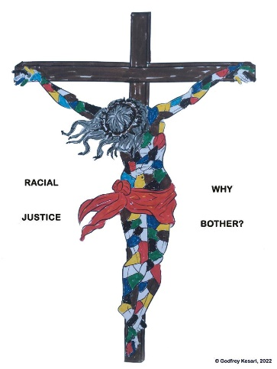
It is fascinating that some dark coloured people like to become fair and some light-coloured people like to have tan. God is more interested in our character, and He is hardly ever interested in our skin colour. As Martin Luther King Jr said, “I look to a day when people will not be judged by the colour of their skin, but by the content of their character.” Or, even better, as we observe the Racial Justice Week, we can pledge to love our neighbour – the term ‘neighbour’ is race-neutral - and leave the judging to the one who knows you and me intimately, God.

Above all, without you and the others the body of Christ is not complete – now and eternally. We shall explore this next week – the Racial Justice Week.

Godfrey Kesari.

