APCM Place Audit Return

An email with the title “APCM Place Audit Return” was sent to all Parish Priests, PCC Secretaries and PCC Administrators, with a parish-specific link to click to allow you to complete your APCM return directly into the diocesan database. Please find detailed instructions on how to complete this return below. The deadline for holding the APCM is the 31st May and the deadline for submissions of your APCM return this year is the 14th June or within two weeks of your meeting – whichever is sooner.

Upon clicking the link that you were sent, you will be taken to a summary page listing all the people currently holding the auditable posts in your parish which will look similar to this:

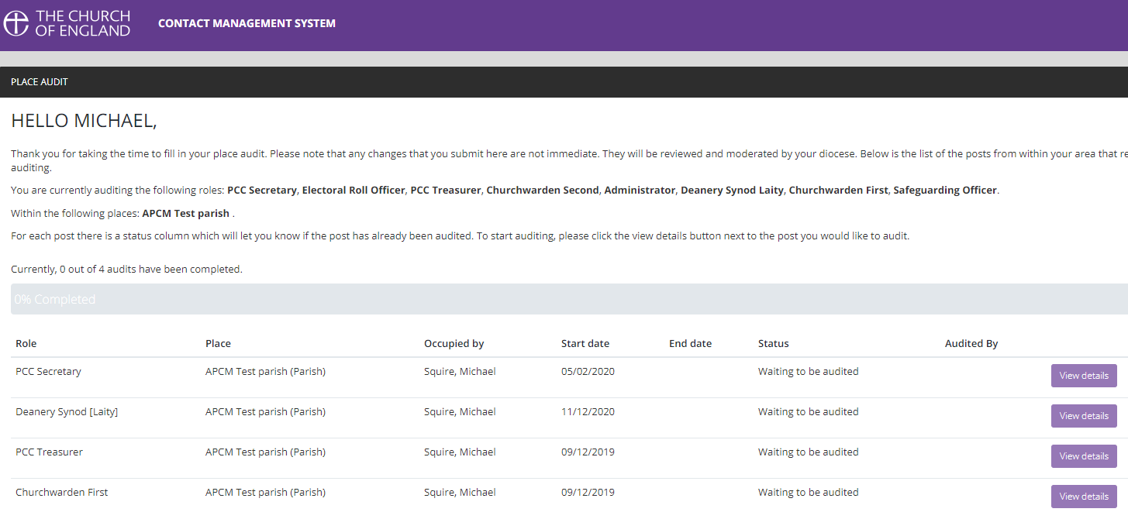

Click the ‘View Details’ button for the person that you would like to edit and you will be taken to this page:
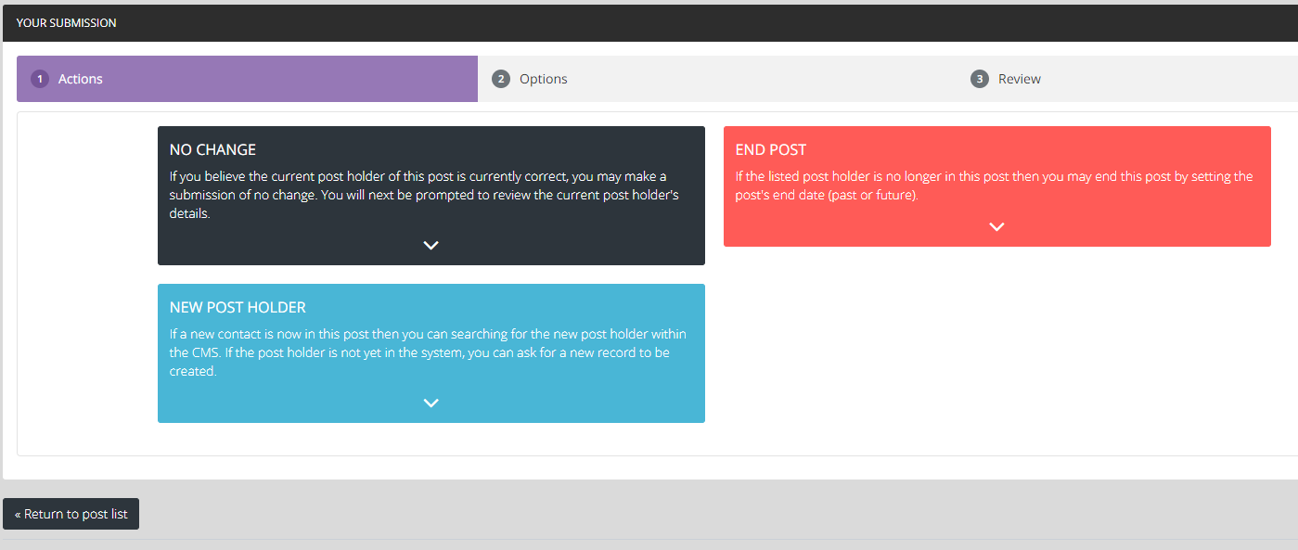
For each person listed, you will need to select one of the following options, which will depend on what was decided at your APCM:
- No Change – This should be selected when the current post-holder will remain in the position.
- New Post Holder – This should be selected when someone will replace the current post-holder.
- End Post – This should be selected when someone is retiring/standing-down but where there was no-one able to replace them in that role (you can create a vacant ‘place-holder’ post through this option).

No Change
If the post-holder will remain the same click No Change and you will be taken to this page to review the details:

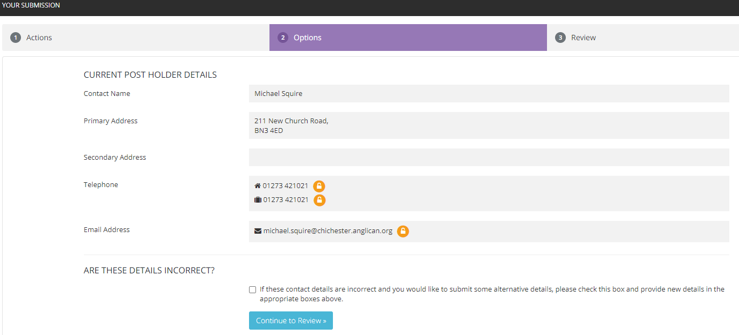

If the personal details are incorrect (perhaps if the person has moved or changed their email address or phone number) click the tick-box in the ‘Are these details correct?’ section and it will open up each line for you to type in new contact details.

Once you have entered the new details, or if the details were already correct, click the blue ‘Continue to Review’ button and you will be taken to the concluding page. If you have made a mistake, click ‘reset audit’ but if you are happy with the changes click ‘Submit your audit for this post’:
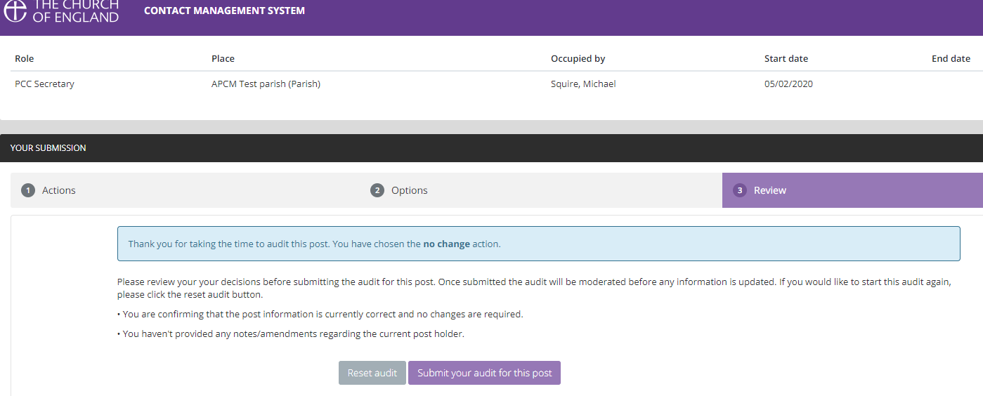

You will now be taken back to the overall summary page, but your overall progress will be updated and the post that you just audited will now appear ‘greyed-out’ which means that nothing more can be done to that role.

New Post Holder
If a new person was elected or chosen to replace the currently listed post-holder then you should select ‘New Post Holder’ which will take you to a screen which looks like this:

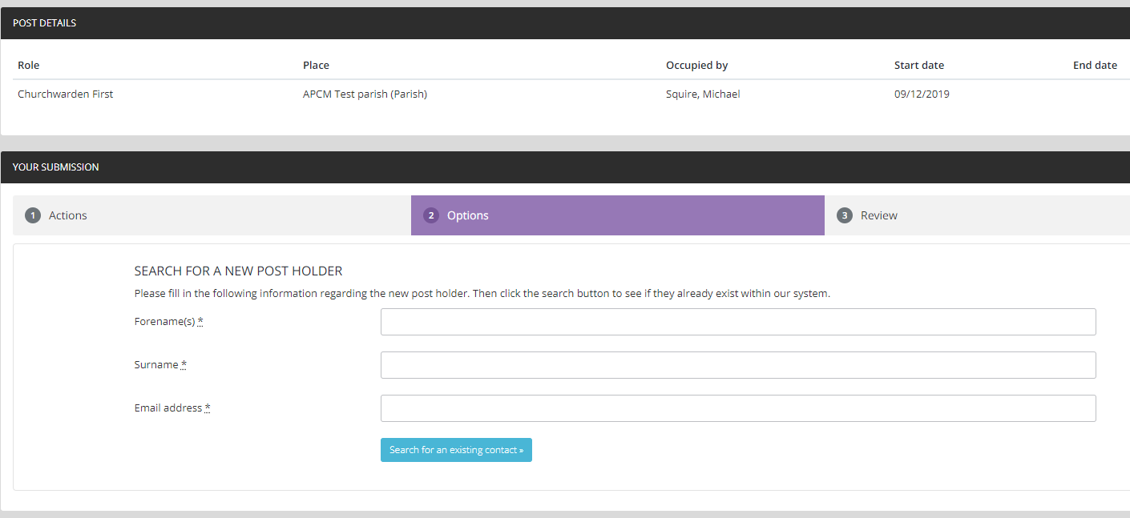

On many occasions the new post-holder might already have a diocesan database profile and in order to prevent duplicates being created you are asked to enter the name and email address of the new post-holder so the database can check for an old profile:

This will take you to a list of names, if there are many potential matches, click ‘show more’ to continue reviewing the list. The option that the database believes is the correct match will be highlighted as you see in the above example. If the person that you are attempting to add as the new post holder appears in this list, click the ‘select this contact’ button. If not, click the ‘Request a new contact is created’ located towards the bottom right of the screen.
NB: If you are adding a completely new contact, after you have added them to the database please could you click here to download a Data Consent Form for them to complete and email to michael.squire@chichester.anglican.org or post to Diocesan Church House, 211 New Church Road, Hove, BN3 4ED.

You will now be taken to a screen to review your selection and to set a succession date (usually the date of your APCM). If the previous post holder has died, and that is why the post was vacated, you have the chance to tick the box to let us know that this is the case (and the profile of the recently deceased person will be deactivated on the database). Click continue to review once you are happy with the information or back to previous step if you think you have made a mistake:

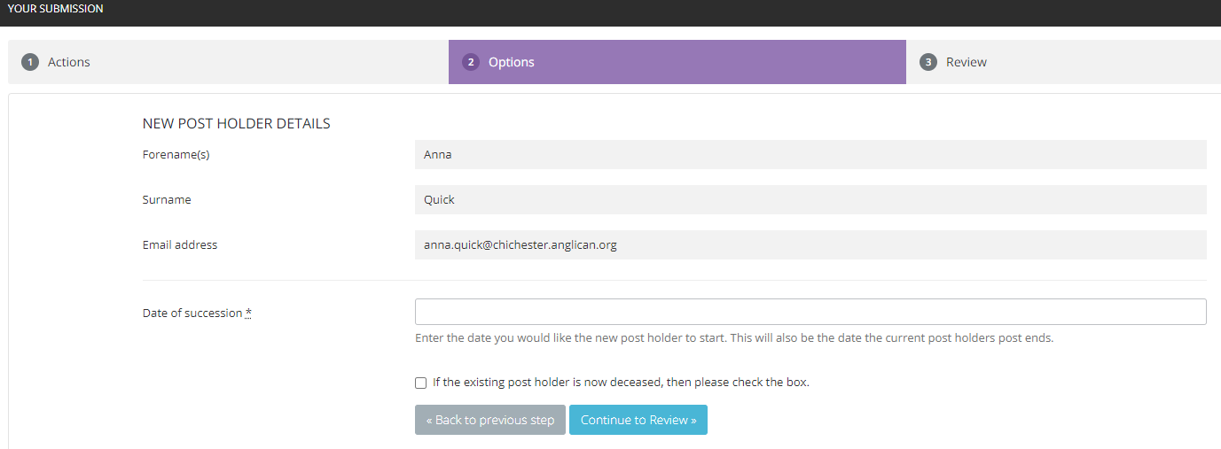

On the final screen, you are given the option to have one last review of the details and then can click ‘Reset audit’ if you have made a mistake, or ‘Submit your audit for this post’ if you are happy with the changes:
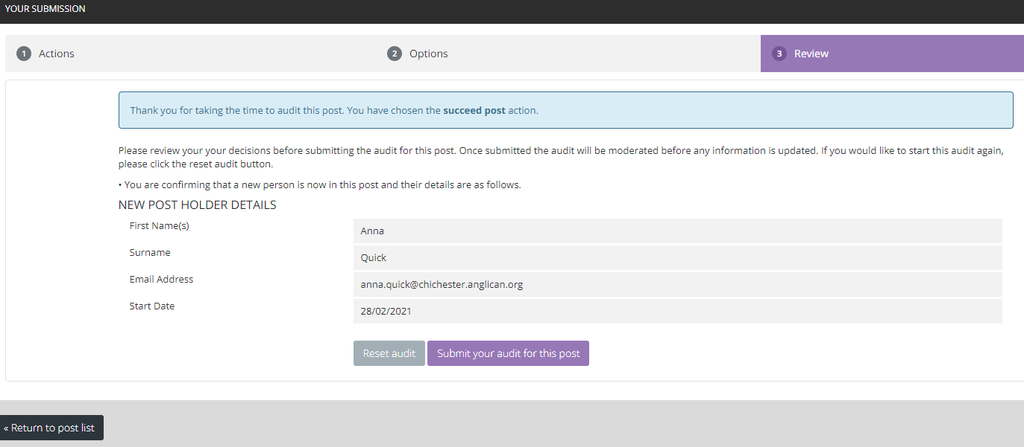

After this you will be returned to the initial summary page showing your updated overall progress and with the posts that you have already audited ‘greyed-out’ to signify that they are completed:

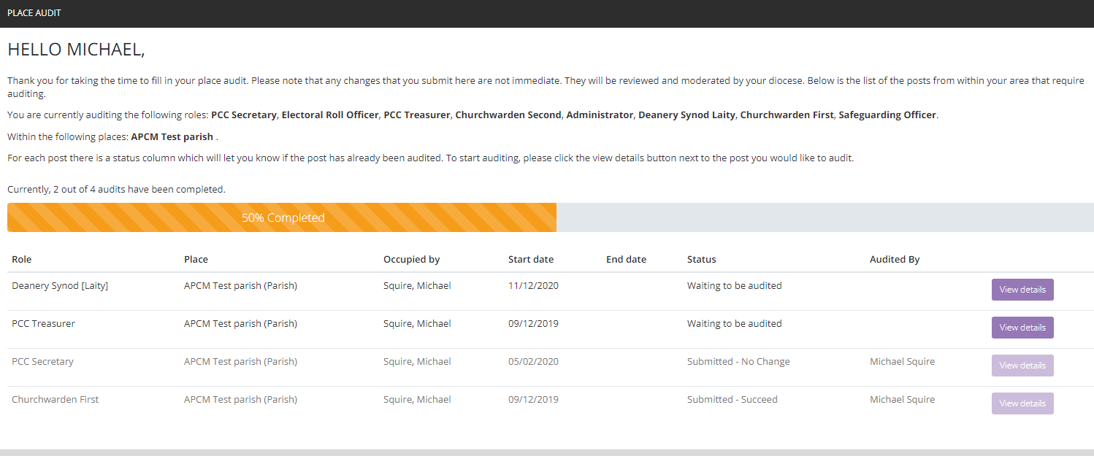

End Post
If someone has retired/stepped down from their post but there is no one to replace them, you should select ‘End Post’. On this screen you will be asked to enter the date that the person resigned from their post and you have the option to mark if the person is now deceased (if this was the reason that the post was vacated) and the option to create a vacant ‘place holder’ post.
NB: You should almost always select the box to create a vacant post if there is no-one to replace the recent post-holder (the only case where you would not tick that box is if the post was duplicated by mistake, e.g. two PCC Secretaries or three Parish Safeguarding Officers, etc and you want only the correct one to remain)
Once you have entered the date and selected the create a vacant post box, click the ‘continue to review’ button:
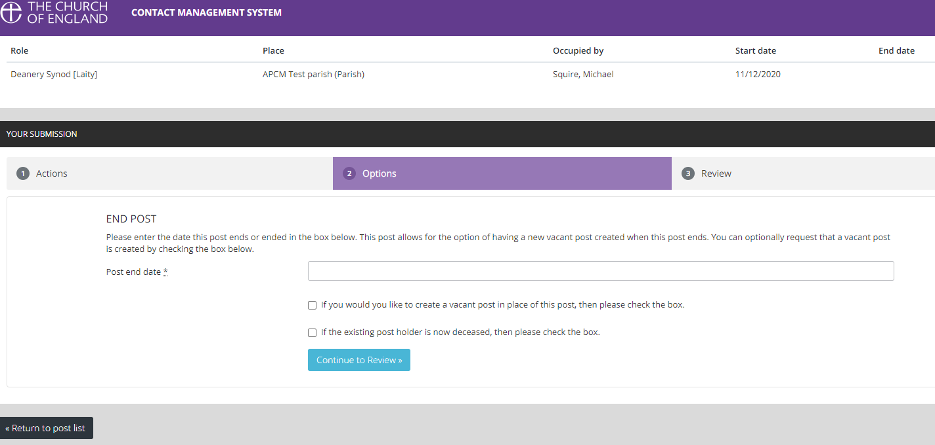

You will then be taken to the final review screen which will show you your changes, if you have made a mistake, click ‘Reset audit’ to begin again, if you are happy with the changes click ‘Submit your audit for this post’.

Completing the APCM Place Audit
Once you have audited each of the posts in the list with one of the above options you will notice that on the initial summary screen you will see the following ‘100% Completed’ text on the progress bar and all of your posts will now be ‘greyed-out’ to signify completion:

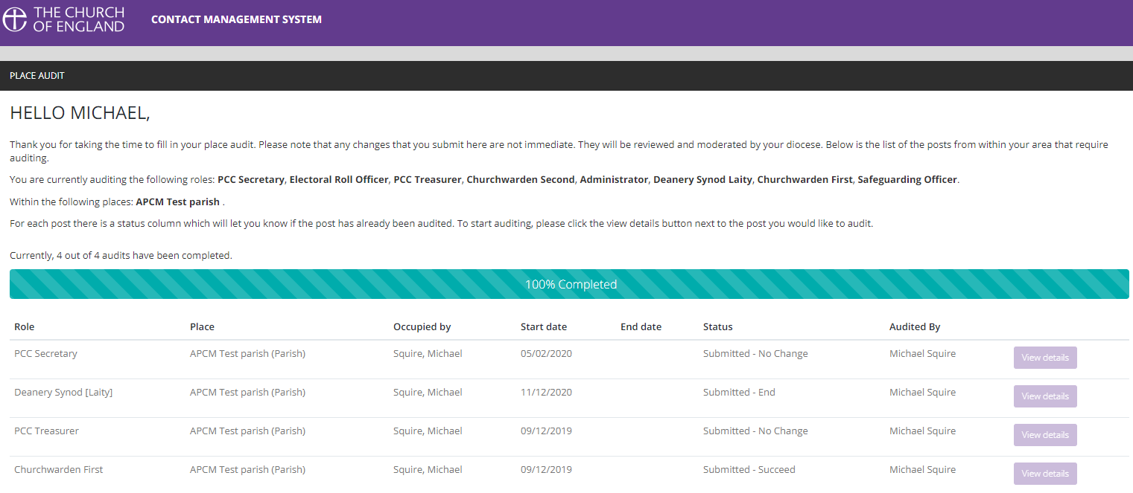

Your APCM return will now be complete and all your submissions will appear in a queue for me to review and confirm for you.
If you realise that you made a mistake on one of the audits but had already confirmed it (so that it appeared ‘greyed-out’) you will not be able to correct the mistake, but if you email me at michael.squire@chichester.anglican.org I will still be able to make adjustments for you.

If you need any further assistance or have any questions regarding the APCM place audit return please email me at michael.squire@chichester.anglican.org and I will be happy to help you.

Thank you for taking the time to complete your APCM return,

Kind Regards,
Michael Squire
Database and Statistics Administrator

