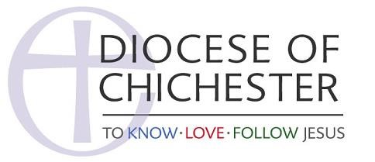
DECLARATION BY CHURCHWARDENS

I HEREBY DECLARE that I, ……………………………………………………………………………. (print name)

will faithfully and diligently perform the duties of the office of churchwarden for the parish of

....................................................................................................during the period of my appointment,

and that I am not disqualified from holding office as a churchwarden under section 2 (1), (2) or
(3) of the Churchwardens Measure 2001 (see notes below)
Notes
- The disqualifications are:
  - disqualification as a charity trustee under s.72 of the Charities Act 1993;
  - convictions within Schedule 1 to the Children and Young Persons Act 1933;
  - disqualifications under section 10(6) of the Incumbents (Vacation of Benefices) Measure 1977.
If you are in any doubt as to whether you are disqualified, please consult the diocesan registrar or archdeacon before signing the form.
- This form when completed, must be handed to the archdeacon or other person acting for the bishop on your admission to office, and will be retained by the archdeacon. Your contact details will be included in the diocesan record once you have completed the data consent form on-line.
Signed……………………………………………. Dated the …………. day of………………2019 (Churchwarden)

