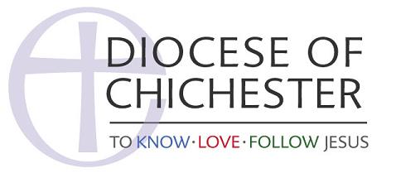
Helpful guidelines for high-profile or celebrity funerals
High-profile funerals, more often than not, will create media attention. A little planning ahead of a high-profile funeral can make all difference to the overall experience for the grieving family and the church community.
It is a highly stressful time and everyone wants everything to go smoothly.
Many high-profile funerals have a co-ordinator and it is worth making contact with them to talk through the logistics of how the media, for example, can be managed.
Contact the diocesan communications officer for assistance with this. They can be on hand on the day and can take much of the stress away from you and your team – you’ll have enough to do as it is!
Some notes to consider when dealing with the media:
• Make sure the family's wishes are addressed.
• Set aside some space, perhaps across the road or on the church path, close enough for the cameras to get their shots, but far enough away not to be intrusive
• With agreement from the family and before anyone arrives, set-up some pre-arranged shots (say an hour before the service, with a precise time they have to be out), where they can film the cards on the flowers, or a pre-record from the vicar, a bit of organ music, shots of the windows etc.
• A few printed orders of services to hand out to journalists/photographers (with details of names of people taking part) can save you answering lots of questions on the day.
• it’s sometimes worth arranging a photo of a dressed coffin lying in the church if it arrives early and can be done discreetly (with the family’s agreement)
• Make sure the undertakers know what arrangements have been agreed with the media so they are aware
• Either have the address or eulogy available for press or an agreed summary of it that you can put out as soon as it is delivered.
Media people find it really helpful to know the boundaries and they can then feed that back to their editors. The diocesan communications officer, or an agreed other person, ideally would stay with the media to respond to their requests. It is helpful to identify who will give interviews ahead of the event as media often approach guests for interviews after the service, but they may try and approach guests at all times if nothing is in place. Contact: communications@chichester.anglican.org

