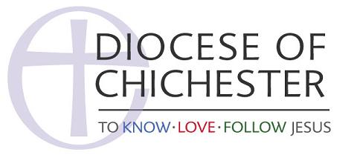

Dealing with Media Enquiries

Not all media calls will be bad news, however, most enquiries from the press, radio or television come in the form of an unexpected telephone call. As a result, it is easy to be caught off guard and to make comments before you have got your mind into gear.

A simple routine procedure, whenever a call is received, reduces any risk, so always be courteous and think about the following when answering a call or email from the media.

- Make a note of the name of publication, radio or TV station and programme.

- Ask if the caller is staff or freelance

- Take down a telephone number and extension number

- Ask what the nature of the enquiry is, the date for publication or broadcast (and time)

- Offer to call back in (say) 10 minutes or ask him/her to call you back. If you agree to ring back, make sure you do and within the time promised. If it is a very simple enquiry deal with it there and then. If you need more time to get facts together - let the journalist know. Reporters work under pressure and will appreciate this.

- Reporters write for their paper’s audience. Expect to see your words ‘translated’. Be helpful and the reporter will usually respond in the same way. If you have problems answering a question, tell the reporter you will find out and call back. Remember - a newspaper reporter can put into print everything you say.

- Write out what you want to say. Use the time to contact third parties if necessary (this may include the diocesan communications officer, safeguarding officer, or archdeacon.

- Be factual and frank when giving out information to the media - but always in a firm, friendly manner.

- Don’t expect a reporter to immediately understand church structures or language. They are not employed to know the facts but to know how to find them.

As well as media support from your diocesan communications officer, the Church of England offer a broad training programme for people who have no knowledge of working with the media either at parish or diocese level. You’ll learn how national and local broadcast and print media work and how you get your stories on air and in print. You will learn how to create a press release, dealing with what happens when a big story breaks and cover interview technique, what to say and what not! For helpful courses visit www.commstraining.cofe.anglican.org

