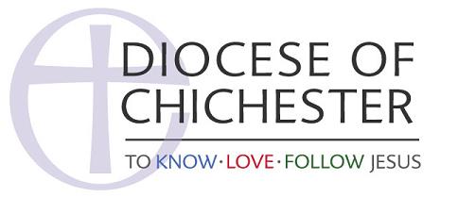

**The Copyright, Designs and Patents Act 1988**

Churches now have access to a vast range of music, video and creative works for use in their services and activities. But the issues related to copyright are complicated, and legal compliance can be confusing.

In 2014 several amendments were made to the Act to include the use and distribution of digital content. The Internet significantly increases the ways in which material can be copied, modified or used so safeguards had to be implemented to protect the creators.

All original work is covered by copyright and the copyright owner. Generally, the copyright belongs to the author(s); however, where the work was conducted by a paid employee, the copyright may belong to the commissioning organisation.

Different rules apply if the work is commissioned from a third party such as a designer. The copyright continues after the owner’s death (the number of years varies, according to the type of work involved).

The following work is currently protected under Copyright laws;

* Literary Material – Books, reports, articles, letters, computer programs and poetry whether these are printed, verbal or through music
* Databases – Any collection of information or materials which are accessible and arranged in an orderly fashion like a report or library catalogue
* Art – regardless of quality, all artistic work is covered including photos, sculptures, maps, buildings and photographs
* Music – Any composition which is recorded. Lyrics are classed as literary material
* Dramatic work – Any non-spoken information provided in print such as stage directions or sections of the performance recorded in print. Scripts will fall into the literary works section
* Recording of sound – The recording can be in a range of different formats. Direct copies of other recordings are excluded
* Film footage – Productions in any format including DVDs and digital files
* Broadcasts – Sounds and images which are used to transmit information to viewers or listeners

A useful summary of The Act is available [here](http://www.copyrightservice.co.uk/copyright/uk_law_summary) You can check out more about Church Copyright Licence at [CCLI](https://uk.ccli.com/copyright-licences/) You can find out more about the The Act [here](http://www.legislation.gov.uk/ukpga/1988/48/introduction)