“Oh, happy band of pilgrims”
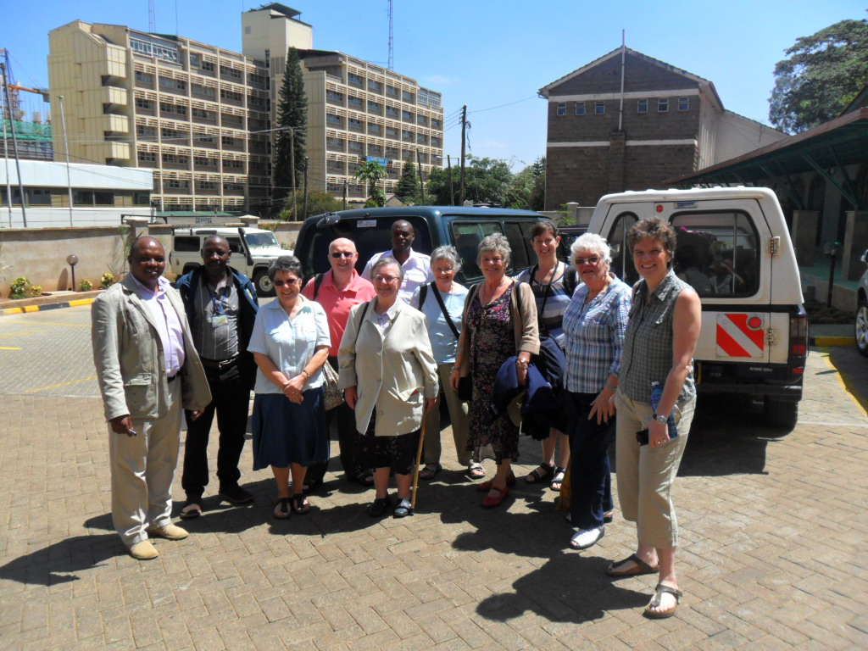
David, Bishop Joseph Muchai’s driver, and Peter arrived to transport us and our baggage to Nakuru. They had been on the road since 6:00 a.m. and arrived around mid-day. The density of traffic and five police check-points made a journey that should not take more than 3 hours and grueling odyssey for them. Yet their warmth, good humour and genuine delight at seeing us hid this costly side to hospitality that we, as visitors, could all too easily ignore. 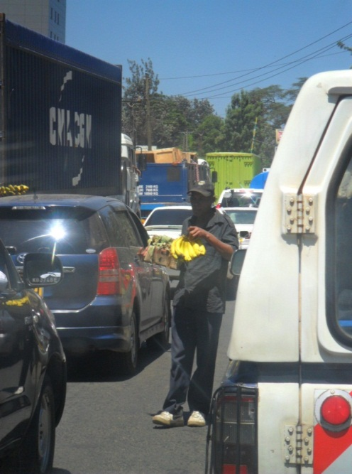
We travelled up the main artery, the A104, northwest towards Nakuru. Driving through Nairobi we are struck by the beauty of the flowering trees, the glittering high-rise office blocks, the density of the traffic and the sheer ordinariness of people hurrying to work. Street vendors abound and one has to admire their courage as they ply their trade dodging cars, breathing in the toxic fog of diesel fumes and seeking to catch the eye of potential customers.
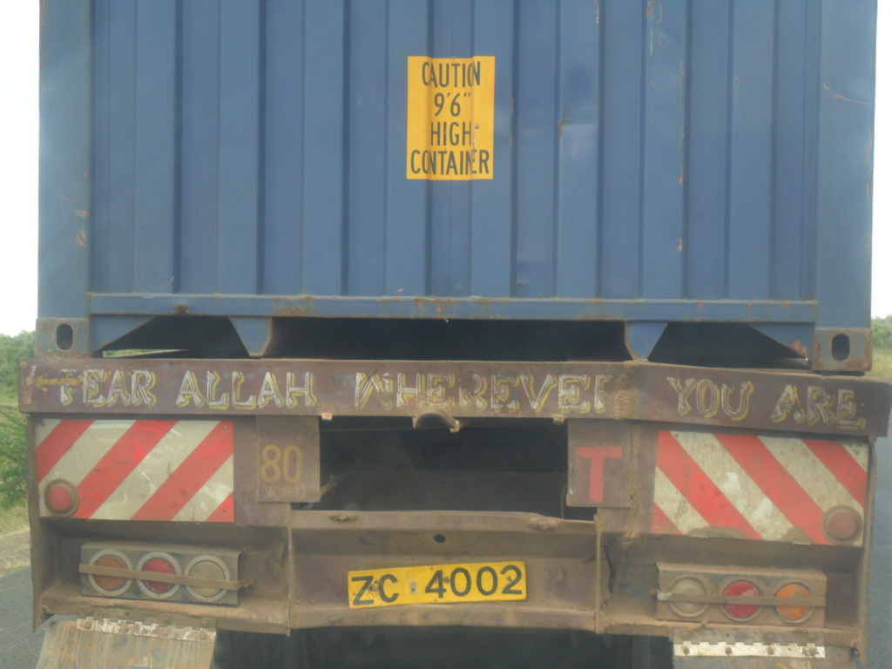
Faith and an awareness of the precariousness of life are evident all around. People pray openly and naturally thanking God for health of body and travelling mercies. Whatever the faith tradition, there is the universal conviction that all life belongs to God. On the journey to Nakuru we discovered and rejoiced in the Kenyan art of calling us to attentiveness and response to God’s presence “wherever you are.”

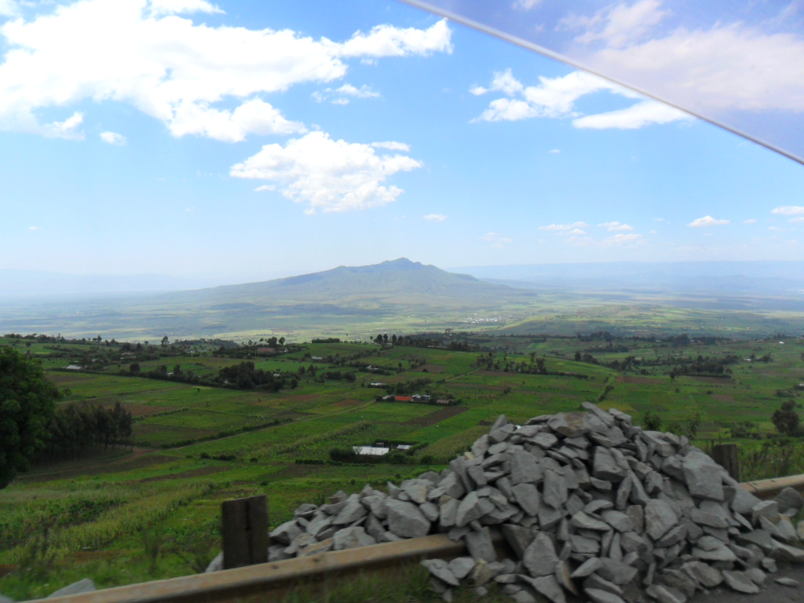
The overwhelming beauty of the land, the rift valley with its lakes and extinct volcanoes, the verdant forests and lovingly tended fields, sighting zebras and gazelles grazing a stone’s throw from the side of the road touch something deep in the soul. We are moved by a deep sense of wonder and awe and our hearts to praise.

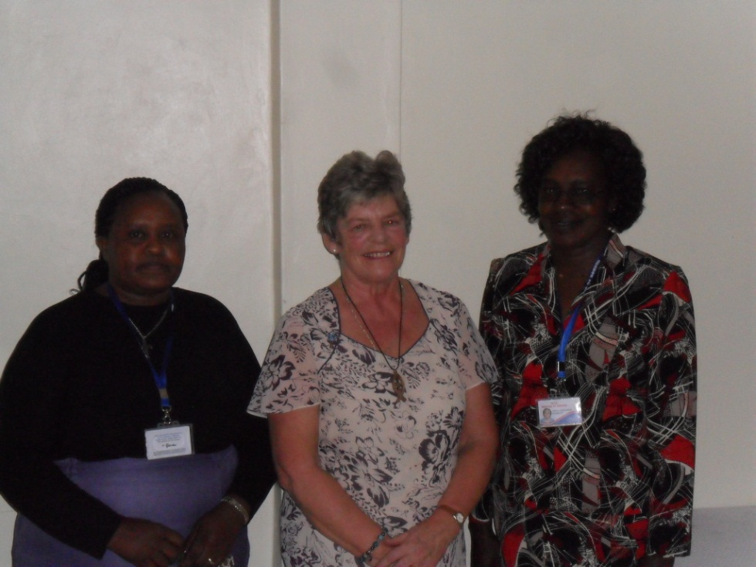
Once in Nakuru we arrive at the Imani Guest House and are shown to our rooms. Nakuru is a bustling city, Kenya’s third largest after Nairobi and Mombasa, but there is a restful quietness and shot through with birdsong at Imani. What a gift!
Our hosts show us the cathedral, the Mothers Union Offices, St. Paul’s University. We meet Mama Mary Muchai (Bishop Joseph’s wife and the Diocesan MU President) and Grace the MU worker for the diocese of Nakuru. There is a real sense of family reunion as they embrace Chris Emson and Ann Swaine and others from Chichester Diocese’s MU.
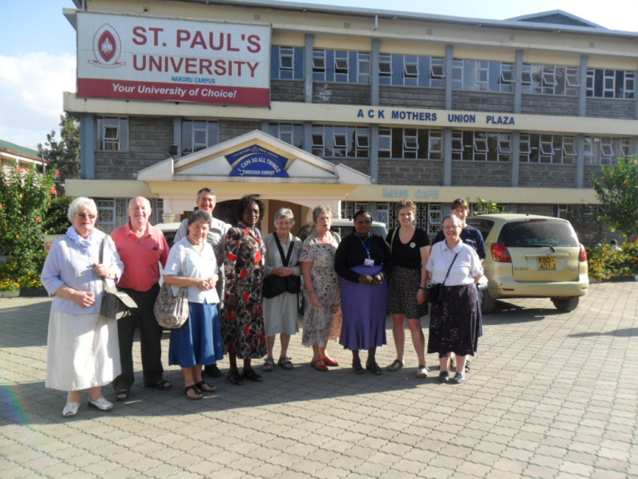
We then go to visit St. Christopher’s parish where the Ven. Philip and Gladys Obwogi now live and serve. We visited St. Christopher’s Home for Young Ladies, a hostel for young medical students studying at the neighbouring teaching hospital. 150 young women live in community in a compound near the picturesque and atmospheric parish church surrounded by shrubs and jacaranda trees in full bloom.
Fr. Philip and Gladys’ warmth and affection touch us all deeply. They are people who have known personal tragedy and pain and through it a profound sense of God’s gracious and sustaining love.

