Manormead Supported Housing
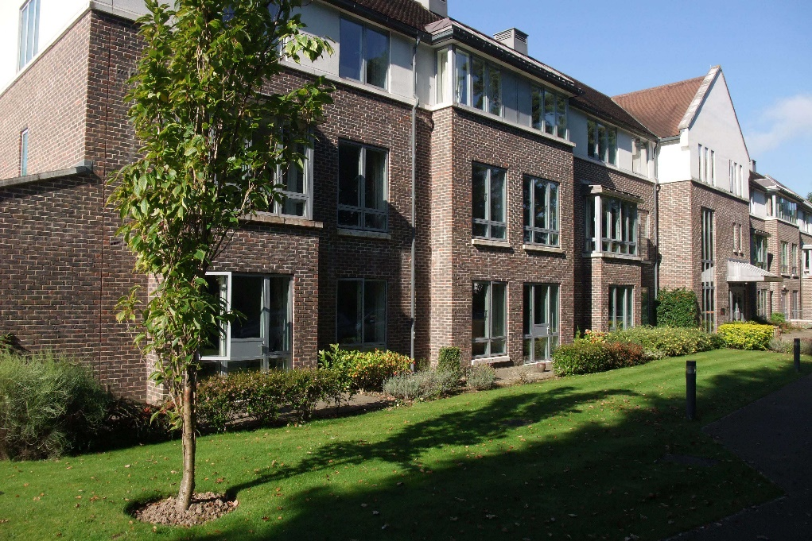

Scheme
Brochure

Manager Peter Hilling peter.hilling@churchofengland.org
Deputy Manager Carolyn Crabbe carolyn.crabbe@churchofengland.org

Telephone Number 01428 601500

Manormead Supported Housing, Tilford Road, Haslemere, Surrey GU26 6RA

Overview
Manormead is one of 7 supported housing schemes provided by the Church of England Pensions Board which are available to retired beneficiaries. Constructed in 2007, Manormead offers an excellent level of accommodation and facilities including 28 well-proportioned unfurnished flats which are suitable for double and single tenancy. All flats have a separate living room, kitchen, bathroom and bedroom with plenty of storage space. The kitchen includes an under the counter fridge, eye level electric cooker and separate hob. Manormead is proud to offer support, friendship and a strong sense of community in a relaxed environment.

Location
Hindhead is a semi urban village within the beautiful Surrey Hills Area of Outstanding Natural Beauty; with Manormead being a short distance from the Devils Punchbowl. There are several towns and villages, such as Haslemere, Farnham and Grayshott, within a short distance which can offer a variety of shopping and other amenities.

Transport
There are local bus services to Haslemere, Aldershot and Farnham which pass by, with connections onwards from these locations. Trains run from Haslemere to Guildford, London, Portsmouth and further afield. We are situated close to the A3. The scheme is fortunate in that it benefits from a volunteer driver service from both Care in Haslemere and The Friends of Manormead. Car parking and garaging is available to residents.

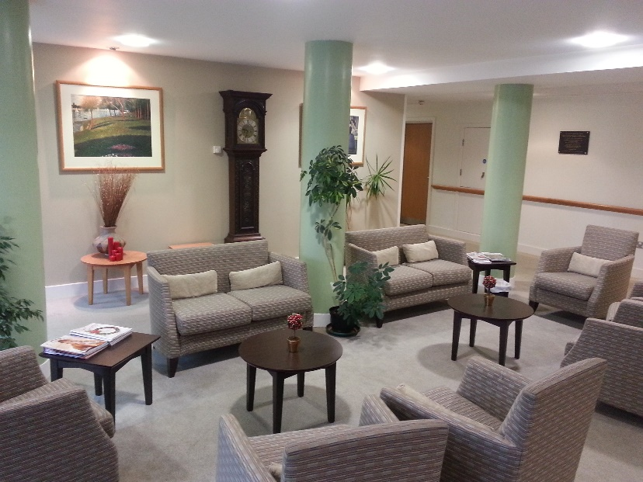

Communal Space
Manormead is proud of its beautiful, well maintained garden which is mainly laid to lawn with flower beds and circular path. We have a dedicated room in which to store and charge outside buggies. Inside you will find a comfortable lounge with grand piano, dining room, well stocked library, activity room and occasional seating. We also have a well-equipped laundry for residents to use any time. On a Monday we open our shop which sells a small selection of non-perishable convenience items. A local hairdresser, chiropodist and hearing aid support make use of our communal treatment room on a regular basis.

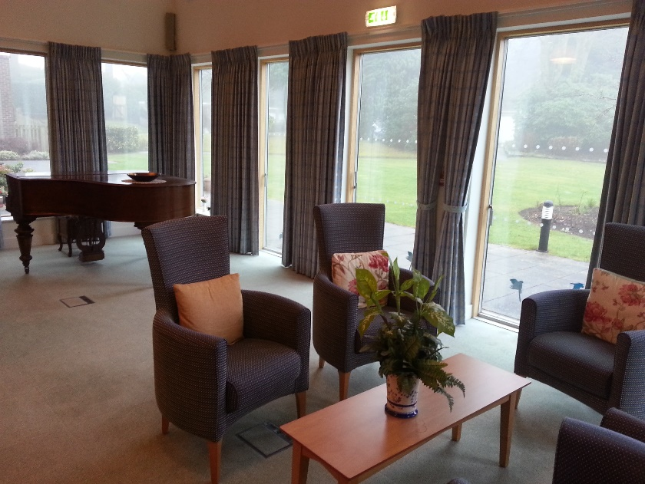
Guest Rooms
We have two guest rooms which, for a reasonable rate, are available for resident guests as well as short stay breaks for beneficiaries. One room is a twin with a shower over bath, and the other is a double with separate shower and bath.

Activities
These are generally organised by residents and include film and games afternoons, a poetry group, bible studies, book club and talks. There’s opportunity for those who wish to socialise and no pressure on those who would prefer a quieter way of life. Staff may from time to time organise quizzes and social teas. A coffee morning takes place while the shop opens, plus there is coffee every day in the lounge after lunch.

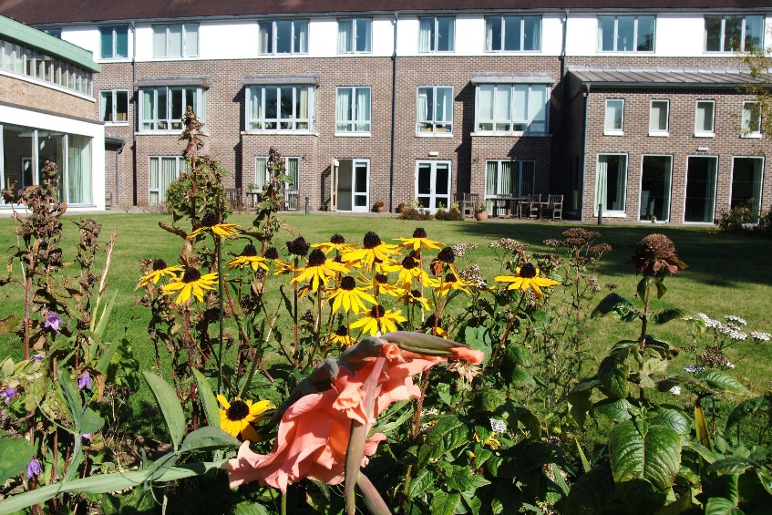
Meals
We offer a cooked lunch in our dining room with choices available from our varied menu. Allergies and special diets can be accommodated by our catering team. We are committed to resident involvement through regular dialogue and meetings to gain feedback and inform menu options. Guests are welcome to join residents at lunch for a small charge.

Support Services
We pride ourselves on offering a flexible balance of independence and support. Staff are on site seven days per week to offer resident wellbeing, company, general assistance and support needs as required. We cannot offer any care or nursing; however, care packages are delivered in the privacy of the person’s own home by either social services or a private care agency. Managers can help residents and next of kin decide on the best package for their needs and offer advice on obtaining benefits. The scheme is equipped with a 24-hour warden call system which can be used to call for emergency assistance from staff or the out of hours call centre. An integral fire alarm system ensures that the building is continuously monitored.

Chapel Life
Our chapel is at the heart of the Manormead community with regular services held on a Sunday and Wednesday. Residents run the chapel and volunteer their services through the chapel committee which benefit from strong links with the local Church and Guildford Diocese.

Pets
We understand how important pets can be. That’s why we’re happy to welcome a well- behaved pet to live with you in your new home.
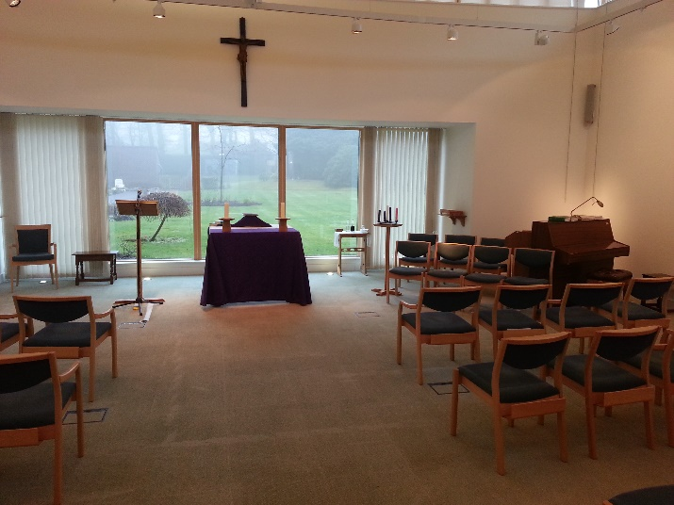
Eligibility
Retired Beneficiaries include; Clergy, Deaconesses, Church and Lay Workers (who hold a Bishop’s License for Ministerial Work), Church Army Officers (who have carried out Parish work and who retired after the 1st April 1983 – this could include Parochial Evangelist or overseas work) – Group A. Also, Non-Stipendiary Ministers, House for Duty, and applicants from Religious Orders, who are able to fully self-fund.
Applicants from Religious Orders can also apply when the Order agree in advance to fully fund the costs. Eligibility also extends to non-Ministerial Lay pensioners, including former employees of the Church of England organisations, and retired staff of the Church’s National Institutions and Episcopal staff. Spouses/widows/widowers and civil partners of the above are also eligible. All Beneficiaries are required to have at least 5 years’ service.

Rent and Service Charges
Living at Manormead means that you can sit back and let us take care of all the maintenance of communal and external areas with no more worrying about the upkeep of a building. Annual charges are based on actual costs and include a rental charge, utilities, facilities, lunch and staff services. These are charged on either a single or double occupancy basis. Telephone calls, guest rooms and meals, garaging and laundry charges are charged additionally on an individual basis. Council tax is paid directly to the local authority. Please contact the Manager or Duty Manager for more information as to current charges.

Affordability
All beneficiaries with limited income and/or capital should be aware that help is available. Anyone with concerns about affordability should contact us in the first instance. If the household capital is less than £16,000 then housing benefit and/or council tax reduction maybe available. Those listed above in Group A would also be eligible, should they qualify, for a grant from the Boards charitable funds to help meet the support charges, which are costs not eligible for housing benefit assistance.

Visits
We welcome visits from anyone interested in Manormead and the Board’s housing in general. All beneficiaries who would like a taste of life at Manormead can either just pop in, book in for lunch, or have a short stay. You will be assured a warm welcome.

Application Process
The Pensions Board holds two lists:
- The Active list – this is for those wanting supported housing in the near future.
- The Reserve list – for those wanting to register their intent but with no immediate plans to move into supported housing.

If you are interested, we would love you to come and visit us. We could also send you an application pack which contains information on supported housing and an application form.

Please contact us on 01428 601500 for an informal chat or to arrange a visit.

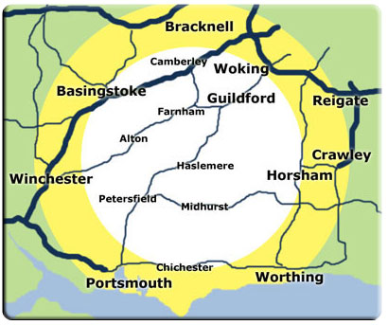
Hindhead

