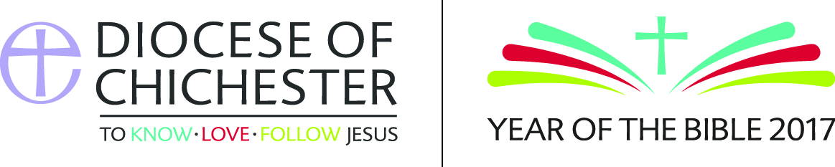
Year of the Bible – recommended books
Suggestions include:
- The Bible for Grown Ups: A New Look at the Good Book- Simon Loveday, Icon Books, £12.99- 978-1-78578-131-5
- Children in the Bible- Anne Richards, SPCK, £12.99, 978-0281-06688-9
- Bread of Angels- Feeding on the Word, Barbara Brown Taylor,Canterbury Press, £12.99, 978-1-84825-781-8
- From God’s Word to our Lives, Lectio Divina, Enzo Bianchi, SPCK, £10.99-978-0-281-07334-4
- The Bible, the Basics, John Barton, Routledge, 978-0-415-41136-3
- Things hidden, scripture as spirituality, Richard Rohr, £12.99, SPCK, 978-0-281-07516-4
- Paradoxology, Krish Kandiah, Hodderfaith, £13.99 , 978-444-74534-4
- The Bible in Pastoral Practice, Paul Ballard and Stephen Holmes, DLT, £17.95, 978-0-732-52611-7
- Conversations with the New Testament, John Holdsworth, SCM Press, £14.99, 978-0-334-04413-0
- Encountering the Bible, Andrew Village, SCM Press, £14.99, 978-0-334-05397-2
- Reading Backwards, Richard B. Hays, SPCK, £16.99, 978-0-281-07408-2
- The Bible in the Contemporary World, Richard Bauckham, SPCK, £15.99, 978-0-281-07484-6
- The Bible, A Very Short Introduction John Riches, OUP, £7.99,978-0-19-265343-1
- The Old Testament, A Very Short Introduction, Michael Coogan,OUP, £6.99, 978-0-19530505-0
- The Bible Makes Sense, Walter Brueggemann, £12.61, 978-0-867165-586
- Commentaries and study materials by NT Wright
- Reading the Bible Wisely, Richard S. Briggs
- The Drama of Scripture, Mike Goheen and Craig Bartholomew
- God’s Big Picture, Vaughan Roberts

