Kericho: redistributing wealth and dignity as we seek to live into the Kingdom.

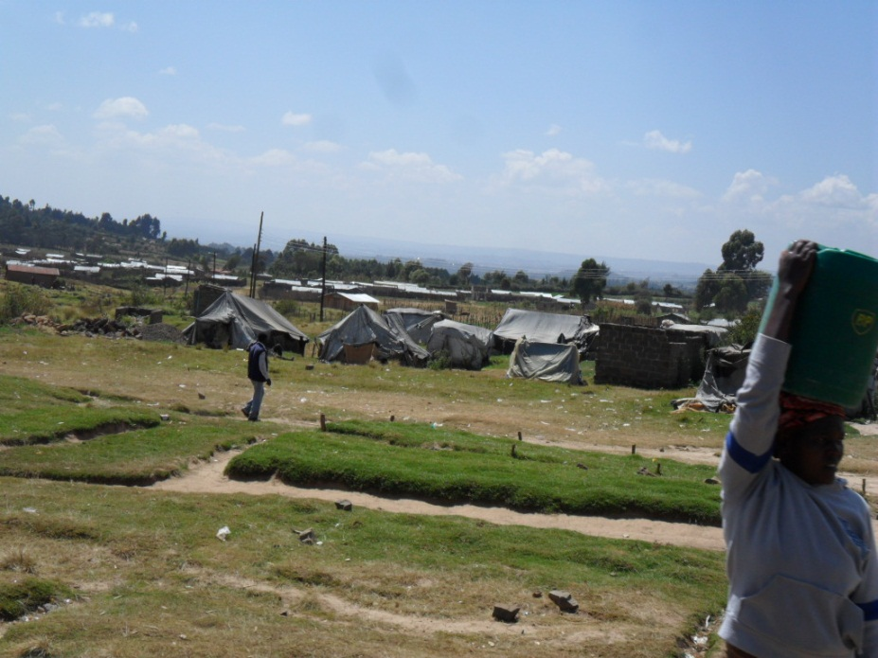
Our journey to Kericho was a steady climb into the hill country so loved by the White Settlers who made their homes in the cool highlands and cultivated its rich fertile soil. At a cross-road we passed through a town still bearing the signs of the violence and bloodshed of inter-tribal conflict two elections ago. The burnt out ruins of homes and businesses and the shabby tents of the internally displaced serve as reminders of those aspects of Kenyan life not easily understood by Europeans and of the government’s inertia or amnesia now that the fickle eye of the international press is focused elsewhere.

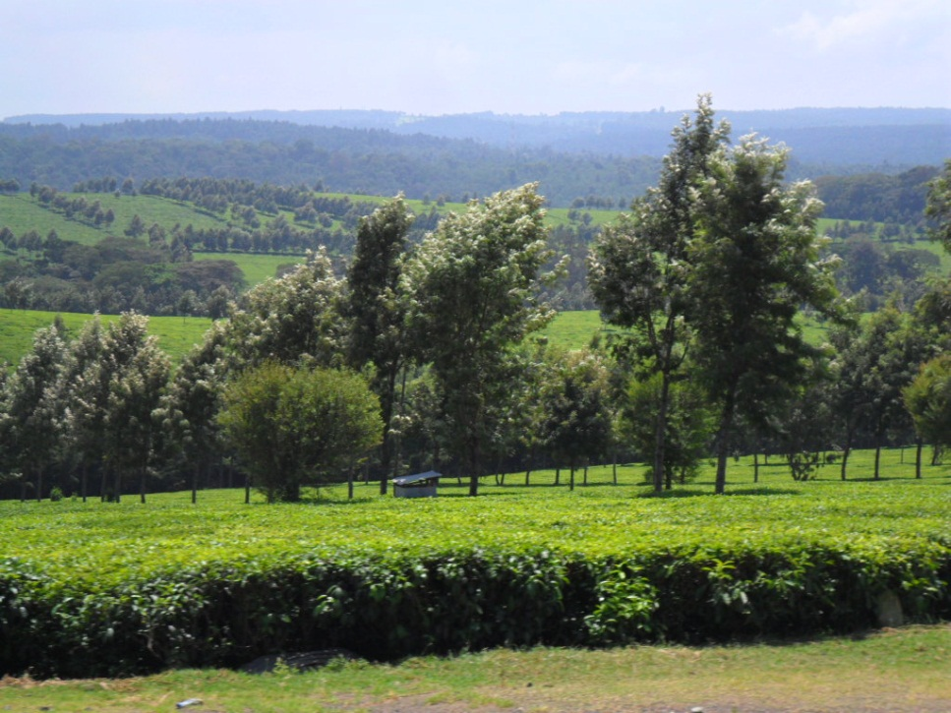
As we approach Kericho a rolling sea of emerald green draws our eyes. Interspersed by trees and clumps of forest, Kenya’s world famous tea plantations stretch out as far as the horizon and beyond. Tea pickers with baskets slung on their backs or large bags lying on top of the neat rows of tea bushes gather in the tender shoots in rhythmic almost hypnotic movements.

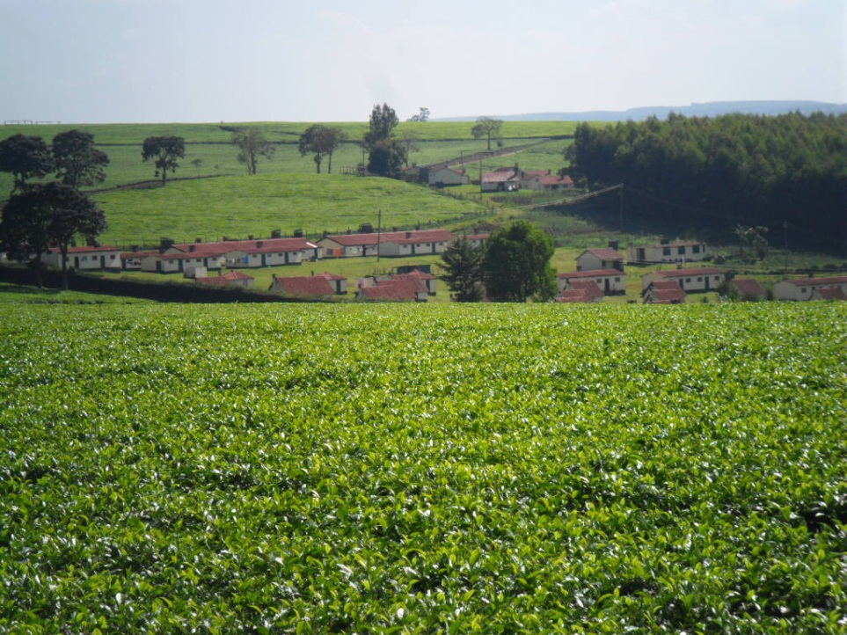
Some plantations still offer their workers lodgings in small tidy little houses arranged in rows. There is something idyllic about this region but its very neatness belies an underlying poverty afflicting many and the disturbing news of rising rates of cancer, which many suspect are caused by the increased and widespread use of chemical fertilizers and pesticides.

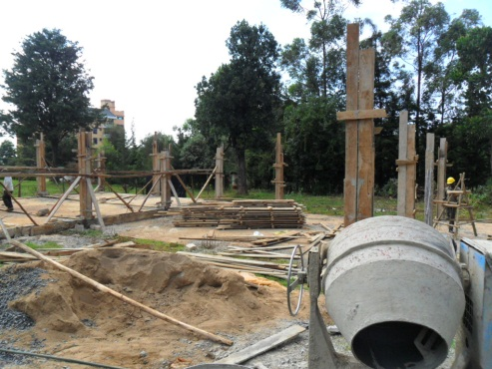
We arrive at the Diocesan Offices set in a large compound containing the Pro-cathedral of the Most Holy Trinity, Holy Trinity Primary School, the MU’s Bookshop, a small computer training centre and the foundations for a future restaurant, MU offices, guest house and commercial complex. Funding from the Diocese of Chichester enabled the Diocese of Kericho to literally lay the foundations for this ambitious project.

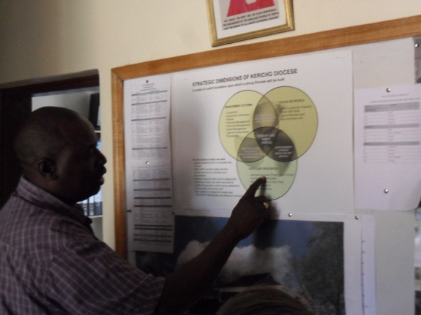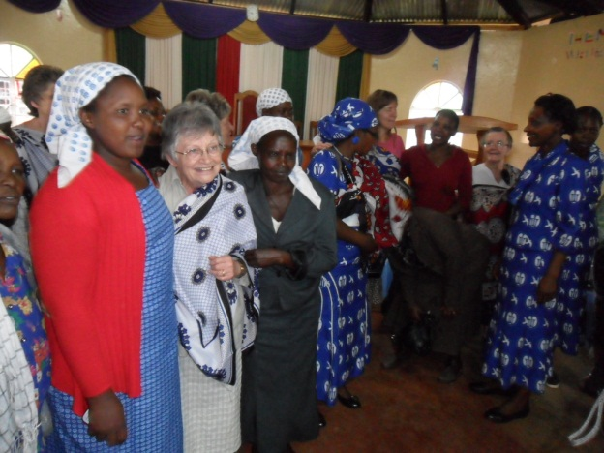
Bishop Jackson Ole Sapit is a man of energy blessed with a scope of vision that is both inspiring and engaging. He is a team player and, rightly, understands that, as Archbishop Rowan Williams once said, “Only the whole Church is able to grasp the whole Gospel.” For that reason he seeks to involve every level of the Christian community in discerning its God-given gifts and talents, and identifying its unique place in God’s transformational activity in the world.

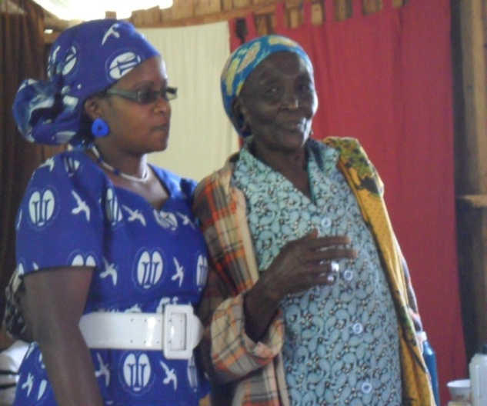
An example of this vision that we experienced and which touched us deeply was a project initiated by the Diocese of Kericho’s Mothers Union worker Emmy Romoh. Emmy introduced a programme which she refers to as “Table Banking.” Working with local MU branches in the poorer rural parishes, the women are encouraged to meet monthly in each other’s homes with the aim of creating and sustaining a rotational lending scheme. Each meeting involves prayer, worship, fellowship and Bible study. Each woman also brings an agreed amount of money. This modest sum is divided into two or three “pots”. A portion of the total is pooled and given to one of the members (lots are drawn to determine the order in which each will receive their lump sum). Another portion is either deposited into a communal savings account to be used at a later date on a project that will benefit the local community or given to the parish to assist in the payment of the diocesan quota.

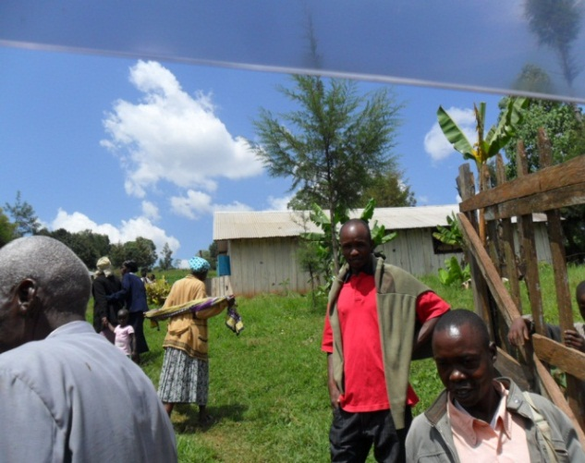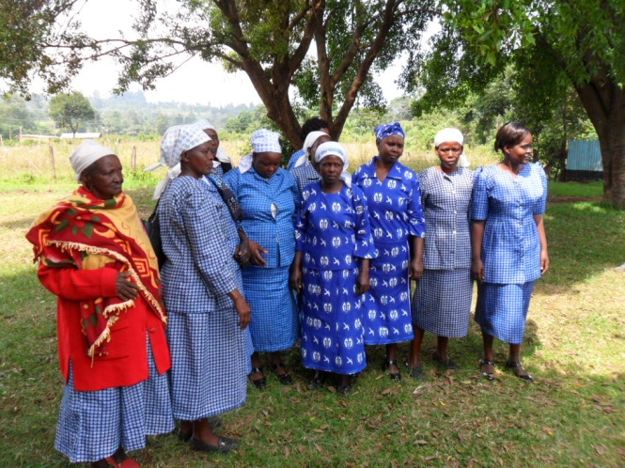
We heard testimonies of women who, when they received their lump sum, were able to invest in setting up modest businesses. Some bought chickens which they reared in order to sell the eggs. Others set up market gardens and sold their produce in the local market. Some were able to pay their children’s school fees and thus keep them at school. All commented how this project had strengthened, deepened and enriched the quality of their relationships at home and in their villages. Table Banking with its rootedness in prayer, worship, Bible study and community has transformed these rural parishes into places where self-esteem, self-confidence and creativity are nurtured and valued and the healing and redemptive presence of Christ known and celebrated.

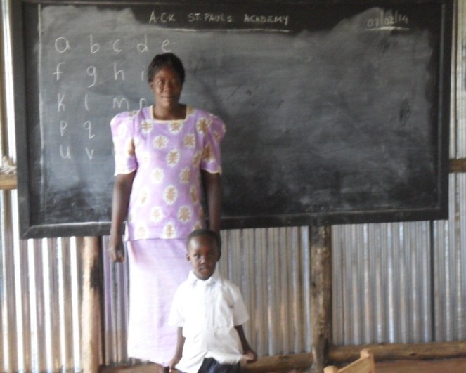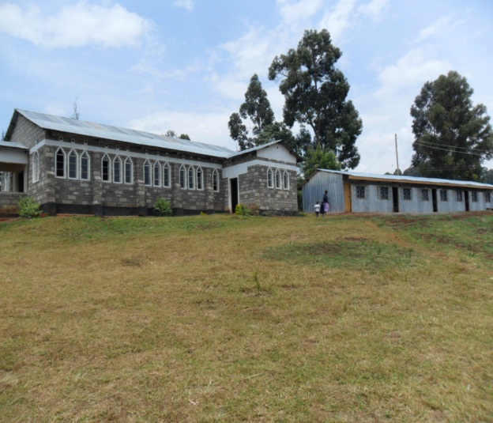
We also visited St. Paul’s, Chepsir. Located some 15 kms from Kericho the parishioners faced the costly, time consuming daily journey to and from the town to take their children to school. In addition, Kenyan schools generally do not provide their pupils with a mid-day meal and so most children walk home for lunch, for the children of Chepsir this was not an option. The community, after much discussion, thought and prayer, decided that they could best serve the villages in their parish by building a school. The four classrooms of wood framework clad in corrugated iron sit upon a concrete base behind the church. The faithful of St. Paul’s invested K$ 300,000 in their construction and borrowed a further K$150,000 to purchase blackboards and simple desks. The parish employs the three members of staff and a cook. The church community feels that by offering the children a nutritious mid-day meal they will be healthier and better able to learn.

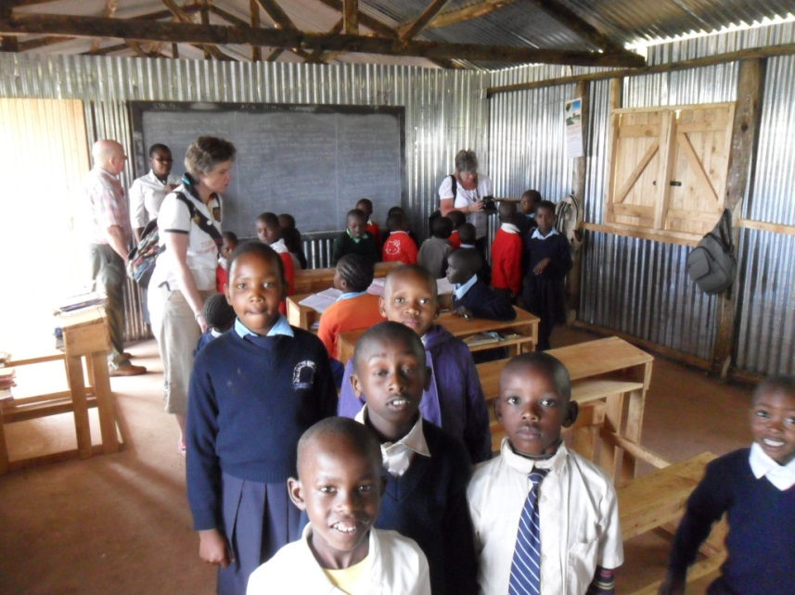
Bishop Jackson blessed and inaugurated the school and new church on the 5th of January 2014. Already the school is at full capacity and needing to expand. Here we have indeed come across a community that, like that lamp Jesus refers to in Matthew’s Gospel, is set high and illuminates all around it. All of us came away thinking that this is the sort of school and parish that would enrich any in the Diocese of Chichester that might wish to link with them!

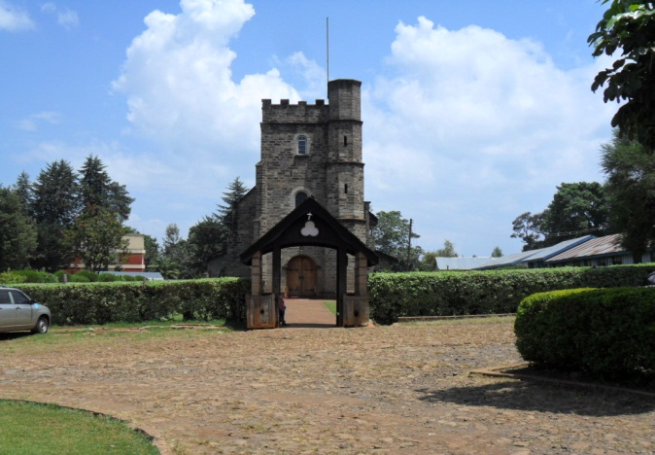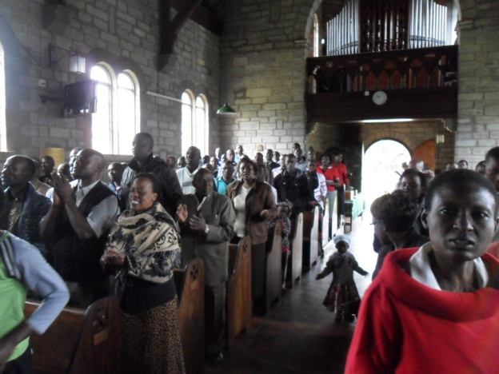
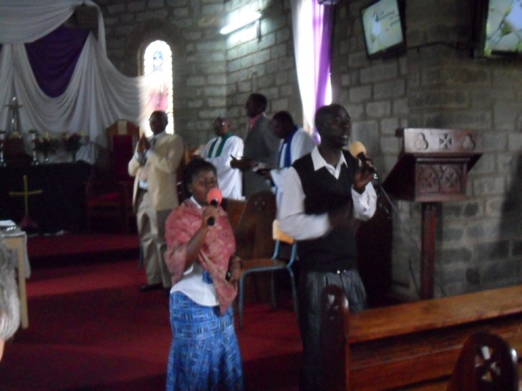
Sunday Morning service was a combined English/Ki-Swahili Mattins with a Kenyan “twist”. The music team had key boards, bongo drums, microphones and powerful speakers. Our ears rang and the moments of silent prayer became all the more precious! One interesting detail that caught our attention as we arrived was to see the back pews cordoned off with purple ribbon. This obliged those who came early to fill the front pews…we were amongst the first to arrive! By the end of the service the cathedral was full to overflowing and there were people standing in the porch and on the lawn at the west end.

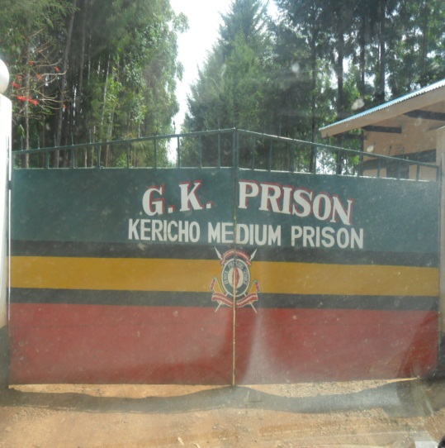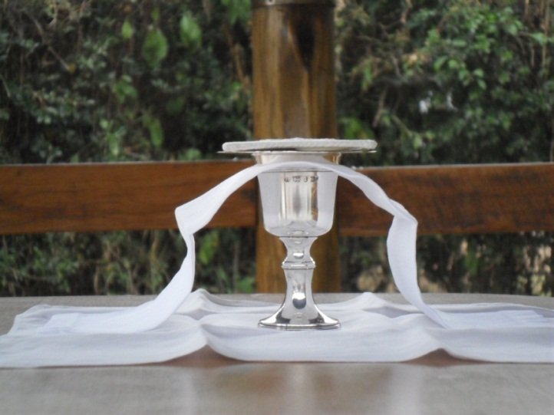
Knowing that we would be attending a non-Eucharistic service on Sunday, our group gathered on Saturday evening for a quiet Communion in the gardens of our modest hotel. We had had a challenging day having visited another very poor rural parish and, in the afternoon, the local women’s prison. The sight of children and babes in arms behind the wire fence living amongst the 80 or more inmates, most of whom were dressed in long black and white striped gowns bearing different coloured badges, was heart breaking and triggered disturbing associations. Emmy and her MU team and Chris Emson our gentle and loving MU President addressed and sought to encourage them. Gifts of toiletries and other little “luxuries” were distributed amidst cheers and ululations. The women sang and chanted responding with enthusiasm to the guidance of the prison chaplain, a young woman from one of the local Pentecostal churches.

Our Eucharist, therefore, was full of long and dense silences as we recalled these unforgettable days and brought to the foot of the cross both the agony and the ecstasy that we had witnessed and participated in, however, fleetingly, during this our Kenyan pilgrimage.

Today, Sunday, we bid farewell to Emmy Romoh; Mama Esther; Fr. Nicholas, the Provost of the Cathedral; and to wonderful Susan, who cooked and cared for us every day of our stay in Kericho. Tonight we dine with Bishop Joseph Muchai of Nakuru and tomorrow we travel back to Nairobi and say farewell to Peter, who has driven us hundreds of kilometers and never once ceased to be considerate, kind, forgiving, wise and full of good humour. We leave this breathtakingly beautiful country with a heightened awareness that “the Lord is here indeed!”

Asante kwaMungu! Thanks be to God!

