Stretched, surprised and nourished by the unexpected

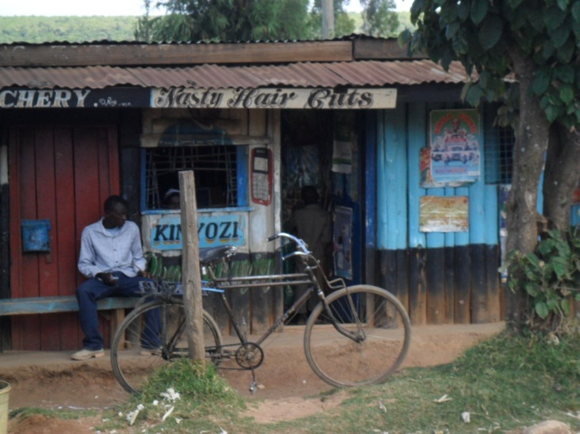

Kenya is, as the saying goes, “full of surprises.” Time and time again, we see things that are familiar and known, but then there is a “twist” that makes you stop, look again and rethink what you thought to be the norm. It might be a simple barber’s shop sign (“Nasty Hair Cuts”!) or the unexpected surprise that Nyahururu cathedral has run out of wine and so we will not share in the Eucharist on Sunday. Instead we are invited into worship that transfigures our hosts from a solemn gathering into an explosion of joyful celebrating saints whom the love of and for God fills with an energy quite unlike anything we might experience in England.

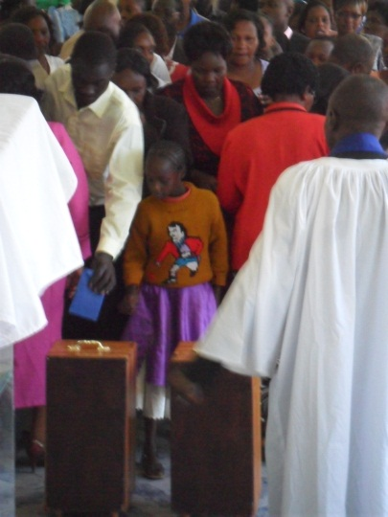

The Sunday morning service began with the unexpected appearance of the Vice-chair of the Christ the King cathedral council who placed a plastic chair in the middle of the nave aisle and a basket upon it. He announced to the congregation that the work on the new cathedral had stopped for lack of money to pay the workers’ wages and so he was inviting the assembled christians to make a special offering so that work might continue. The entire congretation filed up to make their gift. This was to be the first of three collections that morning.

Drums, electric key board, a young Tanzanian composer and the choir filled the air with extraordinary harmonies and moving with the rhythm seemed the most natural thing in the world. We missed the Eucharist and our group met later that afternoon in the gardens of the Thomson Falls Lodge for Communion. The steady rumble of the landmark waterfall calmed and settled us; it was a Candlemas unlike any other but that in itself lent depth to Simeon and Anna’s encounter with the Family in the Temple.
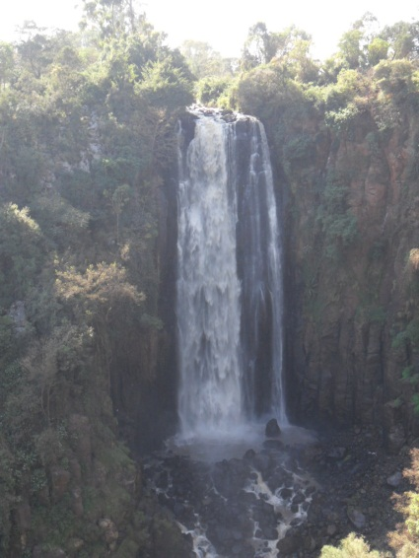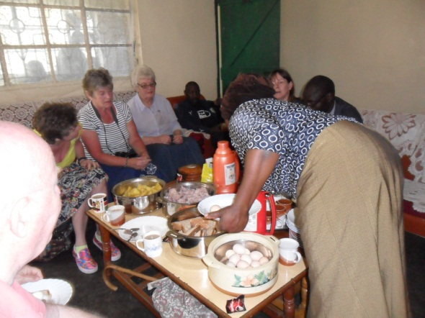

On Monday we set off to visit the southern half of the Diocese of Nyahururu. We visited several parishes, a number of projects and spent time with the clergy and their wives in their homes. In some places we were also met by the local PCCs and always there were refreshments…an abundance of food: boiled eggs, sweet potatoes, arrowroot, bread, chai, coffee and more. Some of us pondered on the times when we, in our rush and busyness, would settle for the minimum effort when guests arrive…and so to be met with such lavish hospitality caused us no little sense of embarrassment. We later discovered that Monday is without exception every priest’s “off day” and the realisation of just how costly welcoming our group deepened. And yet, not a sign of being inconvenienced or bad grace, on the contrary our hosts’ delight and pleasure was genuine.

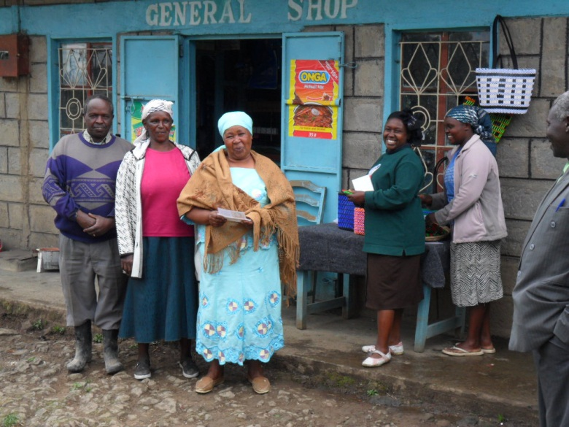

Making time for others and creating space within that for Christ to be with us is at the heart of a little MU project we visited. The older women in this rural community meet with young mothers to do bead work. In the course of time spent together they talk and discuss problems, counsel is given and prayer and catechism offered. The women sell the bags, baskets and table mats they make. The funds are invested in purchasing new materials and the profit divided among them. Always a percentage is given to the church in thanksgiving. Compassion, gentle humour and a strong sense of God’s abiding love is all too evident in our hosts’ shining faces. We, inadvertently, had strayed on to holy ground.

That evening we gathered, as we had since our arrival in Nyahururu, for our final meal with Bishop Stephen, Mama Eunice and Fr. Anthony the Administrative Secretary. Real sadness tinged the air and when it came to our parting Mama Eunice surprised all of us, Bishop Stephen included, by quietly weeping. Something had happened to all of us in these four days, it is hard to find the words to express just how it did but it nevertheless is real. As our minibus drove out of the cathedral compound and turned towards Nakuru we could only quietly say, “Bwana asante” (Lord, thank you).

