Dust, dance and seeds of hope?

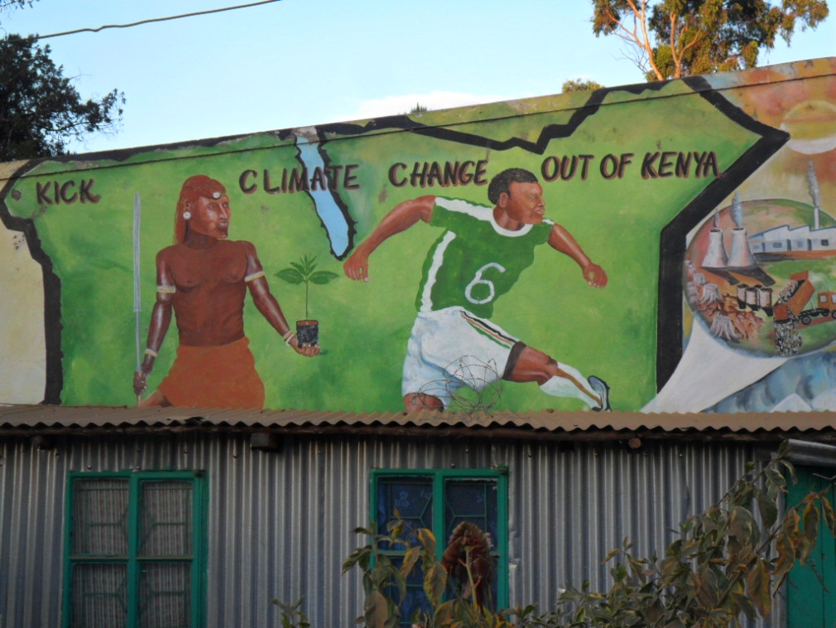

We arrive in Nyahururu crossing the Equator in the process. The altitude means that even when the sun is at its height the temperature, though warm, is pleasant. The vegetation is still green even though it has not rained since December though the dust betrays the fact that the soil is drying out. Farmers are beginning to plough their fields and ready themselves for the rains that should, God willing, come in March. Climate change, however, is something that Kenyans are concerned about as they note that the rhythms of the rains critical to successful harvests are not as they once were.

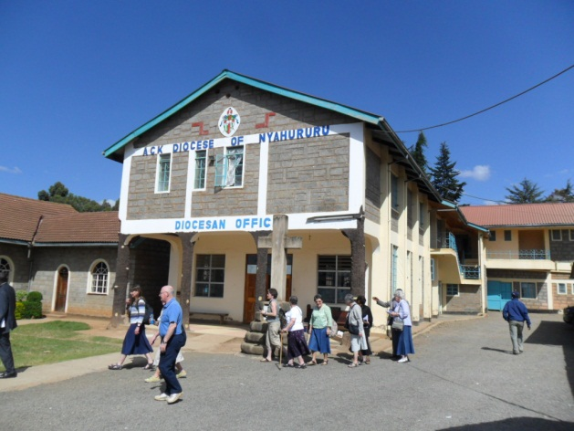

We are shown around the cathedral compound. What we thought to be THE cathedral has been subdivided into Sunday school rooms as the congregation has outgrown the original church. Main services are now held in what was the old hall and the foundations have been laid for a new and much larger cathedral capable of holding three thousand faithful. The Diocesan Administrative Secretary, Fr. Anthony Wanjahi, estimates that the cost of the cathedral will be around K$100,000,000. The diocese does not have the funds to complete this ambitious project but it has the faith and the patience to work diligently for as long as it takes to achieve this goal.

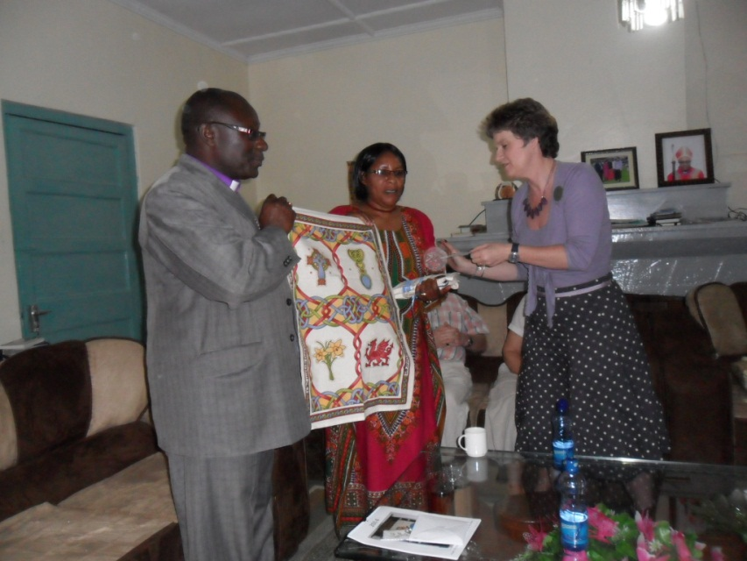

Bishop

Bishop Stephen Kabora and Mama Eunice have kindly opened their home to us. We will be eating with them every evening of our stay here in Nyahururu. That first evening, we were able to give them gifts brought from home and to share something of the challenges and struggles facing the Church in the UK.

Bishop Stephen has served his entire ministry here and was in Nyahururu when it separated from Nakuru to become an autonomous diocese. He knows it intimately and has great hopes to grow the Church in this area. Bishop Stephen gave us copies of the address he gave at his consecration in which he outlined his priorities for the next ten years. Among these are ensuring that his clergy have homes for their retirement and receive the opportunity to receive in-service training and time for spiritual refreshment. Bishop Stephen also hopes that within the next couple of years the Missionary Area of Maralal will be in a position to become an autonomous diocese and that a number of social action and mission programmes that were closed when overseas funding ceased may once again be reinstated.

Fr. Anthony, the Administrative Secretary, and Bishop Stephen have planned a full programme for us. The men (Robin and I) were taken by Fr. John Kiarie to meet Archdeacon Julius Wanjohi who serves the five congregations that make up the parish of Marmanet.

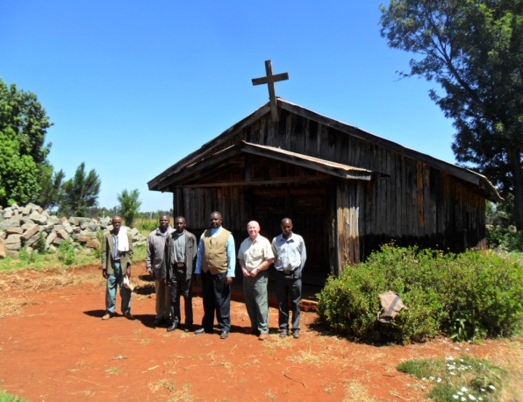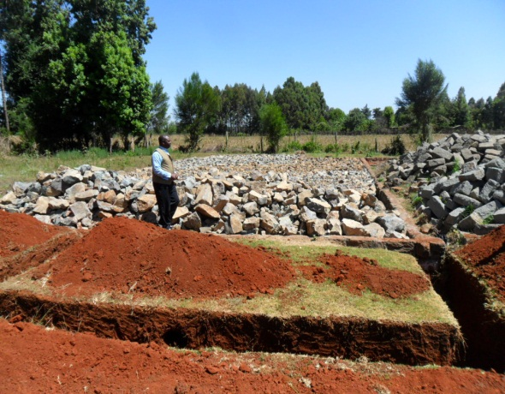

Our first stop is St. Ruth’s Anglican Church. The land was donated many years ago by an elderly couple who farmed it and the surrounding fields. The local community of some 30 to 40 members built a modest split log building that has served them well. The original donors’ son serves as Lay Reader and watchman. Archdeacon Julius (in the waistcoat) is a man of great energy and vision. He has challenged and galvanized the community. With great patience, sacrifice and discipline over the past 5 years the people of St. Ruth’s has purchased the stone blocks for the foundations and walls of their future church (while raising the full diocesan quota on a single Sunday set aside for that purpose!).

Archdeacon Wanjohi’s parish is like many others in rural Kenya small and largely composed of subsistence farmers. These are not people who enjoy the safety nets provided by the NHS and Social Services in the UK. They understand good harvests to be tangible proof of God’s providential love and that generous love can only be responded to with generosity and love. The sacrifices made by these humble Christians for love of God and his Church are deeply moving and not a little uncomfortable to those of us used to expect levels of comfort and ease of access to public services provided by the state.

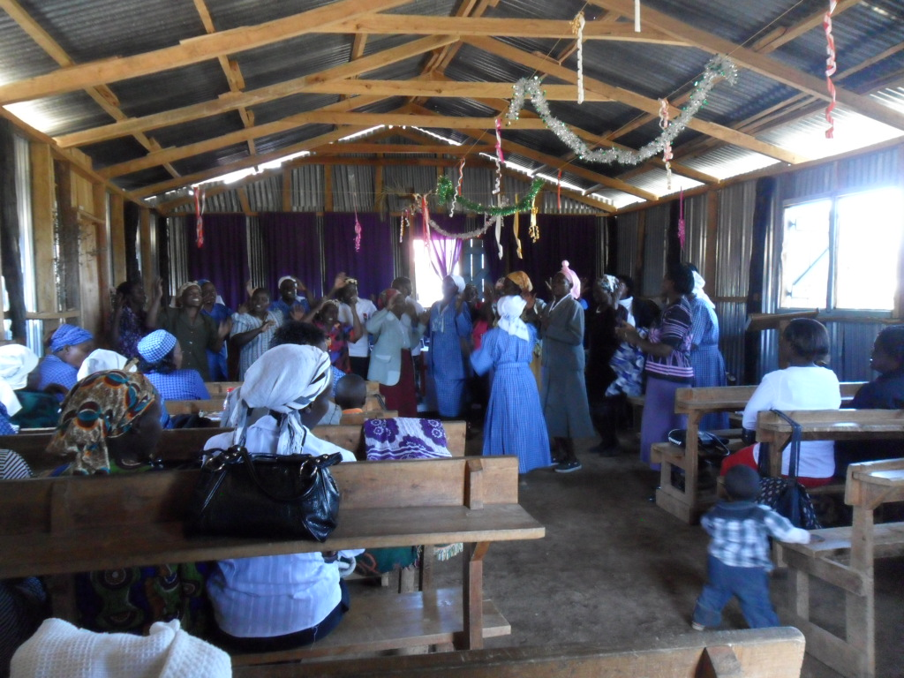

St. Ann’s, Limunga is our next stop. It is literally a “tin tabernacle” made of wood sheathed in corrugated iron. We hear singing, drumming and prayers uttered with great passion. At first we sit outside in the shade but eventually our curiosity gets the better of us. We enter and find ourselves with 80 Mothers Union members dancing to the rhythmic beat of drums and a circular piece of iron struck with a small steel rod. The women’s feet raise clouds of dust from the packed earth floor and the energy and visible enjoyment of the MU members is electrifying. We later learn that the MU had gathered for its quarterly seminar, on this occasion a series of reflections on “Esther, saviour of her people.”

Robin, the Archdeacon and I are served lunch in the vestry before returning to Nyahururu. We stop at the Roman Catholic cathedral of the Immaculate Conception to look more closely at some murals painted on the walls of one of the halls. The picture below captures and communicates so much about the history of Christian mission in this remarkable continent:

In the background we may recognise tropical vegetation typical of the area; the stones echo those used in the construction of homes and churches and so on. That the sower is casting his seed in an African setting is obvious…and yet, he is clearly not an African.

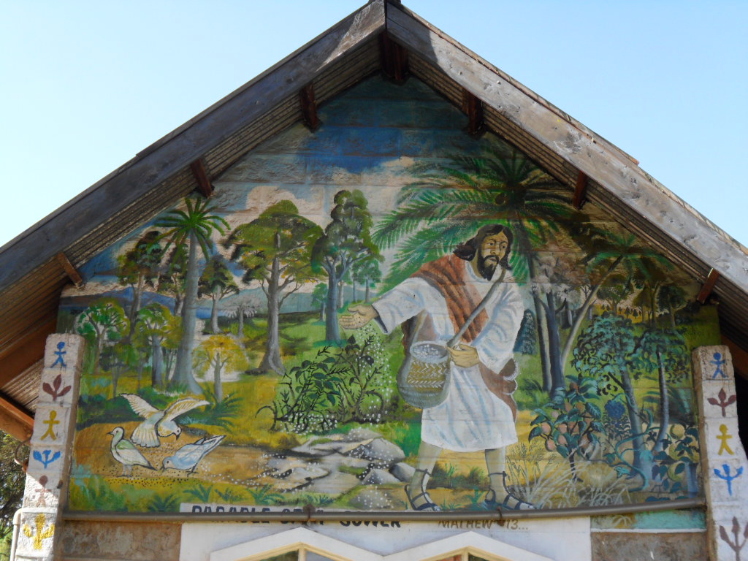

The dancing women of the MU gathered in Limunga are without doubt examples of the rich good soil into which the seed of the Good News of God’s love for humanity has sunk, germinated and grown to produce a rich harvest. But the sower is no longer and can no longer be the European “missionary”. If anything we are left wondering if the circle is closing. Just as in the first centuries it was North African missionaries who took the gospel to Europe we cannot help but wonder if these humble women and their sisters and brothers who face the often perilous journey north in search of work are part of God’s hope for the renewal of His Church in our continent.

